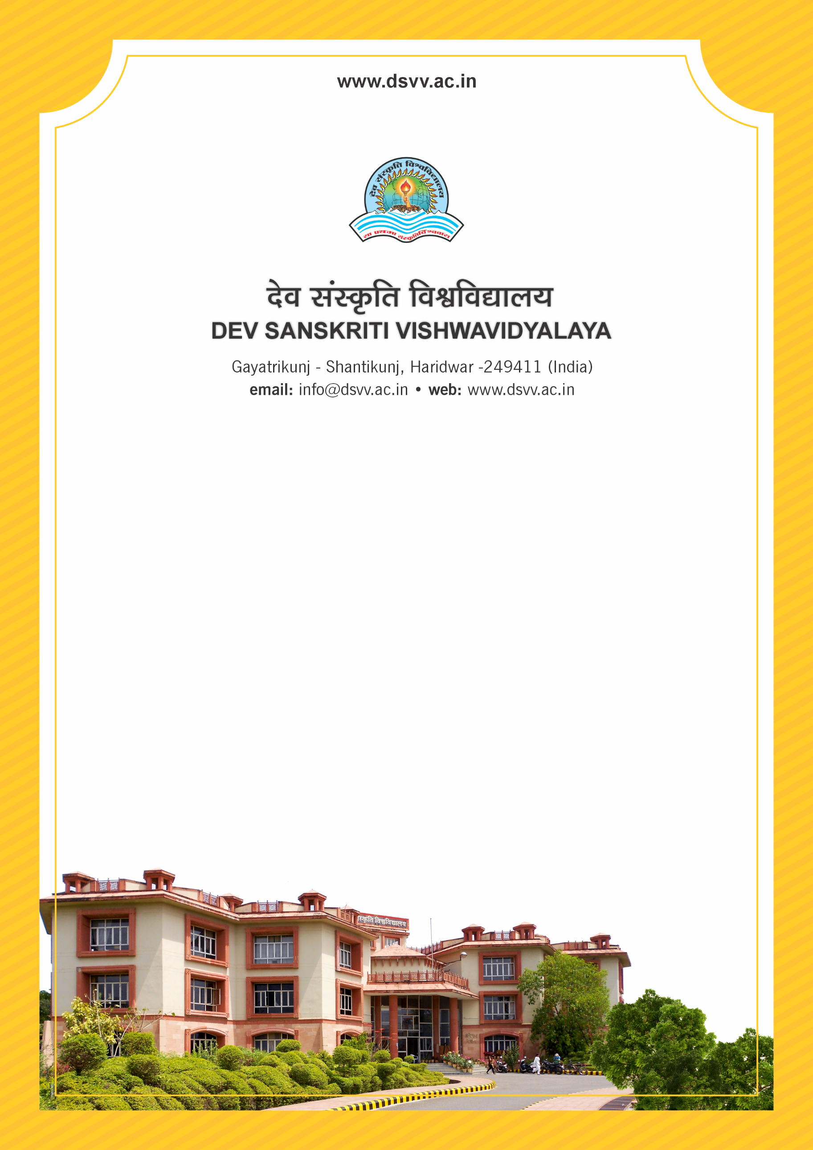
Figure 1Titel
Criteria 7
7.1.6 Quality audits on environment and energy are regularly undertaken by the institution
The institutional environment and energy initiatives are confirmed through the following
1. Green audit / Environmental audit
2. Energy audit
3. Clean and green campus recognitions/awards
4. Beyond the campus environmental promotion and sustainability activities
Response: B. Any 3 of the above
7.1.6
Quality audits on environment and energy are regularly undertaken by the institution
The institutional environment and energy initiatives are confirmed through the following
1. Green audit / Environmental audit
2. Energy audit
3. Clean and green campus recognitions/awards
4. Beyond the campus environmental promotion and sustainability activities
Response: B. Any 3 of the above
File Description | Document
Report on environmental promotional activities conducted beyond the campus with geo-tagged photographs with caption and date
Policy document on environment and energy usage Certificate from the auditing agency.
Institutional data in the prescribed format (data template)
Green audit report of all the years from recognized bodies
Certificates of the awards received from recognized agency (if any).
Provide Links for any other relevant document to
support the claim (if any)

