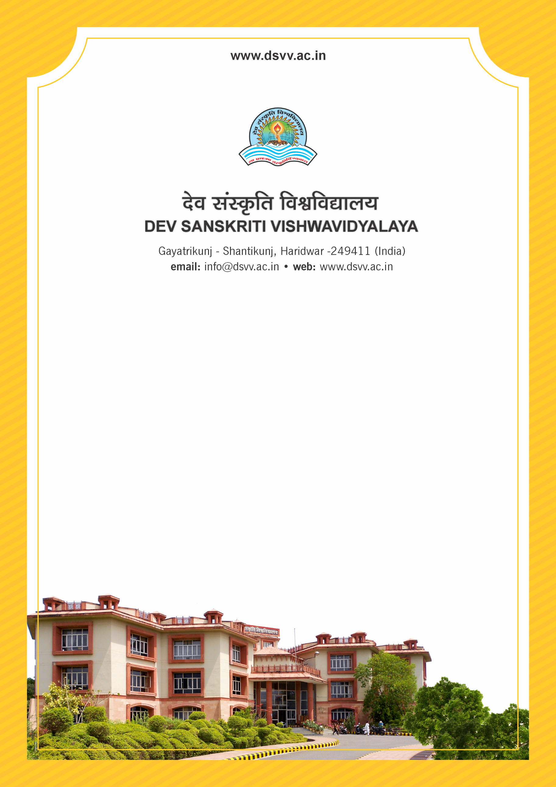
Figure 1Titel
Criteria 7
7.1.4 Water conservation facilities available in the Institution:
1. Rain water harvesting
2. Borewell /Open well recharge
3. Construction of tanks and bunds
4. Waste water recycling
5. Maintenance of water bodies and distribution system in the campus
Response: B. Any 3 of the above
7.1.4
Water conservation facilities available in the Institution:
1. Rain water harvesting
2. Borewell /Open well recharge
3. Construction of tanks and bunds
4. Waste water recycling
5. Maintenance of water bodies and distribution system in the campus
File Description | Document
Institutional data in the prescribed format (data template)
Green audit reports on water conservation by recognised bodies
Geo-tagged photographs of the facilities.
Bills for the purchase of equipment’s for the facilities created under this metric.
Provide Links for any other relevant document to support the claim (if any)
Response: B. Any 3 of the above

