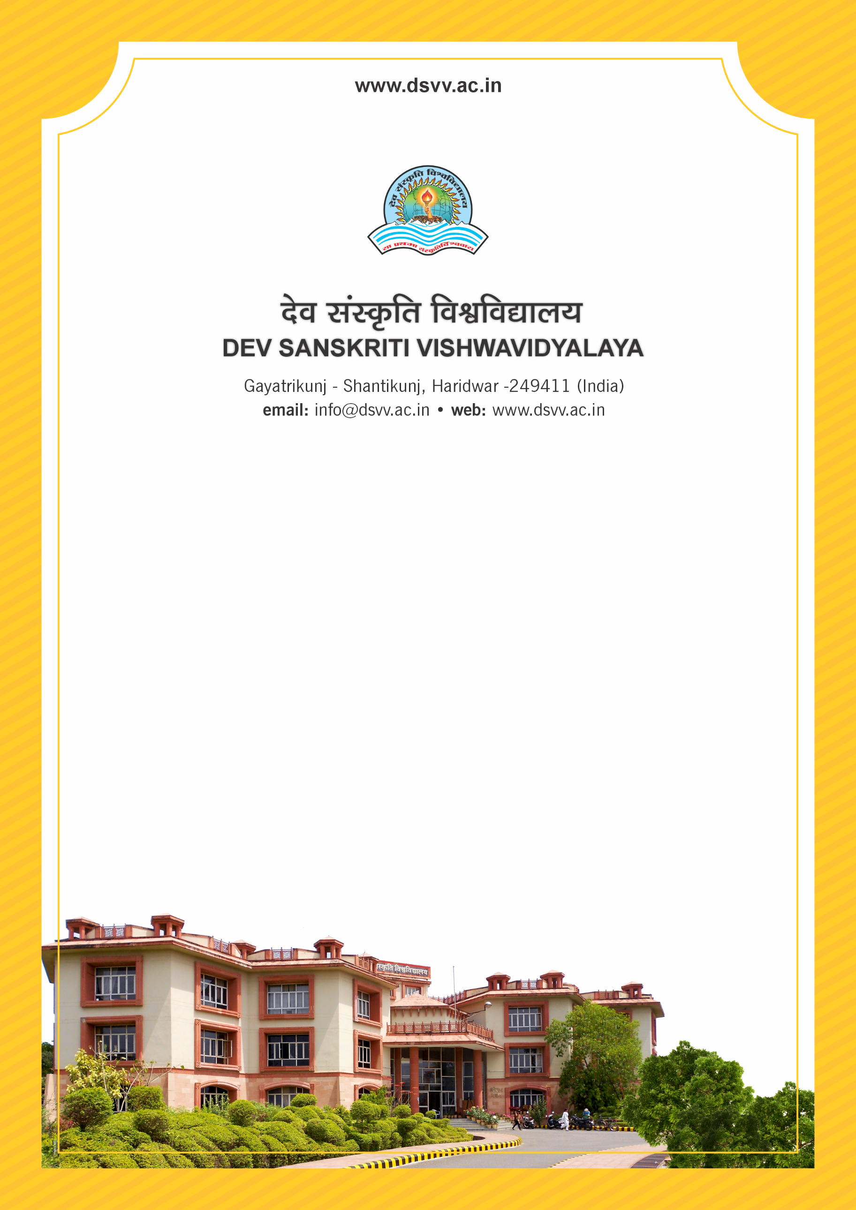
Figure 1Titel
Criteria 7
7.1.2 The Institution has facilities for alternate sources of energy and energy conservation measures
1. Solar energy
2. Biogas plant
3. Wheeling to the Grid
4. Sensor-based energy conservation
5. Use of LED bulbs/ power efficient equipment
6. Wind mill or any other clean green energy
Response: B. Any 3 of the above
7.1.2
The Institution has facilities for alternate sources of energy and energy conservation measures
1. Solar energy
2. Biogas plant
3. Wheeling to the Grid
4. Sensor-based energy conservation
5. Use of LED bulbs/ power efficient equipment
6. Wind mill or any other clean green energy
File Description | Document
Permission document for connecting to the grid from the Government/ Electricity authority.
Institutional data in the prescribed format (data template)
Geo-tagged photographs of the facilities.
Bills for the purchase of equipment’s for the facilities created under this metric
Provide Links for any other relevant document to support the claim (if any)
Response: B. Any 3 of the above

