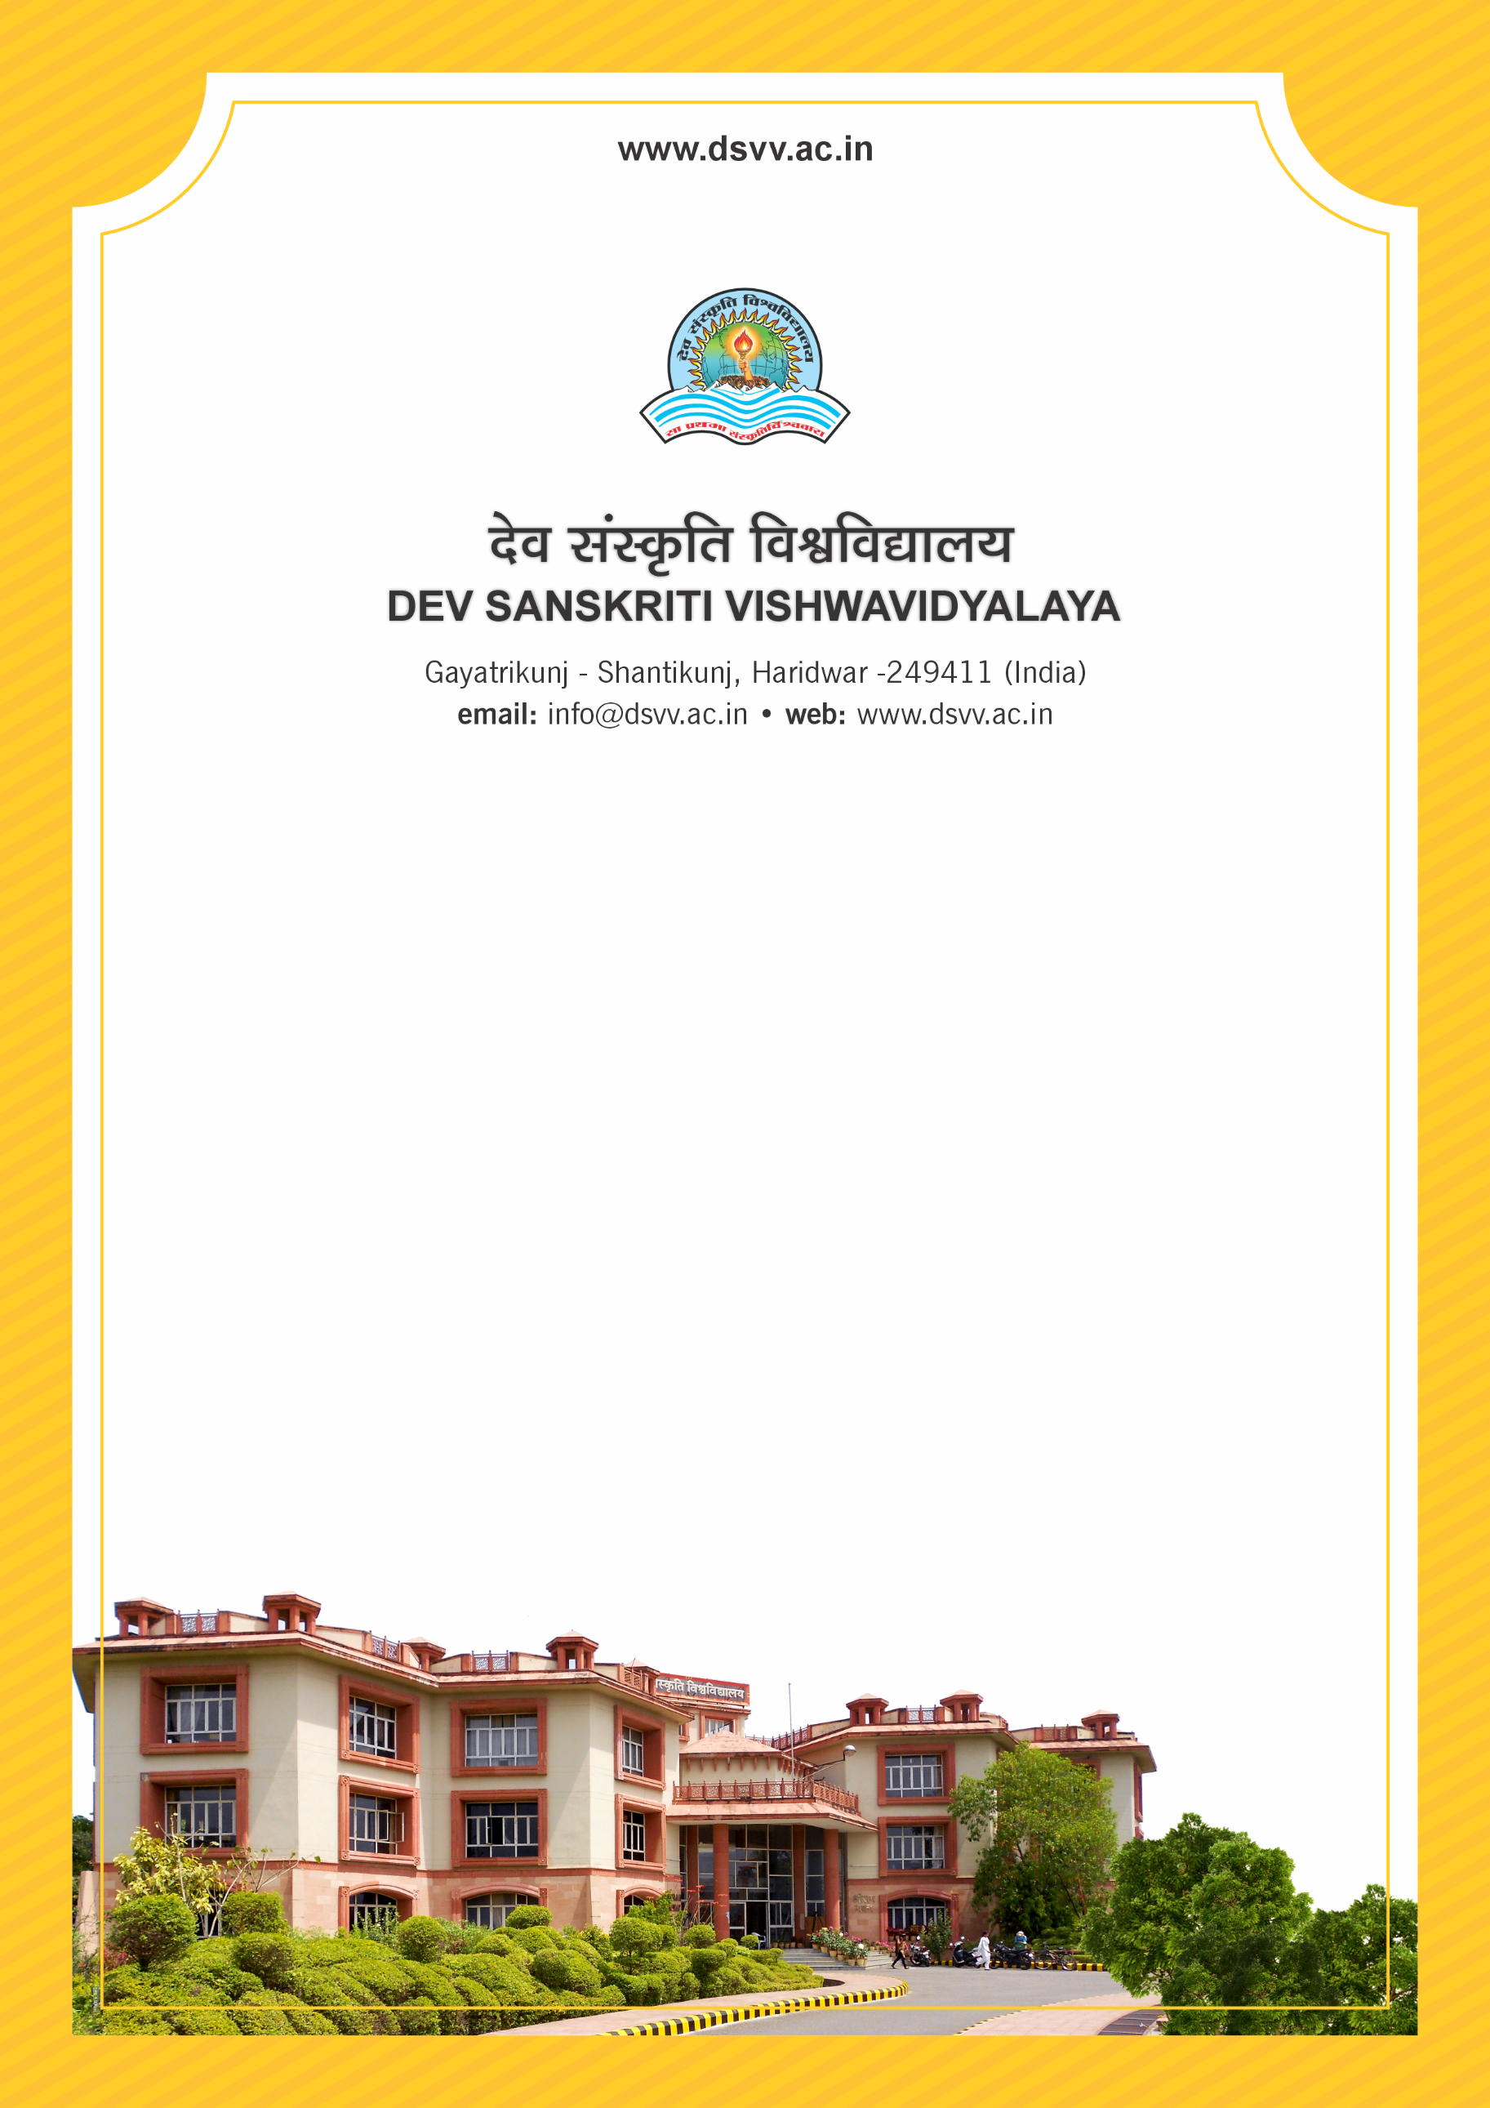
Figure 1Titel
Criteria 7
7.1.10 The Institution has a prescribed code of conduct for students, teachers, administrators and other staff and conducts periodic programmes in this regard.
1. The institutional Code of Conduct principles are displayed on the website
2. There is a committee to monitor adherence to the institutional Code of Conduct principles
3. Institution organizes professional ethics programmes for students, teachers, administrators and other staff
4. Annual awareness programmes on Code of Conduct are organized
Response: B. Any 3 of the above
7.1.10
The Institution has a prescribed code of conduct for students, teachers, administrators and other staff and conducts periodic programmes in this regard.
1. The institutional Code of Conduct principles are displayed on the website
2. There is a committee to monitor adherence to the institutional Code of Conduct principles
3. Institution organizes professional ethics programmes for students, teachers, administrators and other staff
4. Annual awareness programmes on Code of Conduct are organized
File Description | Document
Report on the student attributes facilitated by the Institution
Policy document on code of ethics.
Institutional data in the prescribed format (data template)
Handbooks, manuals and brochures on human values and professional ethics
Document showing the Code of Conduct for students, teachers, governing body and administration as approved by the competent authority.
Constitution and proceedings of the monitoring committee.
Circulars and geo-tagged photographs with date and caption of the activities organized under this metric for teachers, students, administrators and other staff.
Provide Links for any other relevant document to support the claim (if any)
Response: B. Any 3 of the above

