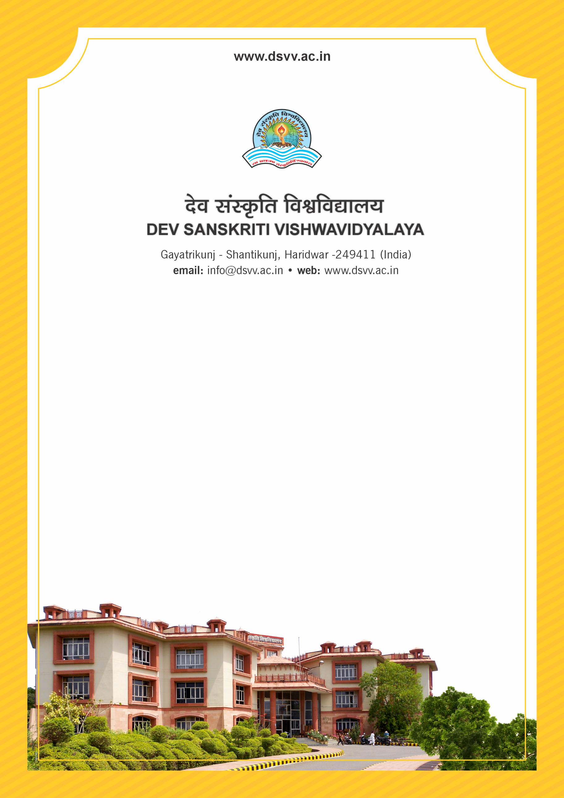
Figure 1Titel
Criteria 6
6.5.2 Institution has adopted the following for Quality assurance:
1. Academic and Administrative Audit (AAA) and follow up action taken
2. Conferences, Seminars, Workshops on quality conducted
3. Collaborative quality initiatives with other institution(s)
4. Orientation programme on quality issues for teachers and students
5. Participation in NIRF and other recognized ranking like Shanghai Ranking, QS Ranking Times Ranking etc
6. Any other quality audit recognized by state, national or international agencies
Response: B. Any 4 of the above
6.5.2
Institution has adopted the following for Quality assurance:
1. Academic and Administrative Audit (AAA) and follow up action taken
2. Conferences, Seminars, Workshops on quality conducted
3. Collaborative quality initiatives with other institution(s)
4. Orientation programme on quality issues for teachers and students
5. Participation in NIRF and other recognized ranking like Shanghai Ranking, QS Ranking
Times Ranking etc
6. Any other quality audit recognized by state, national or international agencies
Response: B. Any 4 of the above
File Description | Document
Supporting documents pertaining to NIRF (along with link to the HEI’s ranking in the NIRF portal) /NBA / ISO as applicable and valid for the assessment period.
List of Orientation programmes conducted on quality issues for teachers and students along with geotagged photos and supporting documents
List of Conferences / Seminars / Workshops on quality conducted along with brochures and geotagged photos with caption and date.
List of Collaborative quality initiatives with other institution(s) along with brochures and geo-tagged photos with caption and date.
Institutional data in the prescribed format (data template)
Provide Links for any other relevant document to support the claim (if any)

