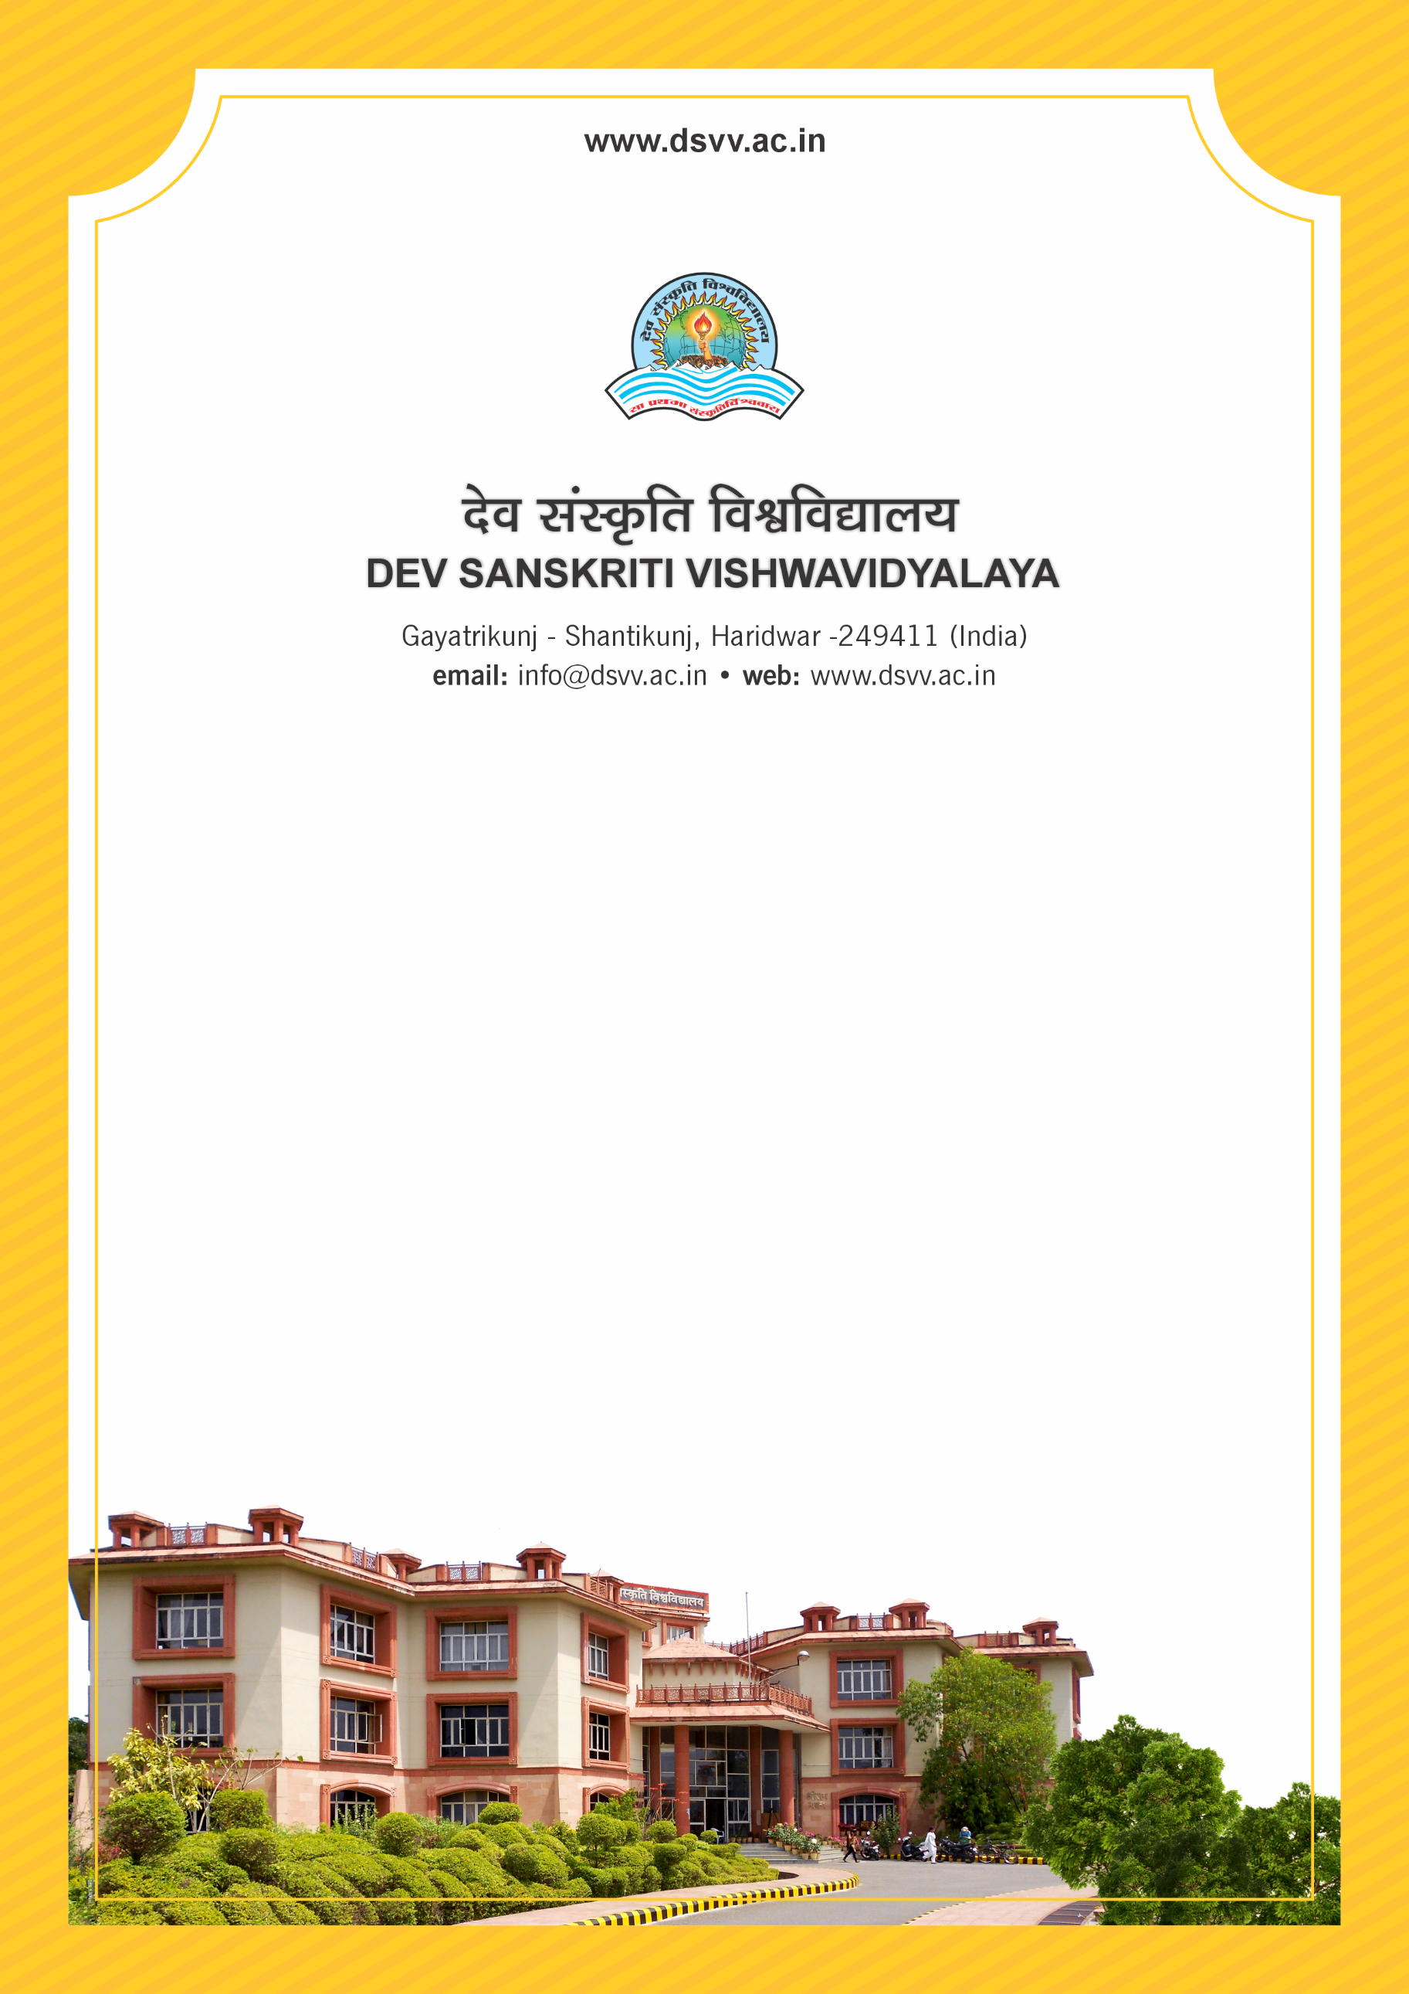
Figure 1Titel
Criteria 6
6.4.2 Funds / Grants received from government bodies/non government and philanthropists during the last five years for development and maintenance of infrastructure (not covered under Criteria III and V)
6.4.2
Funds / Grants received from government bodies/non government and philanthropists during the last five years for development and maintenance of infrastructure (not covered under Criteria III and V)
Response: 175.86
File Description | Document
Institutional data in the prescribed format (data template)
Copy of the sanction letters received from government/ nongovernment bodies and philanthropists for development and maintenance of infrastructure
Annual audited statements of accounts highlighting the grants received.
Provide Links for any other relevant document to support the claim (if any)
6.4.2.1 Total Grants received from government and non-government bodies and philanthropists for development and maintenance of infrastructure (not covered under Criteria III and V) year-wise during the last five years (INR in Lakhs)
2023-24 | 2022-23 | 2021-22 | 2020-21 | 2019-20
12.34 | 23.93 | 75.34 | 0 | 64.25

