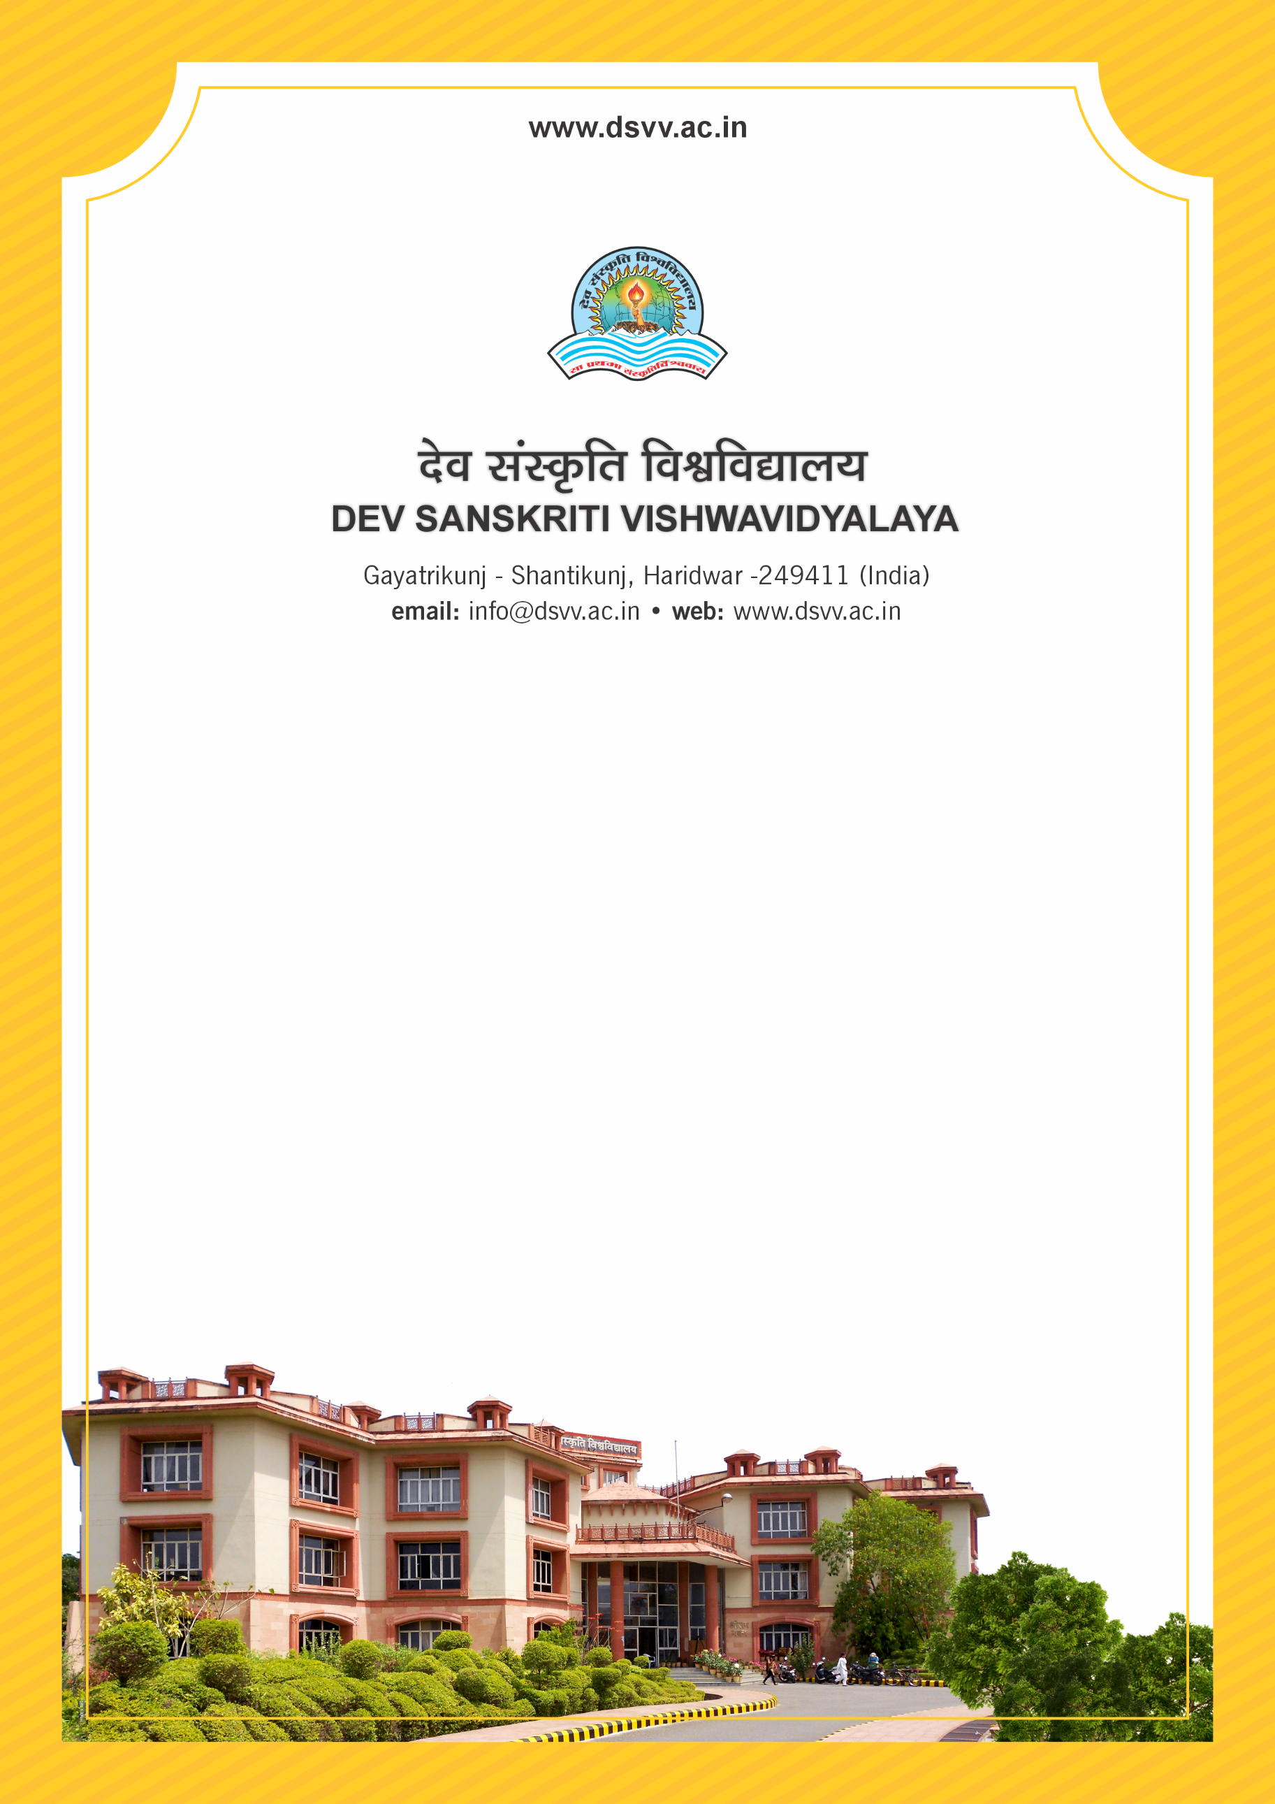
Figure 1Titel
Criteria 6
6.3.3 Percentage of teachers undergoing online/ face-to-face Faculty Development Programmes (FDPs)/ Management Development Programmes (MDPs) during the last five years
6.3.3
Percentage of teachers undergoing online/ face-to-face Faculty Development Programmes (FDPs)/Management Development Programmes (MDPs) during the last five years
Response: 8.49
File Description | Document
Refresher course/Faculty Orientation or other programmes as per UGC/AICTE stipulated periods, as participated by teachers year-wise.
Institutional data in the prescribed format (data template)
E-copy of the certificates of the program attended by teachers.
Annual reports highlighting the programmes undertaken by the teachers
Provide Links for any other relevant document to support the claim (if any)
6.3.3.1 Total number of teachers who have undergone online/ face-to-face Faculty Development Programmes (FDP)/ Management Development Programs (MDP) during the last five years
2023-24 | 2022-23 | 2021-22 | 2020-21 | 2019-20
20 | 2 | 12 | 13 | 3

