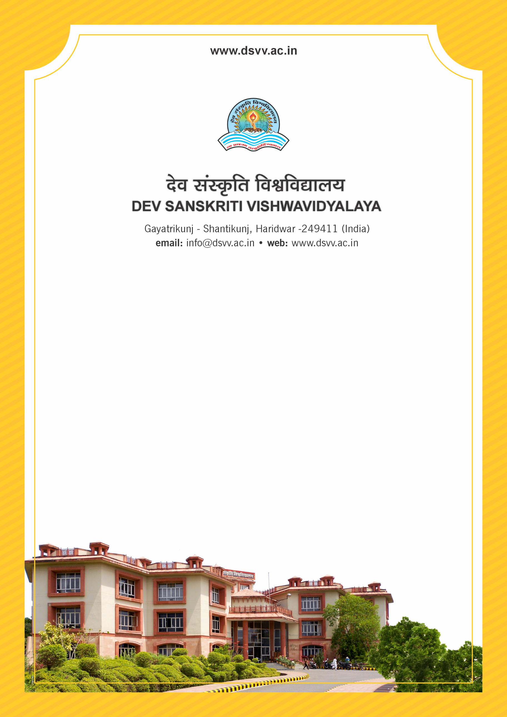
Figure 1Titel
Criteria 6
6.3.2 Percentage of teachers provided with financial support to attend conferences/workshops and towards membership fee of professional bodies during the last five years
6.3.2
Percentage of teachers provided with financial support to attend conferences/workshops and towards membership fee of professional bodies during the last five years
Response: 1.36
File Description | Document
Policy document on providing financial support to teachers
Institutional data in the prescribed format (data template)
E-copy of letter/s indicating financial assistance to teachers and list of teachers receiving financial support year-wise under each head
Audited statement of account highlighting the financial support to teachers to attend conferences/workshops and towards membership fee for professional bodies.
Provide Links for any other relevant document to support the claim (if any)
6.3.2.1 Number of teachers provided with financial support to attend conferences/workshops and towards membership fee of professional bodies year wise during the last five years
2023-24 | 2022-23 | 2021-22 | 2020-21 | 2019-20
5 | 3 | 0 | 0 | 0

