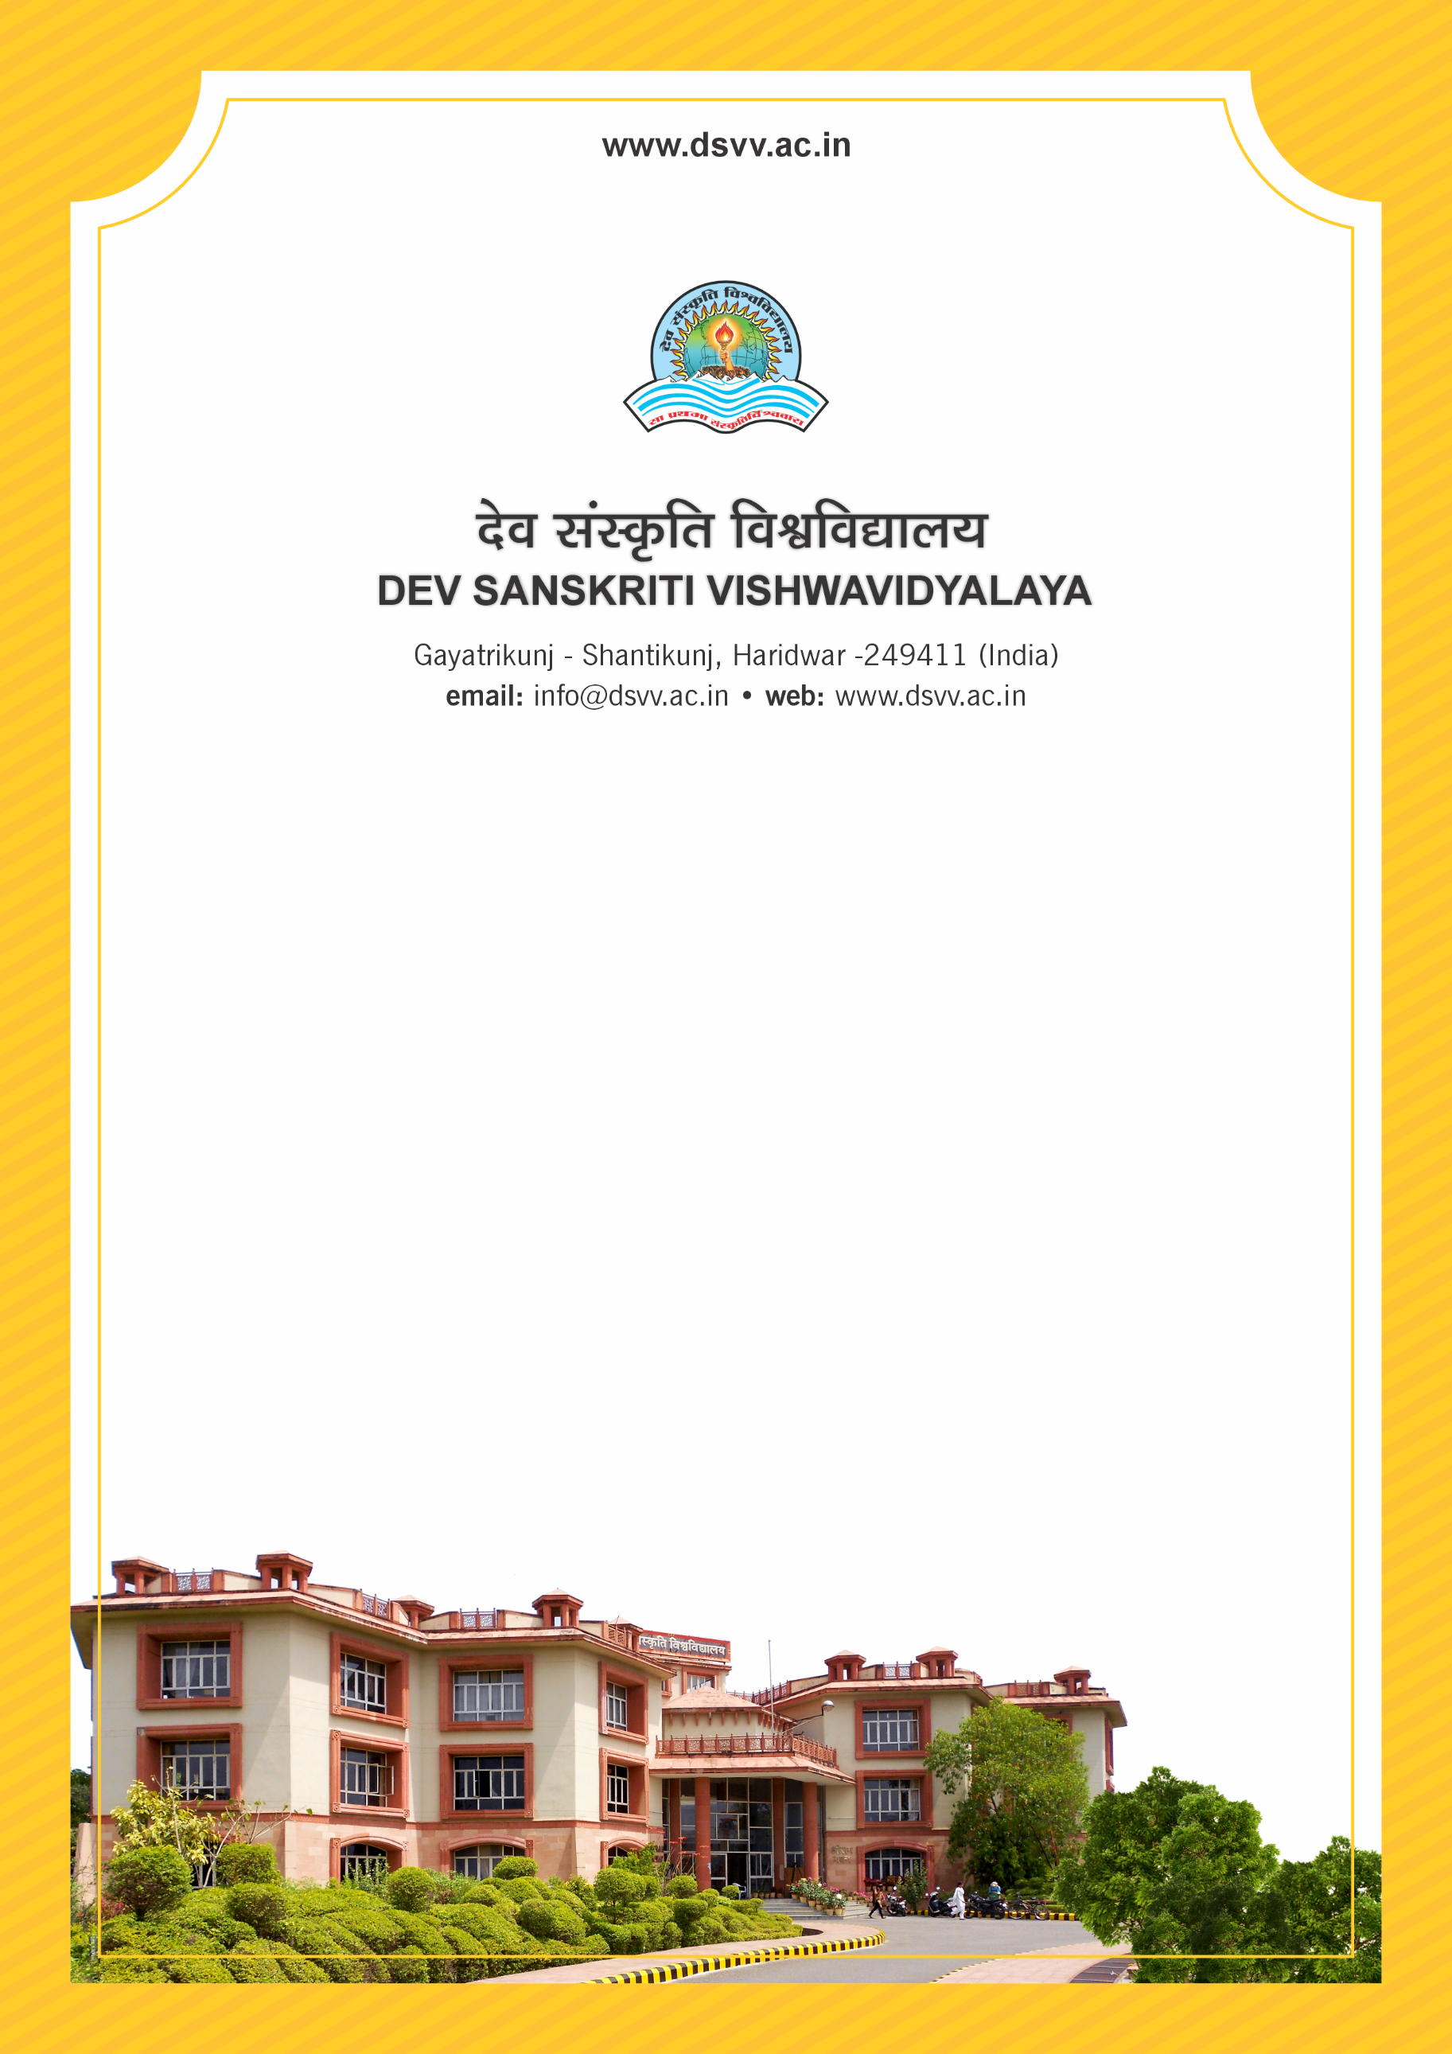
Figure 1Titel
Criteria 5
5.4.1 Alumni contribution during the last five years to the University through registered Alumni Association
5.4.1
Alumni contribution during the last five years to the University through registered Alumni Association
Response: 0.07
File Description | Document
List of alumnus/alumni with the amount contributed year-wise
Annual audited statements of accounts of the HEI highlighting the Alumni contribution duly certified by the Chartered Accountant/Finance Officer.
Provide Links for any other relevant document to support the claim (if any)
5.4.1.1 Total Amount of alumni contribution during the last five years (INR in lakhs) to the institution year wise through registered Alumni association:
2023-24 | 2022-23 | 2021-22 | 2020-21 | 2019-20
0 | 0 | .07 | 0 | 0

