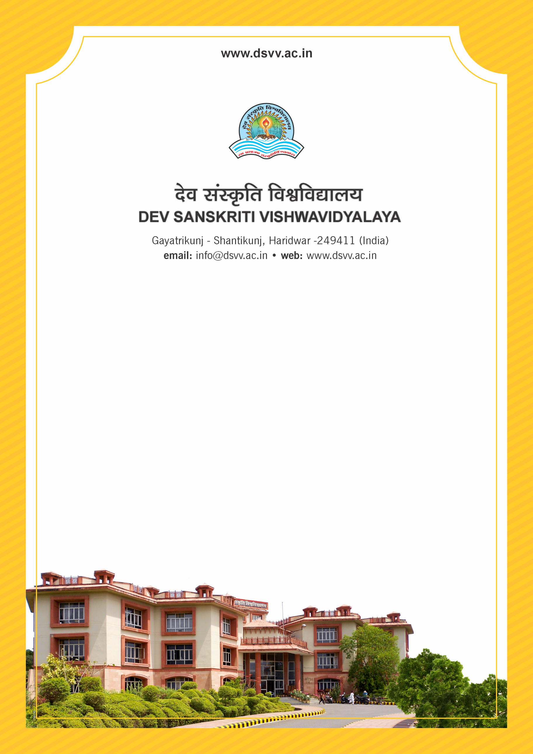
Figure 1Titel
Criteria 5
5.3.3 The institution conducts / organizes following activities:
1. Sports competitions/events
2. Cultural competitions/events
3. Technical fest/Academic fest
4. Any other events through Active clubs and forums
Response: A. All four of the above
5.3.3
The institution conducts / organizes following activities:
1. Sports competitions/events
2. Cultural competitions/events
3. Technical fest/Academic fest
4. Any other events through Active clubs and forums
Response: A. All four of the above
File Description | Document
Report of the Technical fest/academic fests along with photographs appropriately dated and captioned year- wise.
Report of the Sports competitions/events along with photographs appropriately dated and captioned year- wise.
Report of the Cultural competitions/events along with photographs appropriately dated and captioned year- wise.
Report of the Any other events through active clubs and forums along with photographs appropriately dated and captioned year- wise.
List of students participated in different events year wise signed by the head of the Institution.
Institutional data in the prescribed format (data template)
Copy of circular/brochure indicating such kind of activities
Provide Links for any other relevant document to support the claim (if any)

