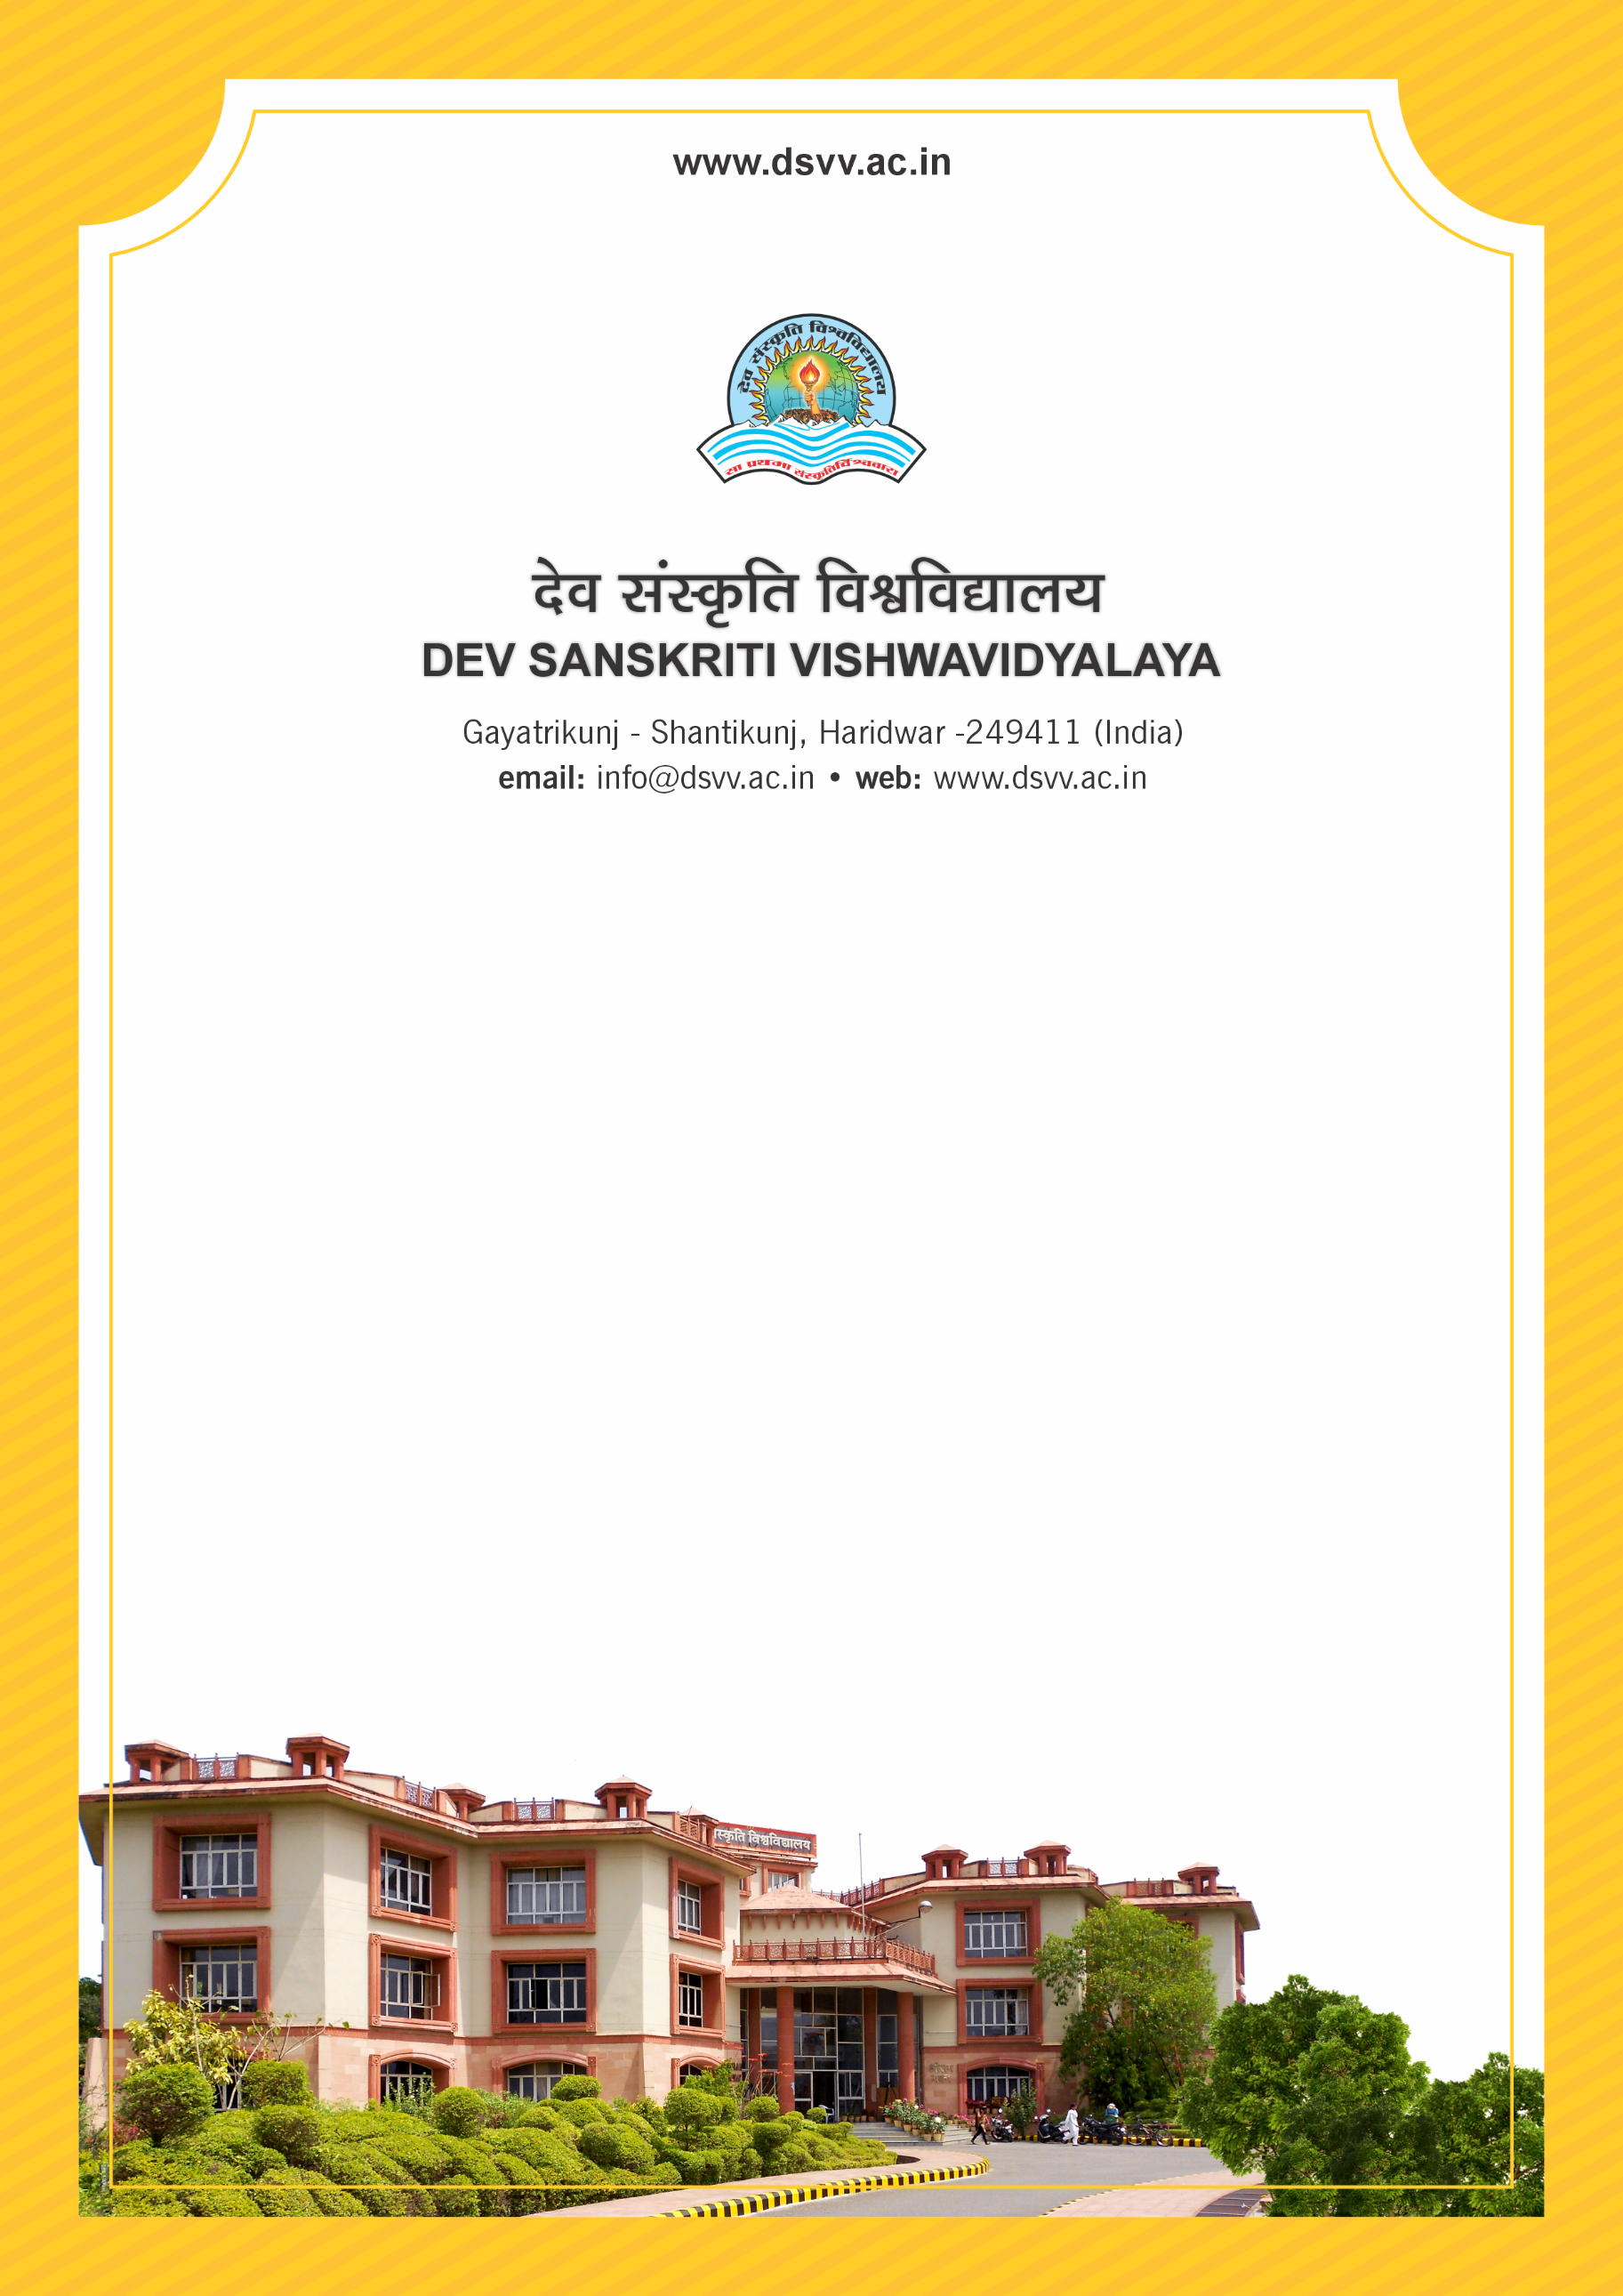
Figure 1Titel
Criteria 5
5.3.1 Number of awards/medals won by students for outstanding performance in sports/cultural activities at inter-university/state/national/international events (award for a team event should be counted as one) during the last five years

5.3.1
Number of awards/medals won by students for outstanding performance in sports/cultural activities at inter-university/state/national/international events (award for a team event should be counted as one) during the last five years
Response: 9
File Description | Document
Provide the relevant information in institutional website as part of public disclosure
list and links to e-copies of award letters and certificates
Institutional data in the prescribed format (data template)
Provide Links for any other relevant document to support the claim (if any)
5.3.1.1 Number of awards/medals won by students for outstanding performance in sports/cultural activities at inter-university/state/ national/international level (award for a team event should be counted as one) year-wise during the last five years
2023-24 | 2022-23 | 2021-22 | 2020-21 | 2019-20
5 | 1 | 1 | 0 | 2

