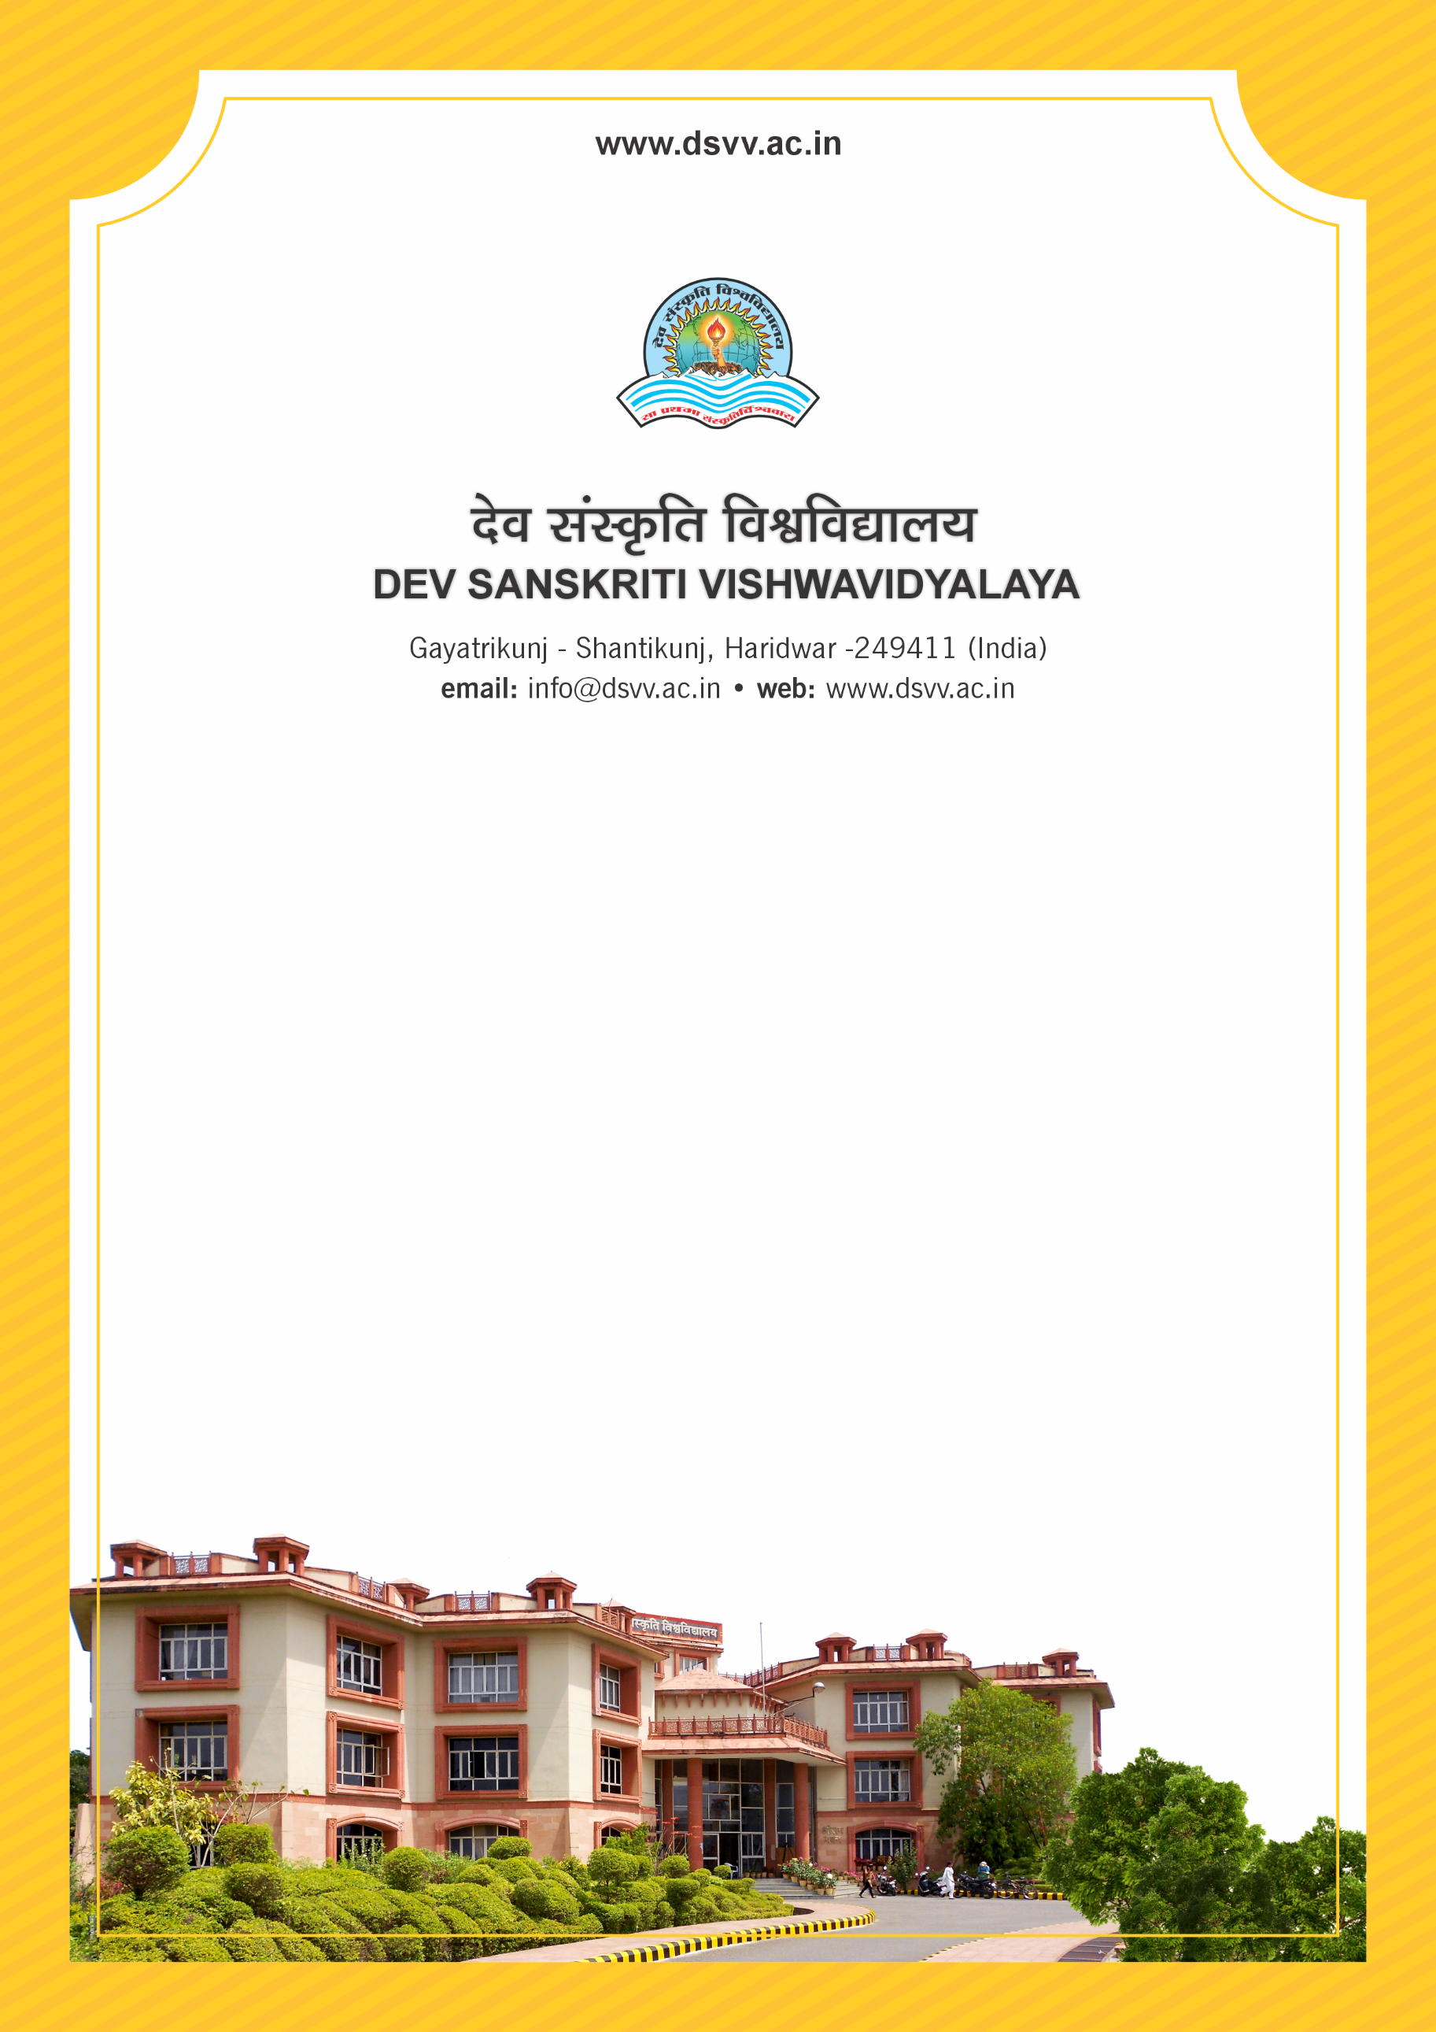
Figure 1Titel
Criteria 5
5.2.3 Percentage of students qualifying in state/ national/ international level examinations out of the graduated students during the last five years
(eg: NET/SLET/ Civil Services/State government examinations etc.)
5.2.3 Percentage of students qualifying in state/ national/ international level examinations out of the graduated students during the last five years
(eg: NET/SLET/ Civil Services/State government examinations etc.)
Response: 4.15
5.2.3.1 Number of students qualifying in state/National/International level Examination during last five years (eg. SLET, NET, UPSC etc)
File Description | Document
List of students qualified year wise under each category and links to Qualifying Certificates of the students taking the examination
Institutional data in the prescribed format (data template)
Provide Links for any other relevant document to support the claim (if any)
Response: 103

