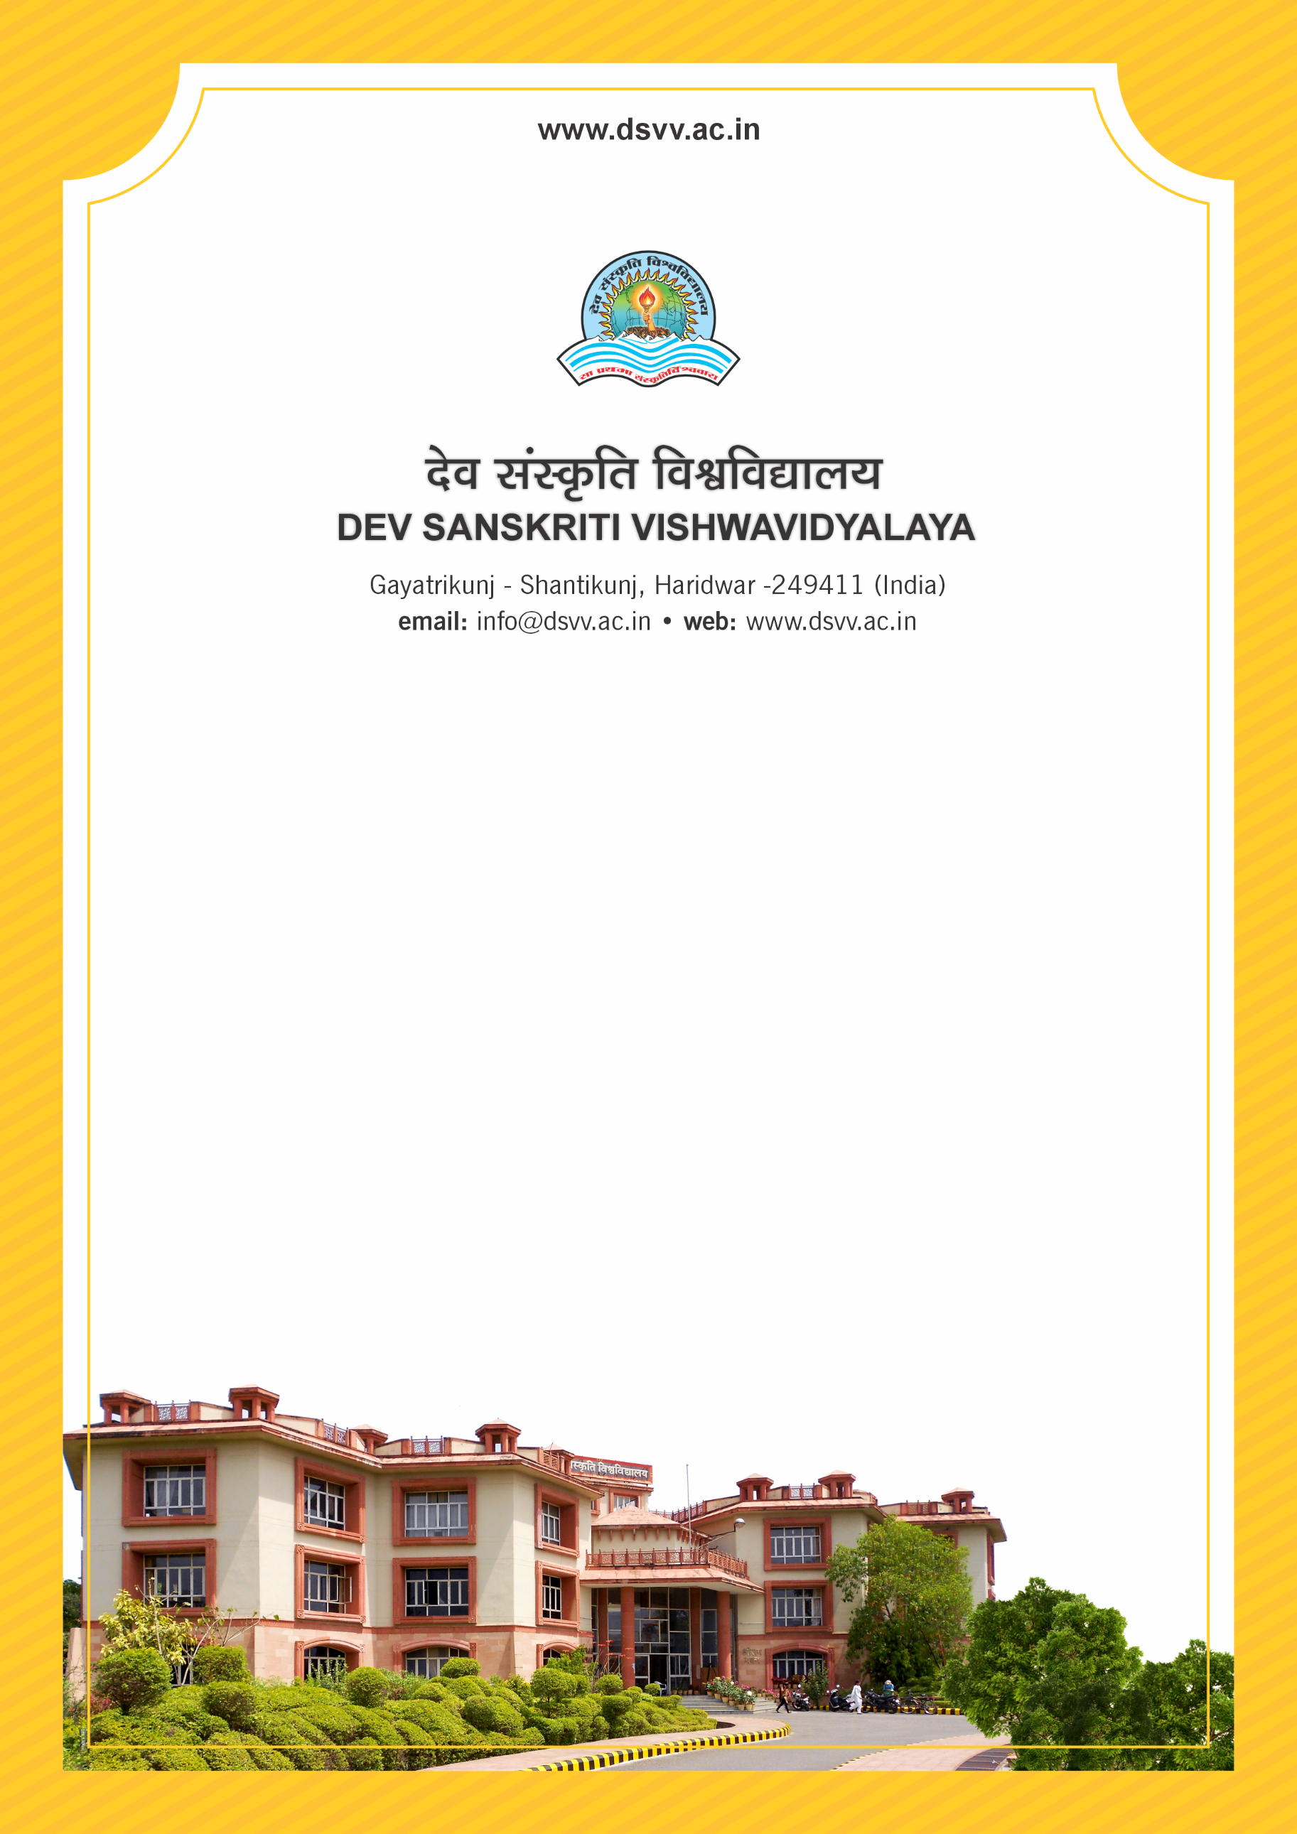
Figure 1Titel
Criteria 5
5.2.2 Percentage of graduated students who have progressed to higher education year-wise during last five years
5.2.2
Percentage of graduated students who have progressed to higher education year-wise during last five years
Response: 8.69
5.2.2.1 Number of outgoing students progressing to higher education
2023-24 | 2022-23 | 2021-22 | 2020-21 | 2019-20
34 | 28 | 35 | 54 | 56
File Description | Document
List of students progressing for Higher Education, with details of program and institution that they are/have enrolled along with links to proof of continuation in higher education. (the above list should be available in institutional website)
Institutional data in the prescribed format (data template)
Provide Links for any other relevant document to support the claim (if any)

