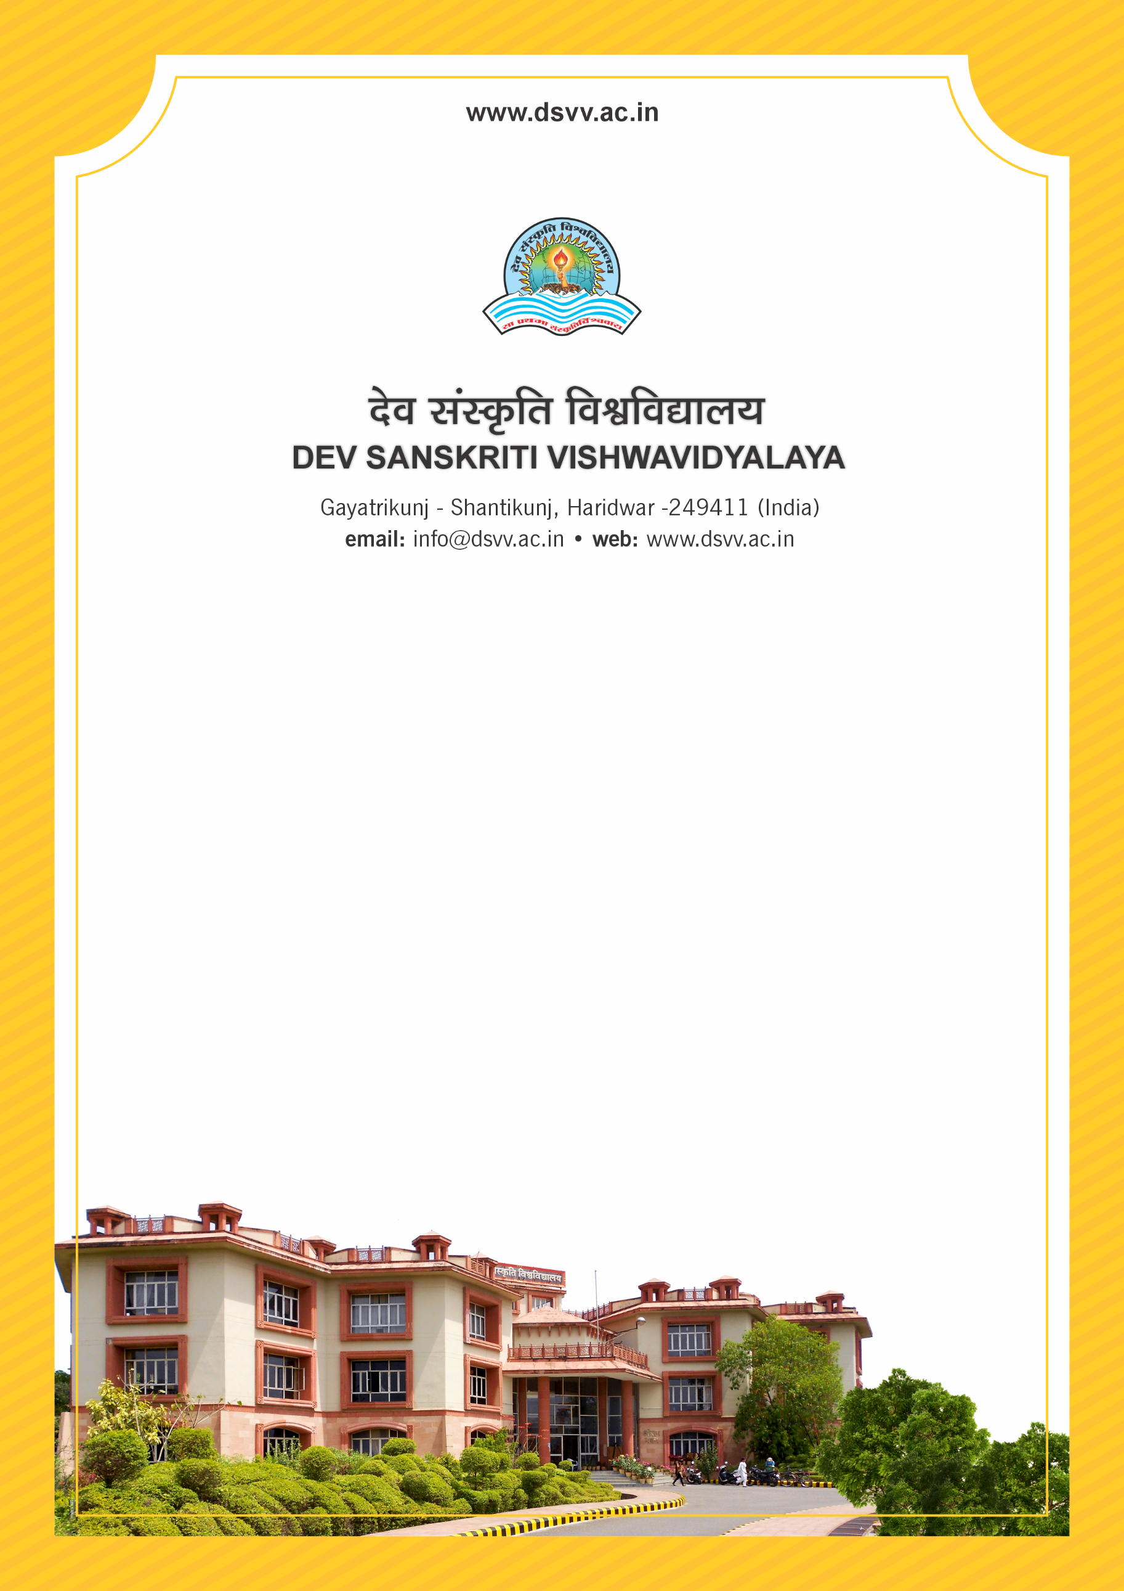
Figure 1Titel
Criteria 5
5.2.1 Percentage of placement of outgoing students during the last five years
5.2.1
Percentage of placement of outgoing students during the last five years
Response: 4.35
5.2.1.1 Number of outgoing students placed year wise during the last five years
2023-24 | 2022-23 | 2021-22 | 2020-21 | 2019-20
16 | 4 | 48 | 14 | 17
File Description | Document
Number and List of students placed along with placement details such as name of the company, compensation, etc and links to Placement order (the above list should be available in institutional website)
Institutional data in the prescribed format (data template)
Provide Links for any other relevant document to support the claim (if any)

