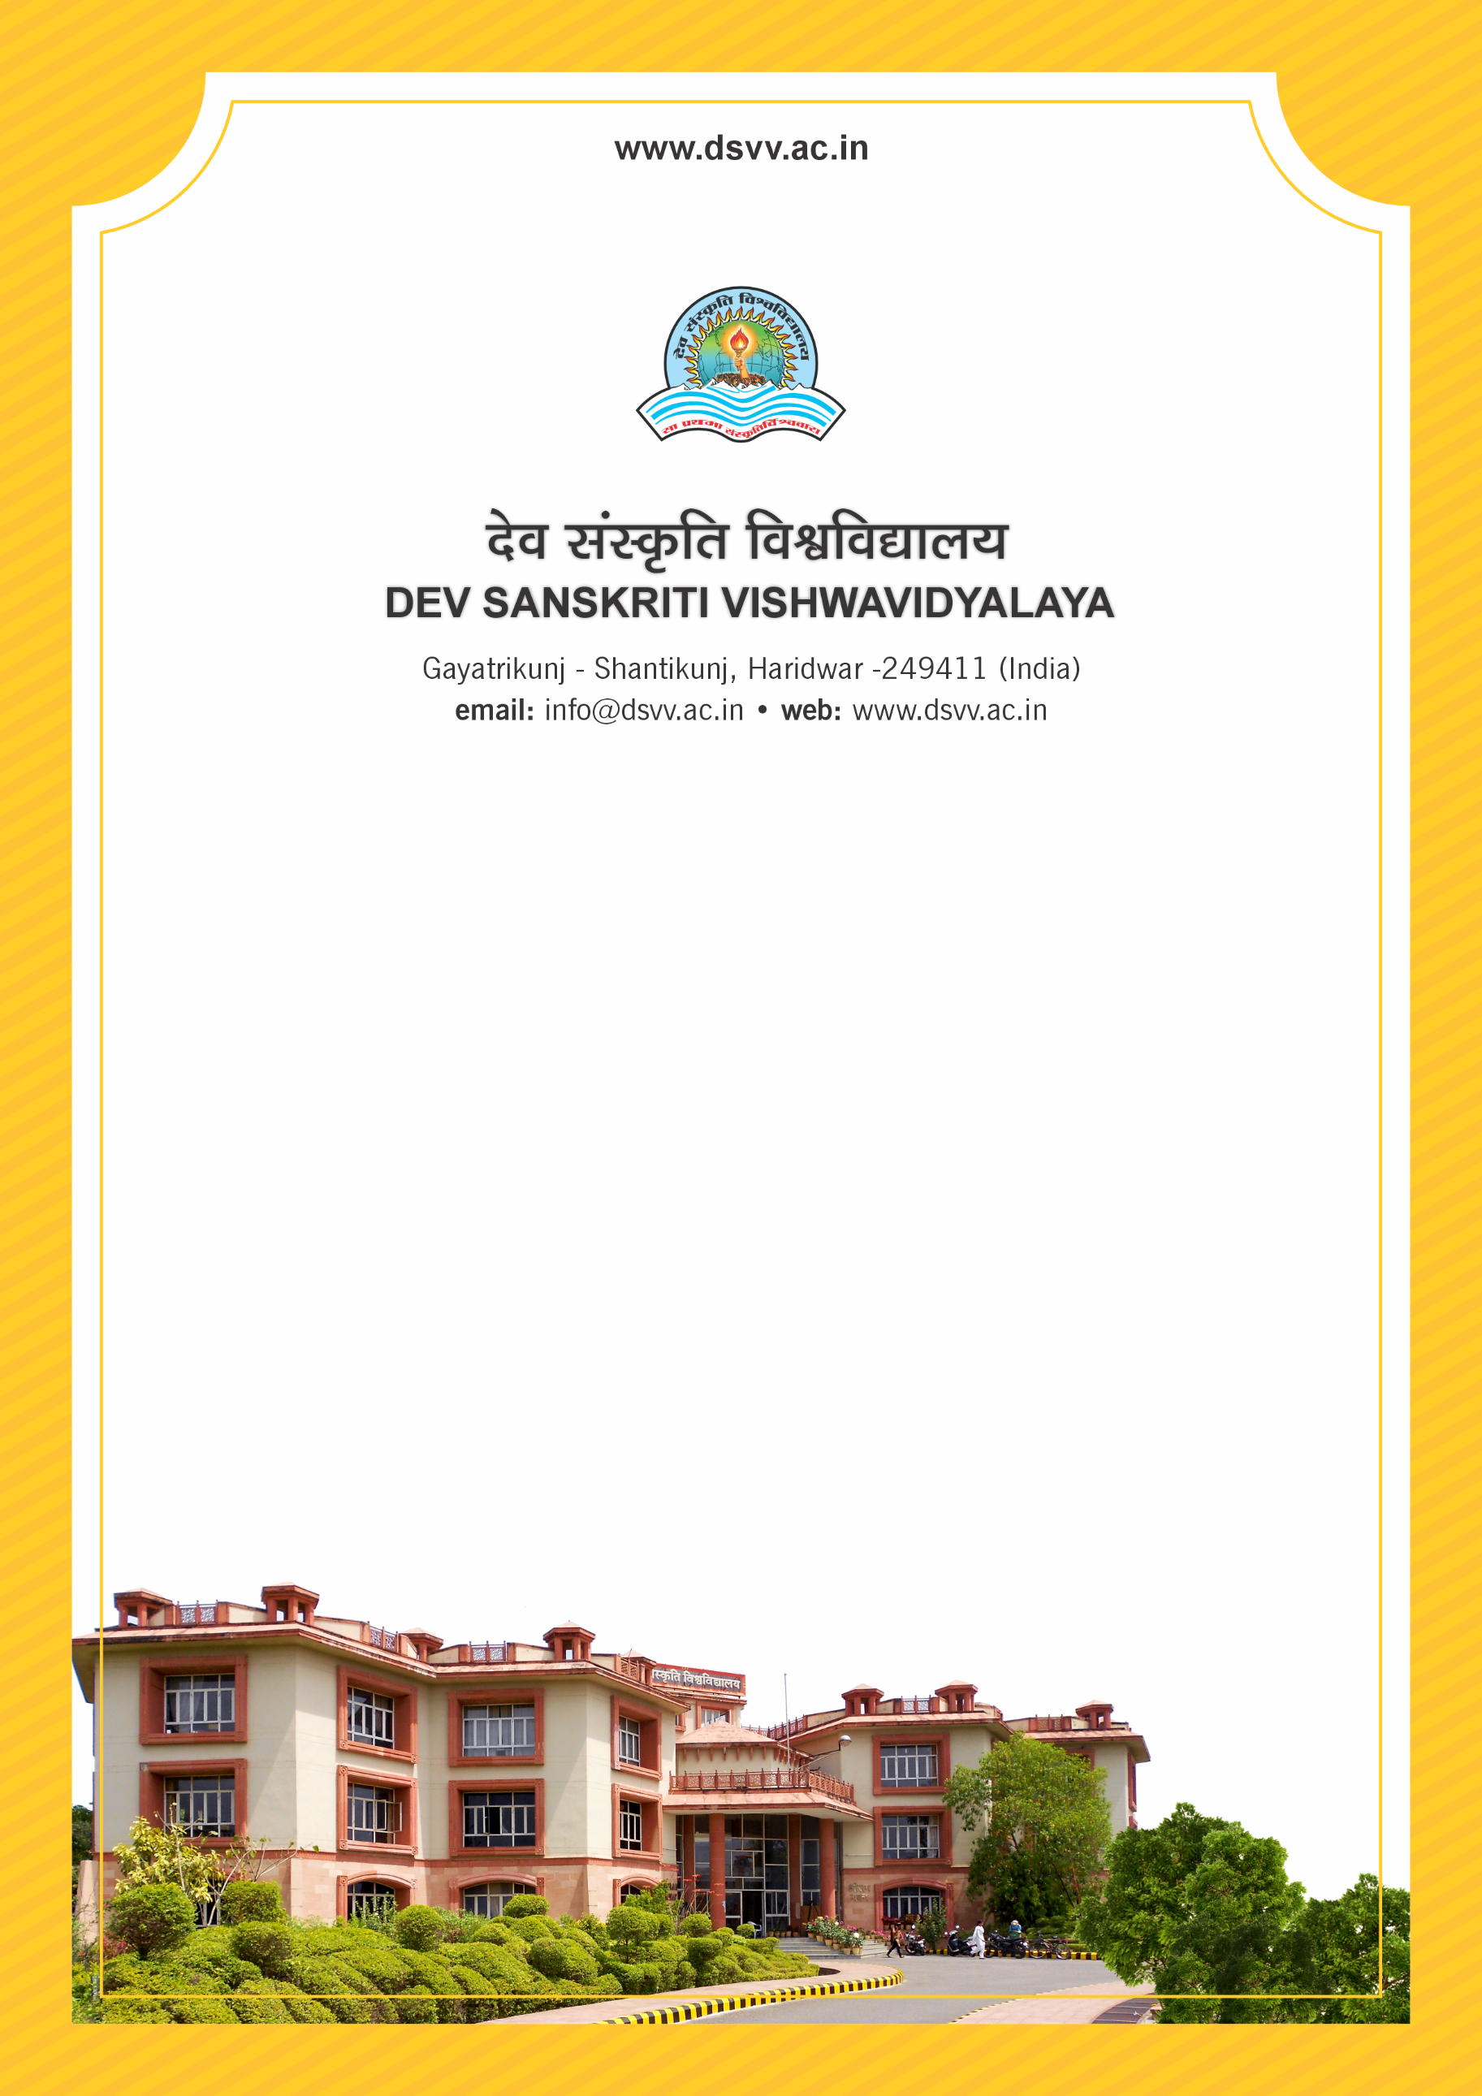
Figure 1Titel
Criteria 5
5.1.4 The institution adopts the following for redressal of student grievances including sexual harassment and ragging cases
1. Implementation of guidelines of statutory/regulatory bodies
2. Organisation wide awareness and undertakings on policies with zero tolerance
3. Mechanisms for submission of online/offline students’ grievances
4. Timely redressal of the grievances through appropriate committees
Response: A. All of the above
5.1.4
The institution adopts the following for redressal of student grievances including sexual harassment and ragging cases
1. Implementation of guidelines of statutory/regulatory bodies
2. Organisation wide awareness and undertakings on policies with zero tolerance
3. Mechanisms for submission of online/offline students’ grievances
4. Timely redressal of the grievances through appropriate committees
Response: A. All of the above
File Description | Document
Report of Organisation wide awareness and undertakings on policies with zero tolerance
Proof related to Mechanisms for submission of online/offline students’ grievances
Proof for Implementation of guidelines of statutory/regulatory bodies
Institutional data in the prescribed format (data template)
Details of statutory/regulatory Committees (to be notified in institutional website also)
Annual report of the committee monitoring the activities and number of grievances

