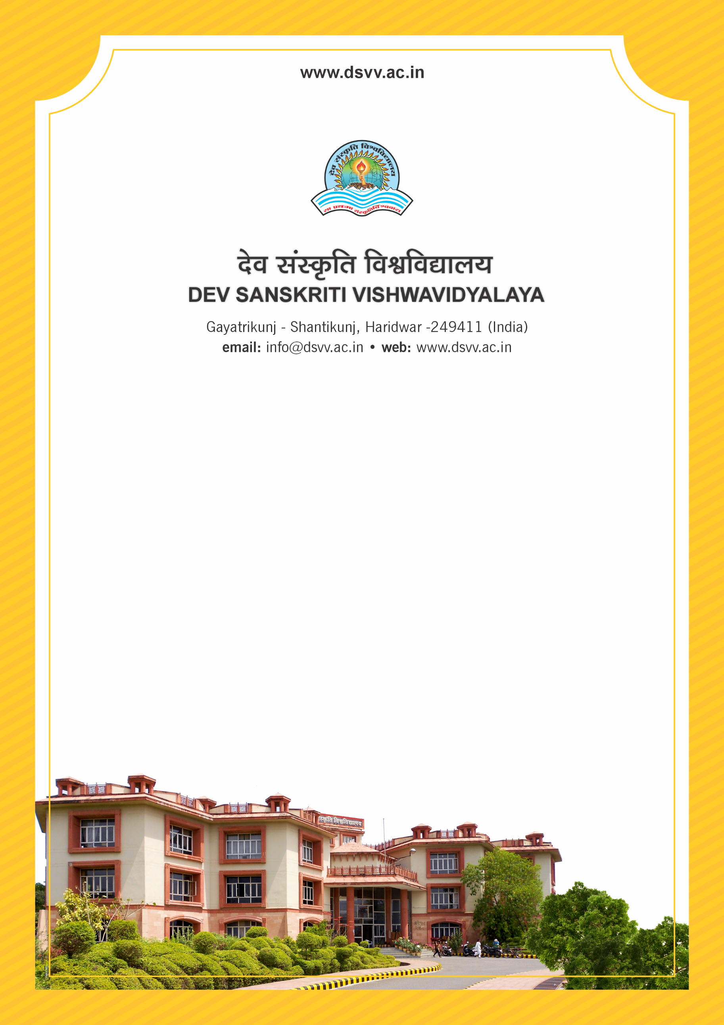
Figure 1Titel
Criteria 5
5.1.3 Following capacity development and skills enhancement activities are organised for improving students’ capability
1. Soft skills
2. Language and communication skills
3. Life skills (Yoga, physical fitness, health and hygiene, self-employment and entrepreneurial skills)
4. Awareness of trends in technology
Response: A. All of the above
5.1.3
Following capacity development and skills enhancement activities are organised for improving students’ capability
1. Soft skills
2. Language and communication skills
3. Life skills (Yoga, physical fitness, health and hygiene, self-employment and entrepreneurial skills)
4. Awareness of trends in technology
Response: A. All of the above
File Description | Document
Report with photographs on soft skills enhancement programs
Report with photographs on Life skills (Yoga, physical fitness, health and hygiene) enhancement programs
Report with photographs on Language & communication skills enhancement programs
Report with photographs on ICT/computing skills enhancement programs
Institutional data in the prescribed format (data template)

