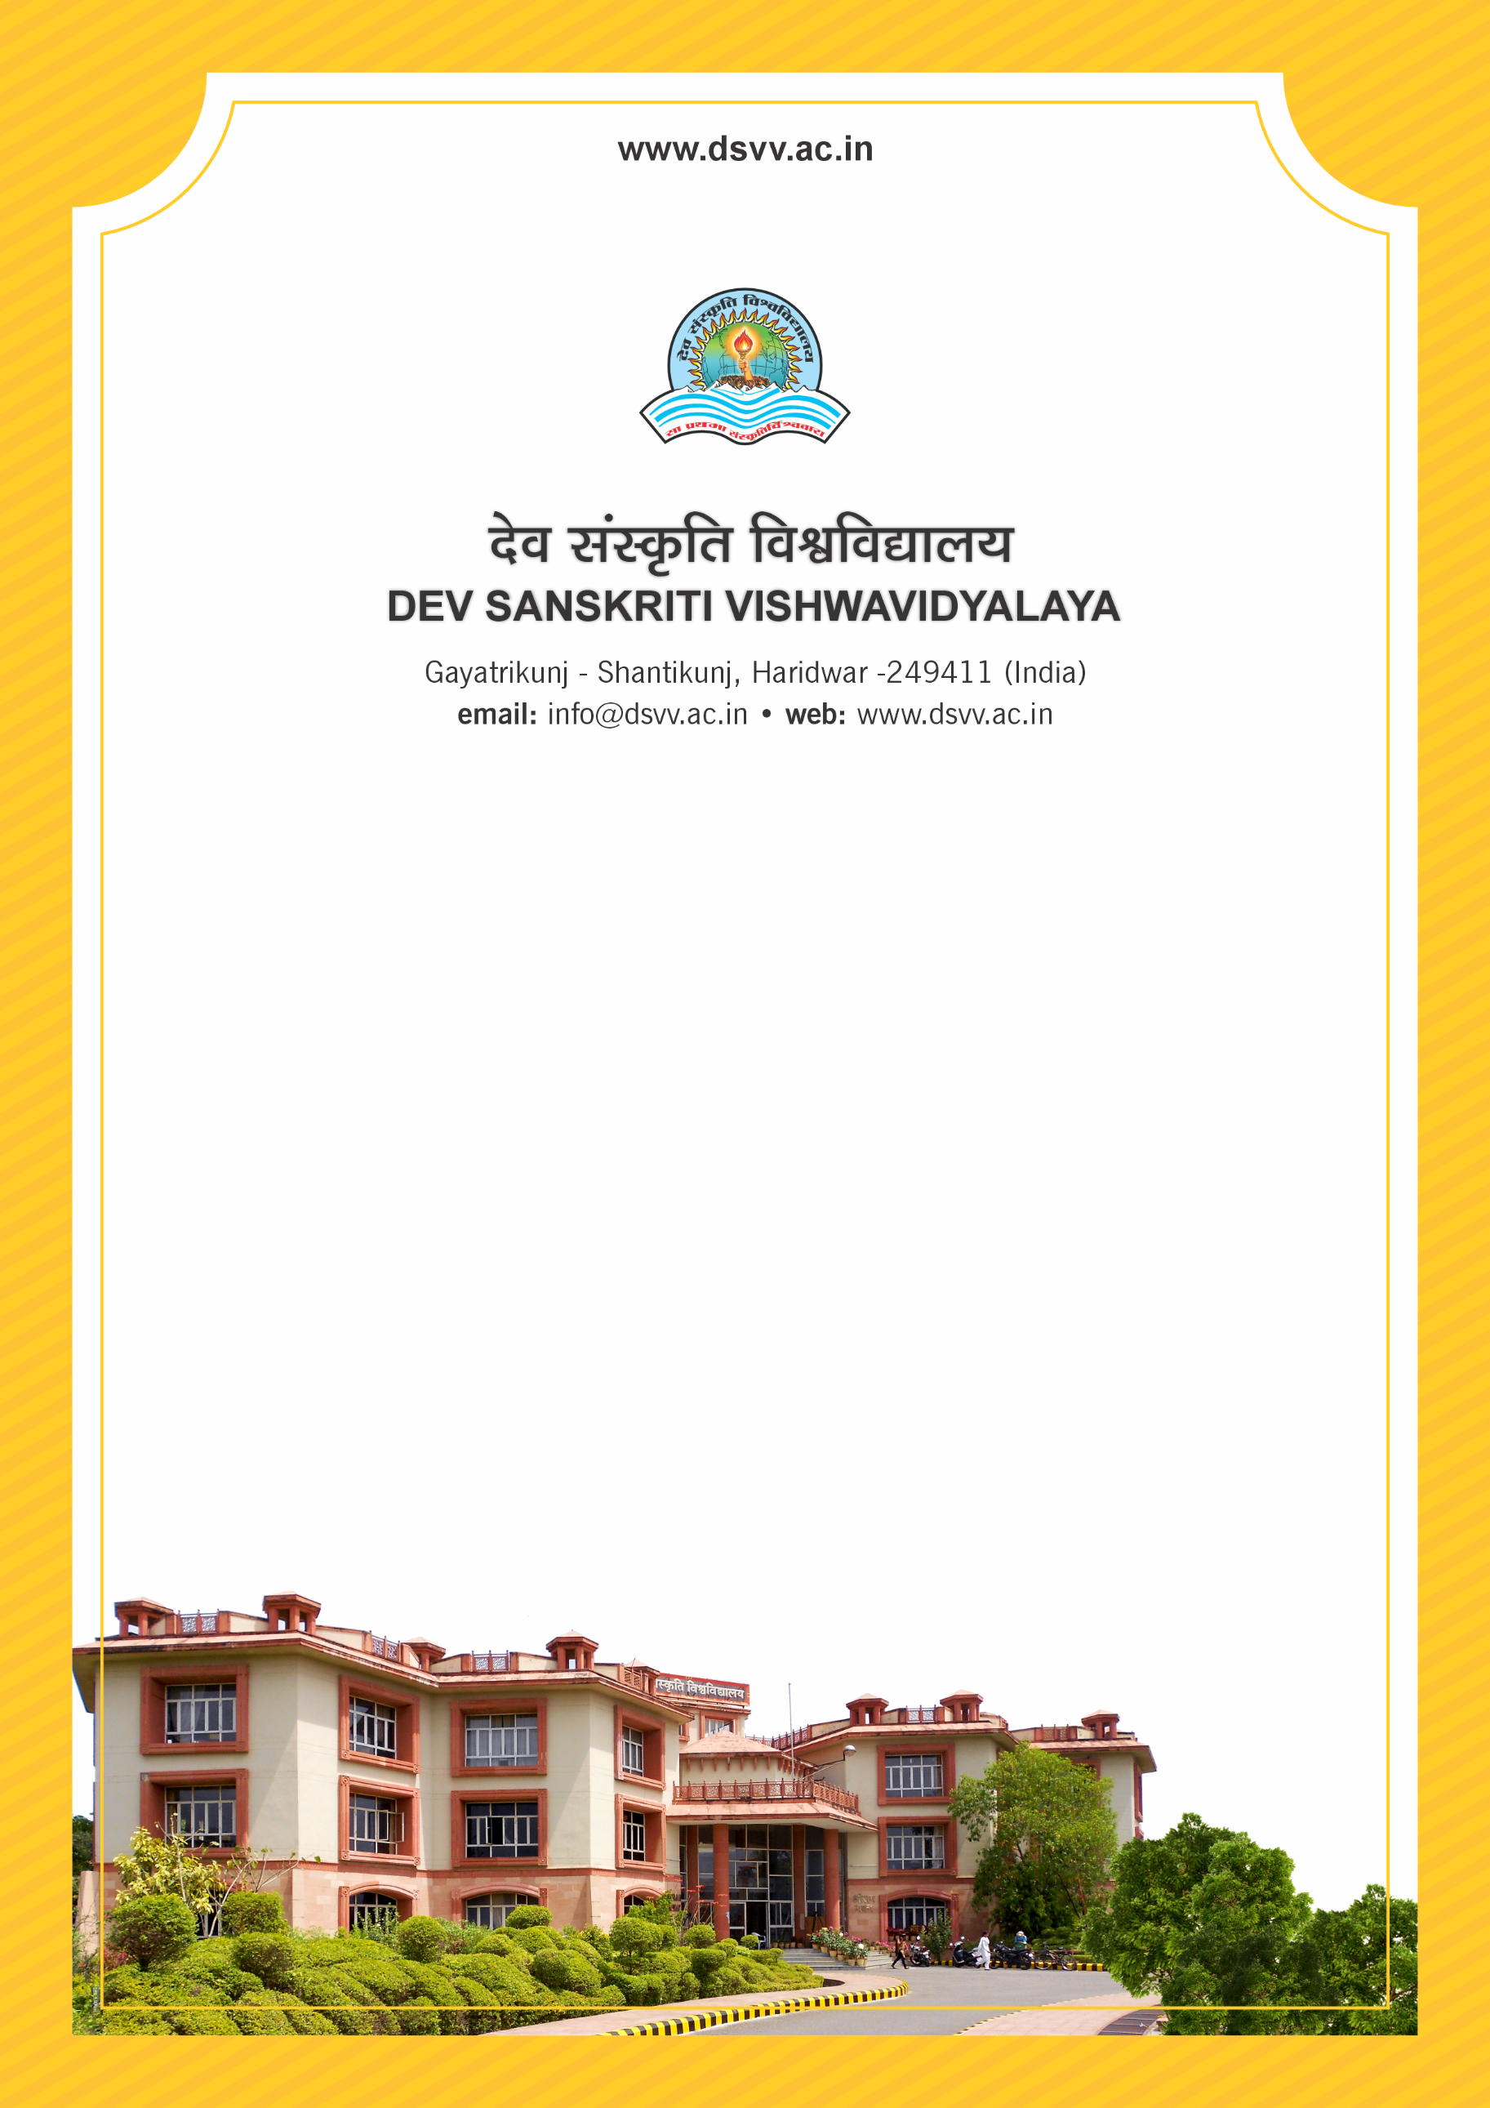
Figure 1Titel
Criteria 5
5.1.1 Percentage of students benefited by scholarships and freeships provided by the institution, government and non-government bodies, industries, individuals, philanthropists during the last five years
5.1.1
Percentage of students benefited by scholarships and freeships provided by the institution, government and non-government bodies, industries, individuals, philanthropists during the last five years
Response: 32.52
File Description | Document
Year-wise list of beneficiary students in each scheme duly signed by the competent authority
Upload Sanction letter of scholarship and free ships (in English).
Upload policy document of the HEI for award of scholarship and freeships.
Institutional data in the prescribed format (data template)
5.1.1.1 Number of students benefited by scholarships and freeships provided by the institution, Government and (NGOs)non-government bodies, industries, individuals, philanthropists year-wise during the last five years
2023-24 | 2022-23 | 2021-22 | 2020-21 | 2019-20
180 | 130 | 355 | 1208 | 117

