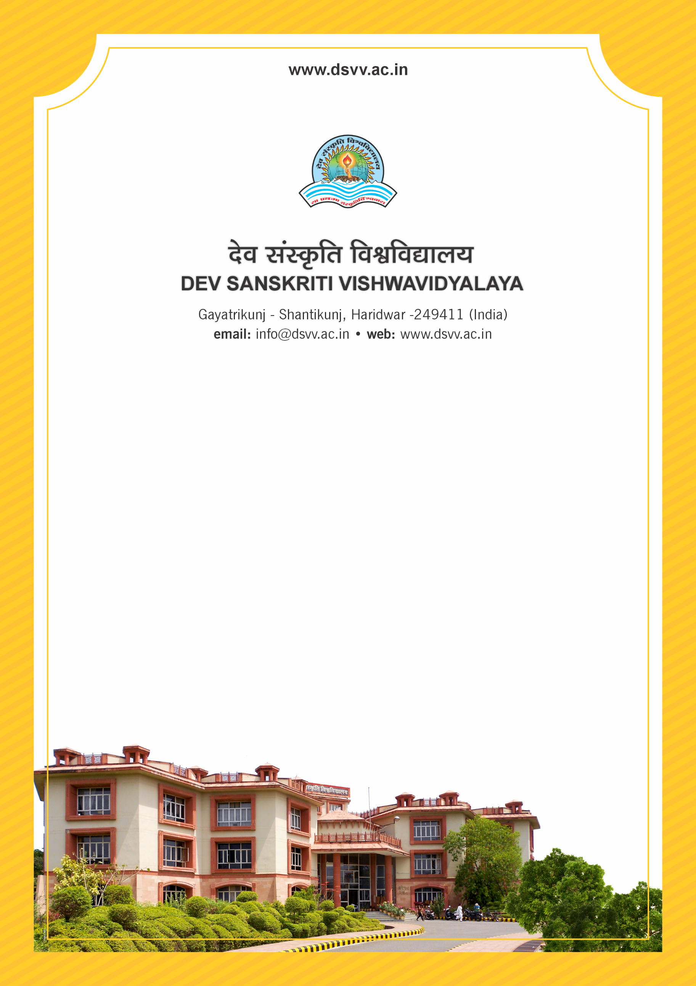
Figure 1Titel
Criteria 4
4.4.1 Percentage expenditure incurred on maintenance of physical facilities and academic support facilities excluding salary component, during the last five years
4.4.1 Percentage expenditure incurred on maintenance of physical facilities and academic support facilities excluding salary component, during the last five years
Response: 79.41
4.4.1.1 Expenditure incurred on maintenance of physical facilities and academic support facilities excluding salary component year - wise during the last five years (INR in lakhs)
2023-24 | 2022-23 | 2021-22 | 2020-21 | 2019-20
640.66 | 368.11 | 1400.83 | 271.57 | 589.38
File Description | Document
Institutional data in the prescribed format (data template)
Audited income and expenditure statement of the institution to be signed by CA and counter signed by the competent authority (relevant expenditure claimed for maintenance of infrastructure should be clearly highlighted)

