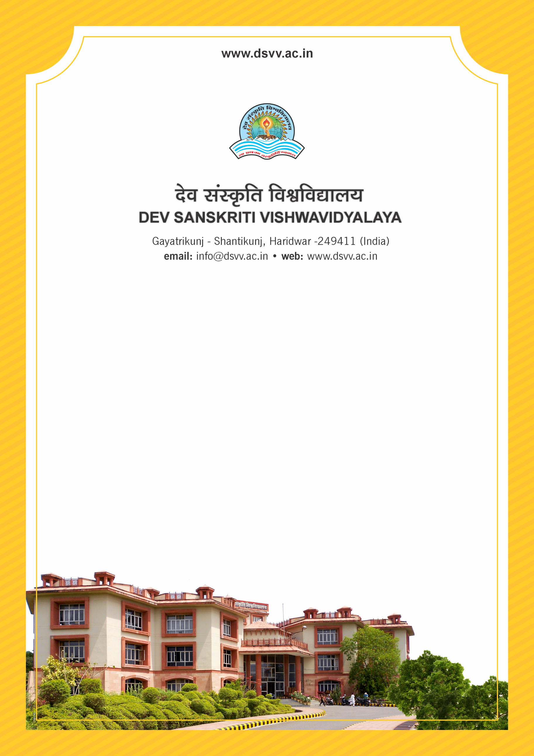
Figure 1Titel
Criteria 4
4.3.3 Institution has the following Facilities for e-content development and other resource development
1. Audio visual center, mixing equipment, editing facilities and Media Studio
2. Lecture Capturing System (LCS)
3. Central Instrumentation Centre
4. Animal House 5. Museum
6. Business Lab 7. Research/statistical database
8. Moot court 9. Theatre
10. Art Gallery 11. Any other facility to support research
Response: A. Any 7 or more of the above
4.3.3
Institution has the following Facilities for e-content development and other resource development
1. Audio visual center, mixing equipment, editing facilities and Media Studio
2. Lecture Capturing System (LCS)
3. Central Instrumentation Centre
4. Animal House
5. Museum
6. Business Lab
7. Research/statistical database
8. Moot court
9. Theatre
10. Art Gallery
11. Any other facility to support research
Response: A. Any 7 or more of the above
File Description | Document
Videos and geo-tagged photographs of each of the facilities available in the HEI. Details of the structures of each of the facilities available in the HEI.
Purchase Bill / stock register, entry for lecture capturing system, mixing equipment, software for editing
Institutional data in the prescribed format (data template)
Copy of the subscription letter for database is essential for Option Research/Statistical Databases
Provide Links for any other relevant document to support the claim (if any)

