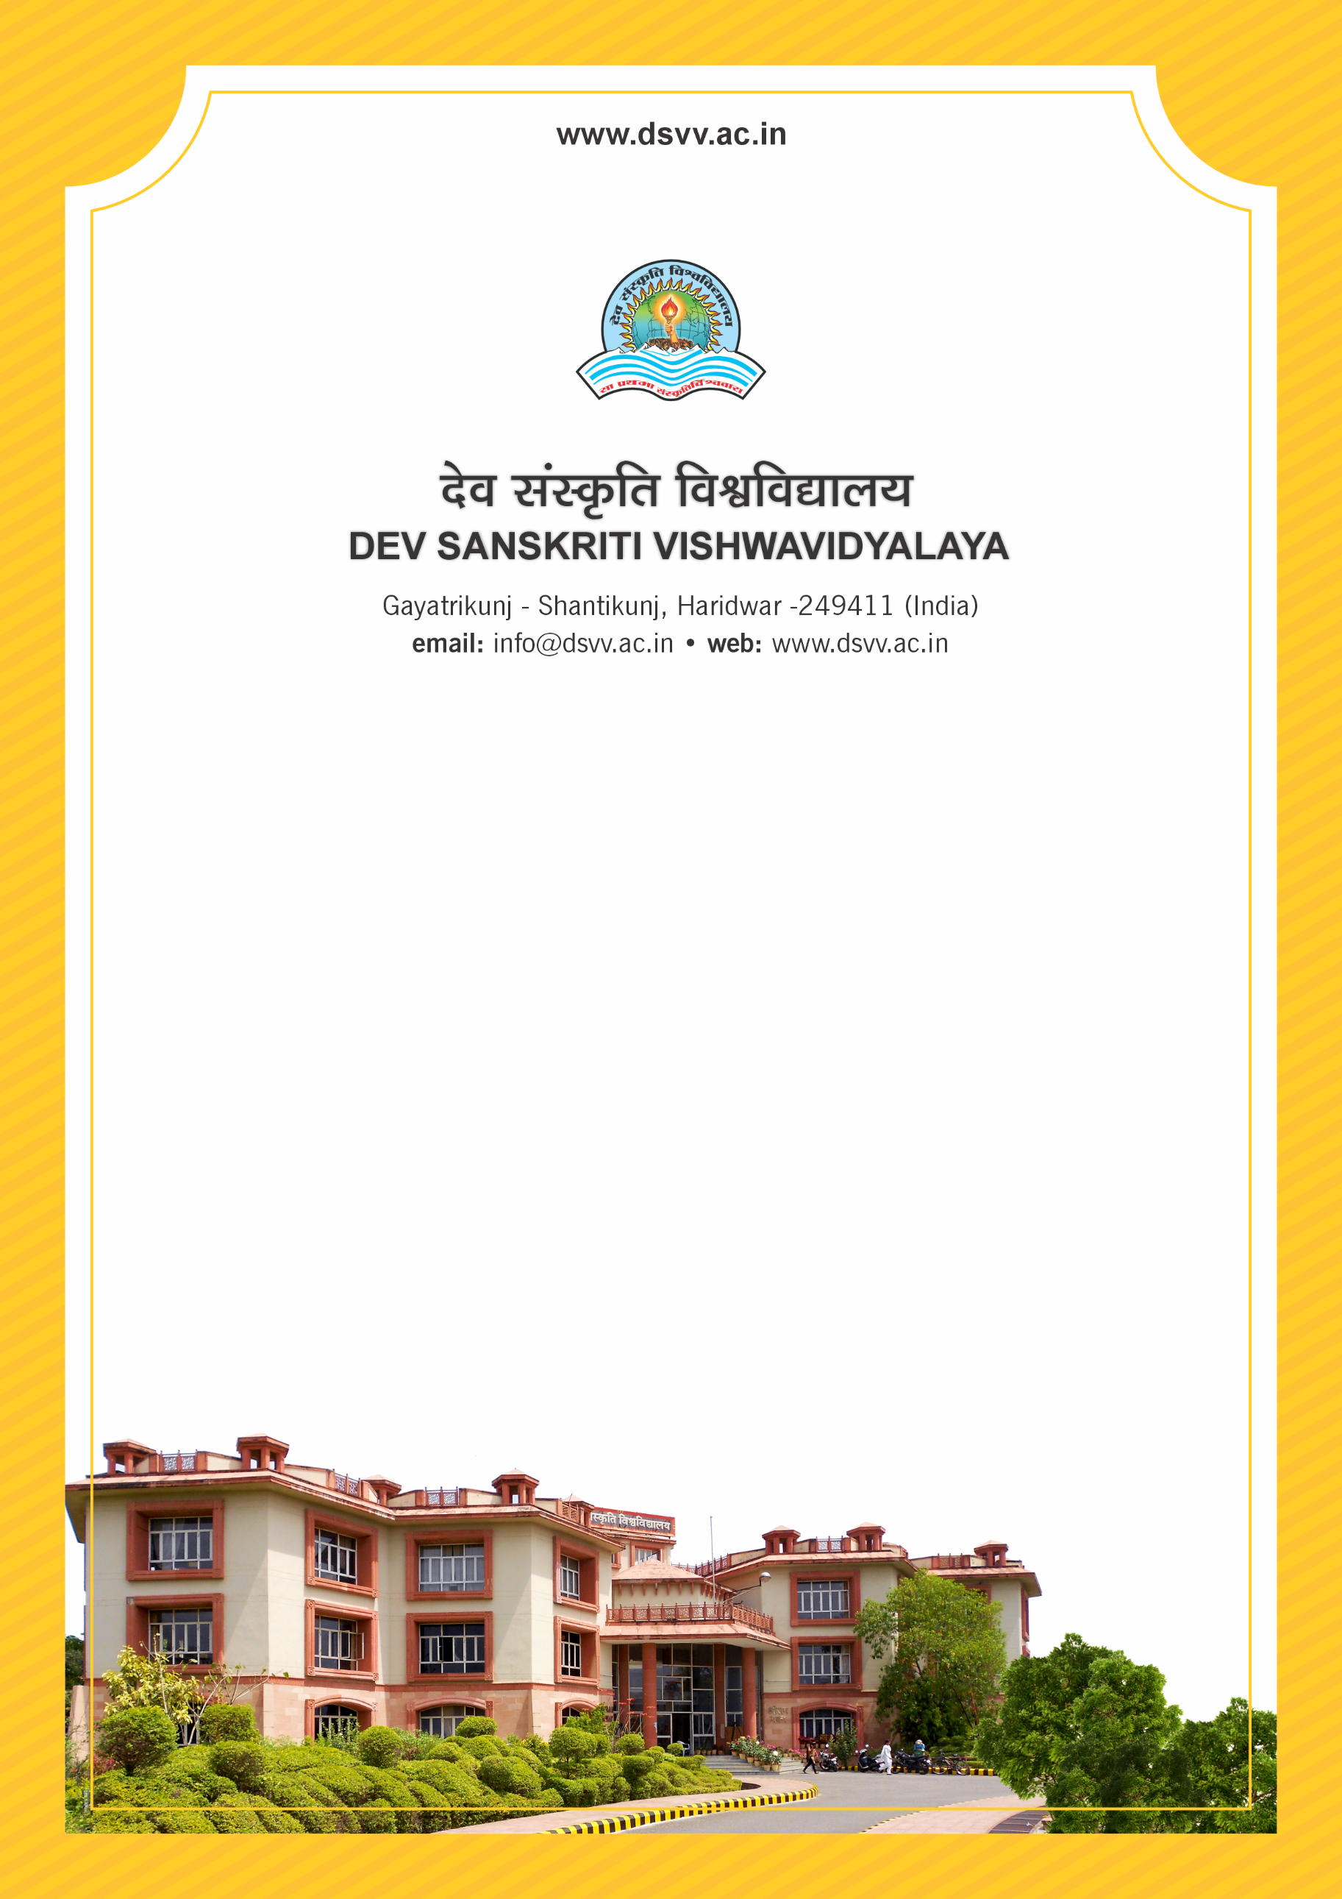
Figure 1Titel
Criteria 4
4.3.2 Student - Computer ratio (Data for the latest completed academic year)
4.3.2
Student - Computer ratio (Data for the latest completed academic year)
Response: 4.73
4.3.2.1 Number of computers available for students usage during the latest completed academic year:
Response: 237
File Description | Document
Stock register/extracts highlighting the computers issued to respective departments for student’s usage
Purchased Bills/Copies

