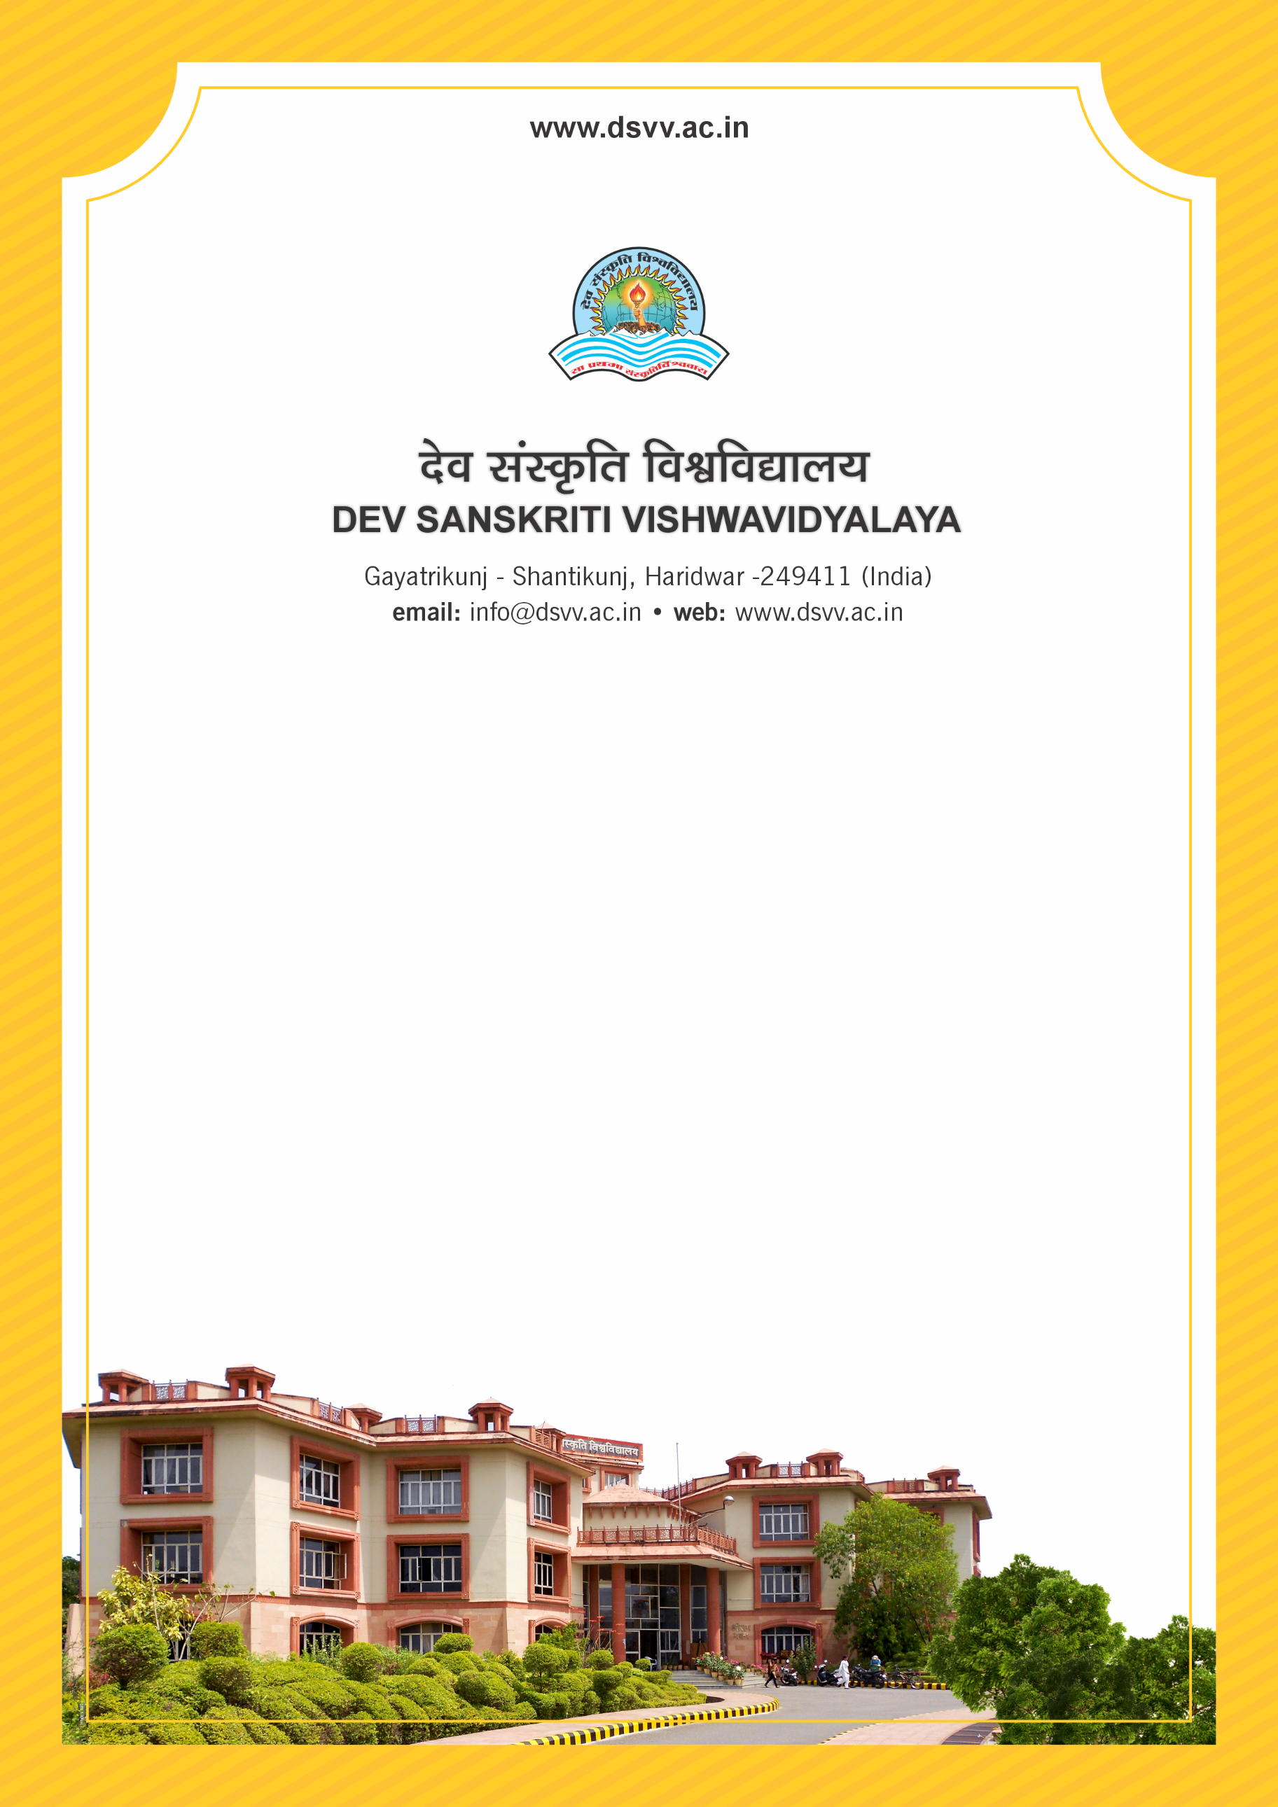
Figure 1Titel
Criteria 4
4.2.2 Percentage of expenditure for purchase of books/ e-books and subscription to journals/e-journals year wise during the last five years
4.2.2
Percentage of expenditure for purchase of books/ e-books and subscription to journals/e-journals year wise during the last five years
Response: 0.45
4.2.2.1 Annual expenditure for purchase of books and journals year-wise during the last five years (INR in Lakhs)
2023-24 | 2022-23 | 2021-22 | 2020-21 | 2019-20
2.90 | 6.51 | 3.09 | 1.68 | 4.28
File Description | Document
Institutional data in the prescribed format
Audited income and expenditure statement of the institution to be signed by CA and counter signed by the competent authority (relevant expenditure claimed for purchase of books/ e-books and subscription to journals/e-journals should be clearly highlighted)
Provide Links for any other relevant document to support the claim (if any)

