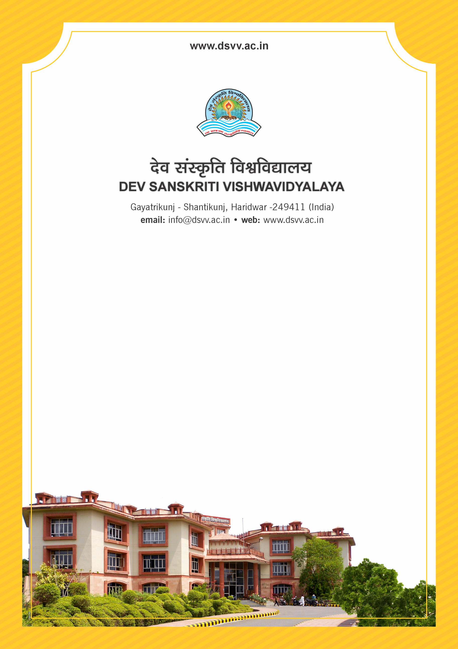
Figure 1Titel
Criteria 4
4.1.2 Percentage of expenditure excluding salary, for infrastructure development and augmentation year wise during the last five years
4.1.2
Percentage of expenditure excluding salary, for infrastructure development and augmentation year wise during the last five years
Response: 49.41
4.1.2.1 Expenditure for infrastructure development and augmentation, excluding salary year wise during last five years (INR in lakhs)
2023-24 | 2022-23 | 2021-22 | 2020-21 | 2019-20
732.7 | 457.93 | 344.13 | 180.52 | 319.74
File Description | Document
Institutional data in the prescribed format (data template)
Audited income and expenditure statement of the institution to be signed by CA and counter signed by the competent authority (relevant expenditure claimed for infrastructure augmentation should be clearly highlighted)
Provide Links for any other relevant document to support the claim (if any)

