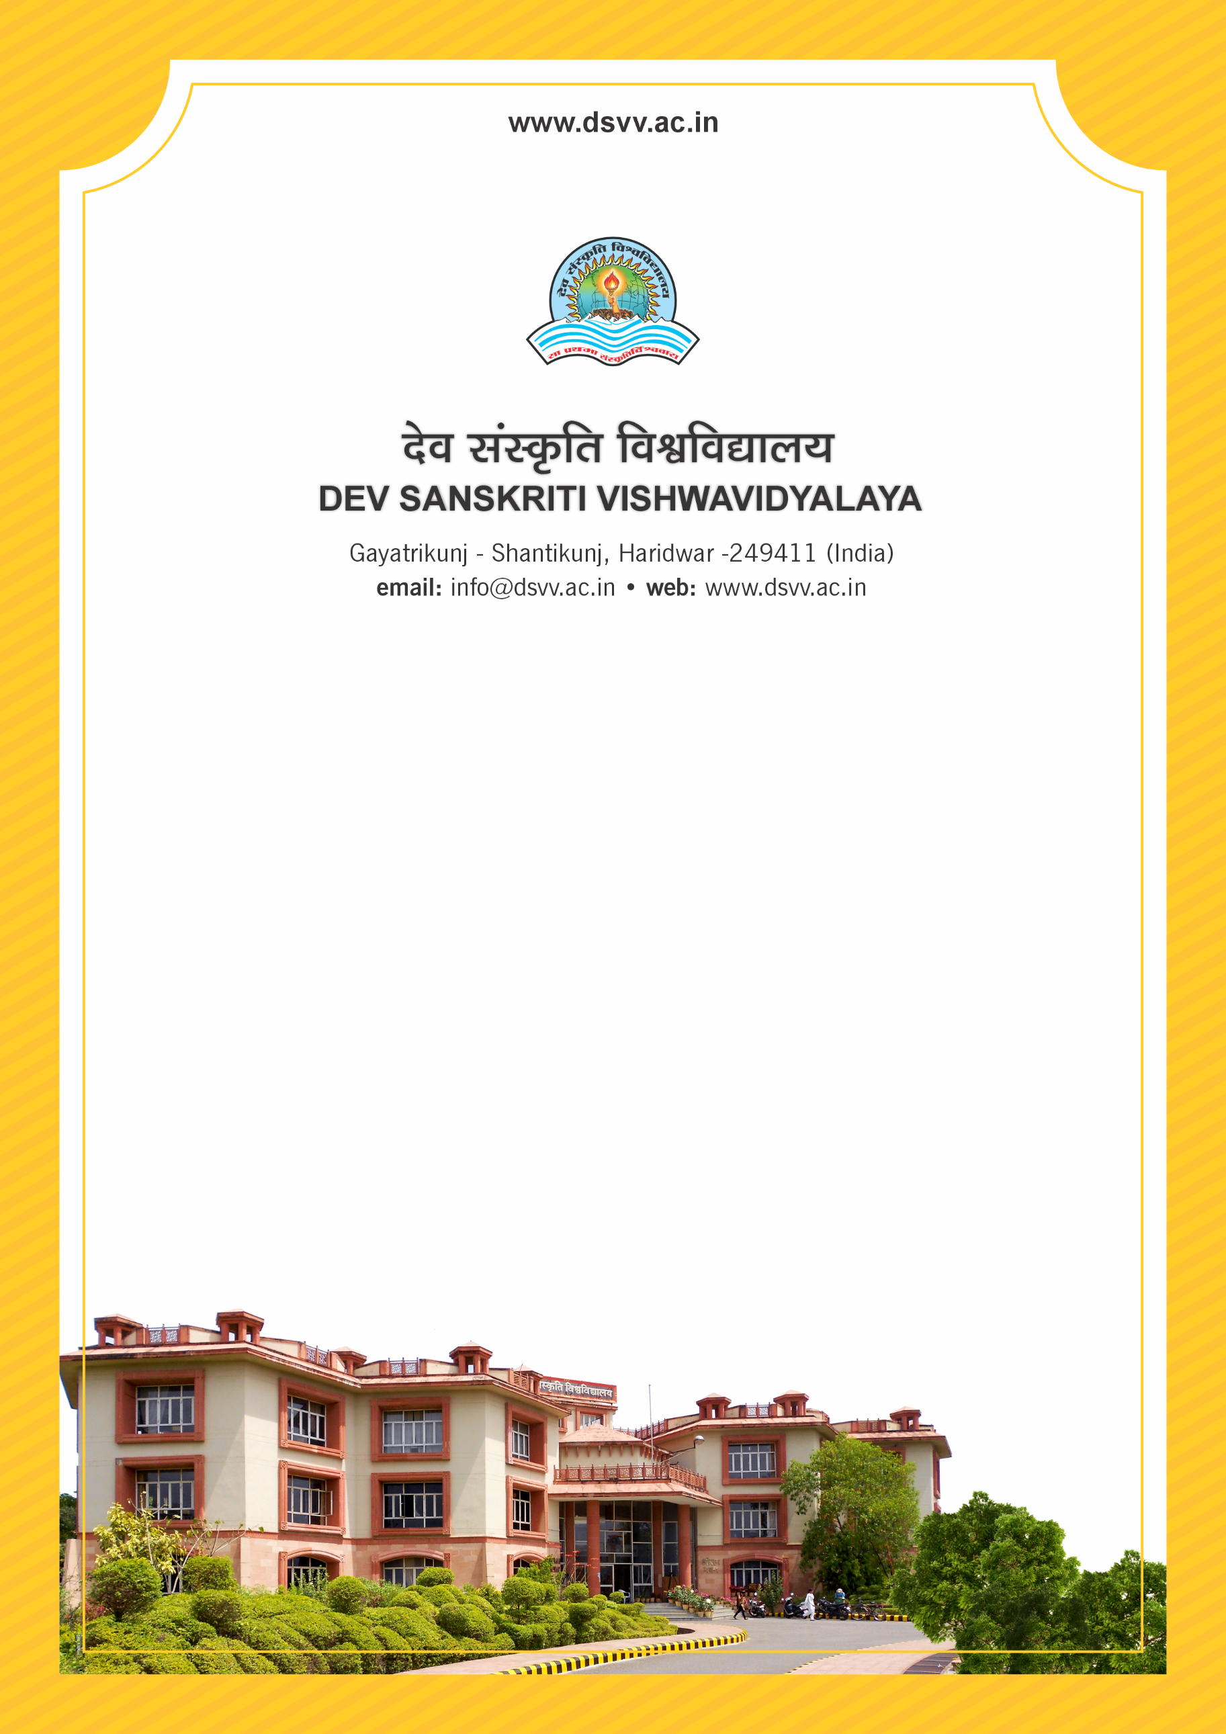
Figure 1Titel
Criteria 3
3.7.1 Number of functional MoUs/linkages with institutions/ industries in India and abroad for internship, on-the-job training, project work, student / faculty exchange and collaborative research during the last five years
3.7.1
Number of functional MoUs/linkages with institutions/ industries in India and abroad for internship, on-the-job training, project work, student / faculty exchange and collaborative research during the last five years
Response: 67
File Description | Document
Summary of the functional MoUs/linkage/collaboration indicating start date, end date, nature of collaboration etc.
List of year wise activities and exchange should be provided
List and Copies of documents indicating the functional MoUs/linkage/collaboration activity-wise and year-wise
Institutional data in the prescribed format (data template)

