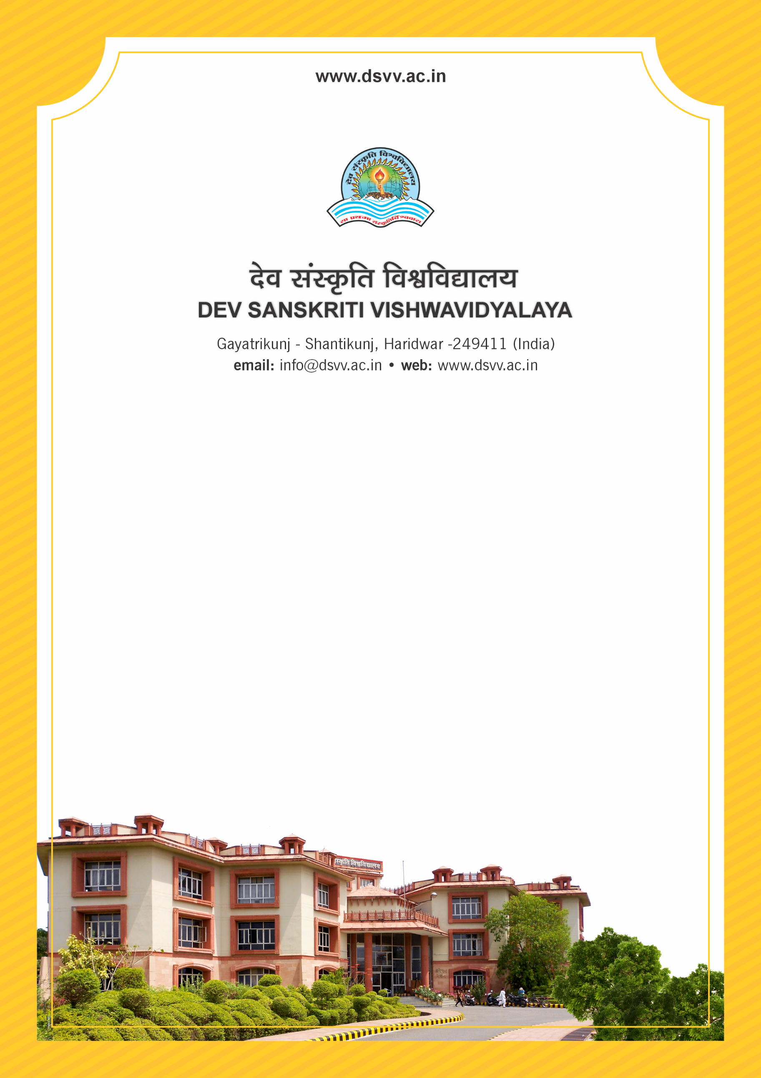
Figure 1Titel
Criteria 3
3.6.2 Number of extension and outreach programs conducted by the institution through organized forums like NSS/NCC with involvement of community year wise during the last five years
3.6.2.1 Number of extension and outreach programs conducted by the institution through organized forums including NSS/NCC with involvement of community year wise during the last five years.

3.6.2
Number of extension and outreach programs conducted by the institution through organized forums like NSS/NCC with involvement of community year wise during the last five years
Response: 99
3.6.2.1 Number of extension and outreach programs conducted by the institution through organized forums including NSS/NCC with involvement of community year wise during the last five years.
2023-24 | 2022-23 | 2021-22 | 2020-21 | 2019-20
15 | 30 | 33 | 09 | 12

File Description | Document
Institutional data in the prescribed format (data template)
Geo-tagged Photographs and any other supporting document of relevance should have proper captions and dates.
Detailed list and report for each extension and outreach program to be made available, with specific mention of number of students participated and the details of the collaborating agency
Provide Links for any other relevant document to support the claim (if any)

