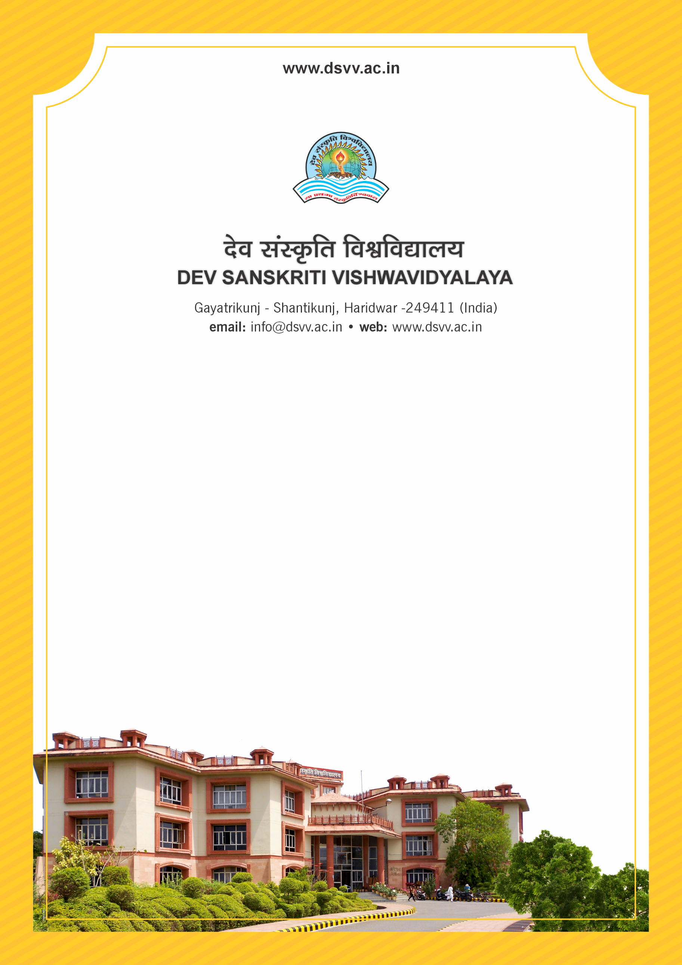
Figure 1Titel
Criteria 3
3.5.1 Revenue generated from consultancy and corporate training during the last five years
3.5.1.1 Total amount generated from consultancy and corporate training year-wise during the last five years (INR in lakhs).
3.5.1
Revenue generated from consultancy and corporate training during the last five years
Response: 23.47
3.5.1.1 Total amount generated from consultancy and corporate training year-wise during the last five years (INR in lakhs).
2023-24 | 2022-23 | 2021-22 | 2020-21 | 2019-20
4.8 | 2.4 | 2.34 | 00 | 13.93

File Description | Document
Letter from the corporate to whom training was imparted along with the fee paid
Letter from the beneficiary of the consultancy along with details of the consultancy fee.
Institutional data in the prescribed format (data template)
CA certified copy of statement of accounts as attested by head of the institution.
Audited statements of accounts indicating the revenue generated through and corporate training/consultancy.
Provide Links for any other relevant document to support the claim (if any)

