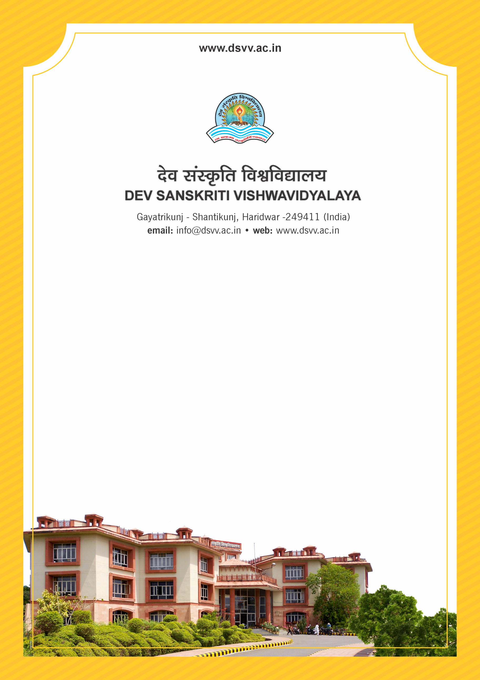
Figure 1Titel
Criteria 3
3.4.6 E-content is developed by teachers:
1. For e-PG-Pathshala
2. For CEC (Under Graduate)
3. For SWAYAM
4. For other MOOCs platform
5. Any other Government initiative
6. For institutional LMS\
Response: E. None of the above
3.4.6
E-content is developed by teachers:
1. For e-PG-Pathshala
2. For CEC (Under Graduate)
3. For SWAYAM
4. For other MOOCs platform
5. Any other Government initiative
6. For institutional LMS
Response: E. None of the above

File Description | Document
Supporting documents from the sponsoring agency for the e- content developed by the teachers need to be provided.
Institutional data in the prescribed format (data template)
Give links to upload document of e-content developed showing the authorship/contribution
For institution LMS a summary of the e-content developed and the links to the e-content should be provided

