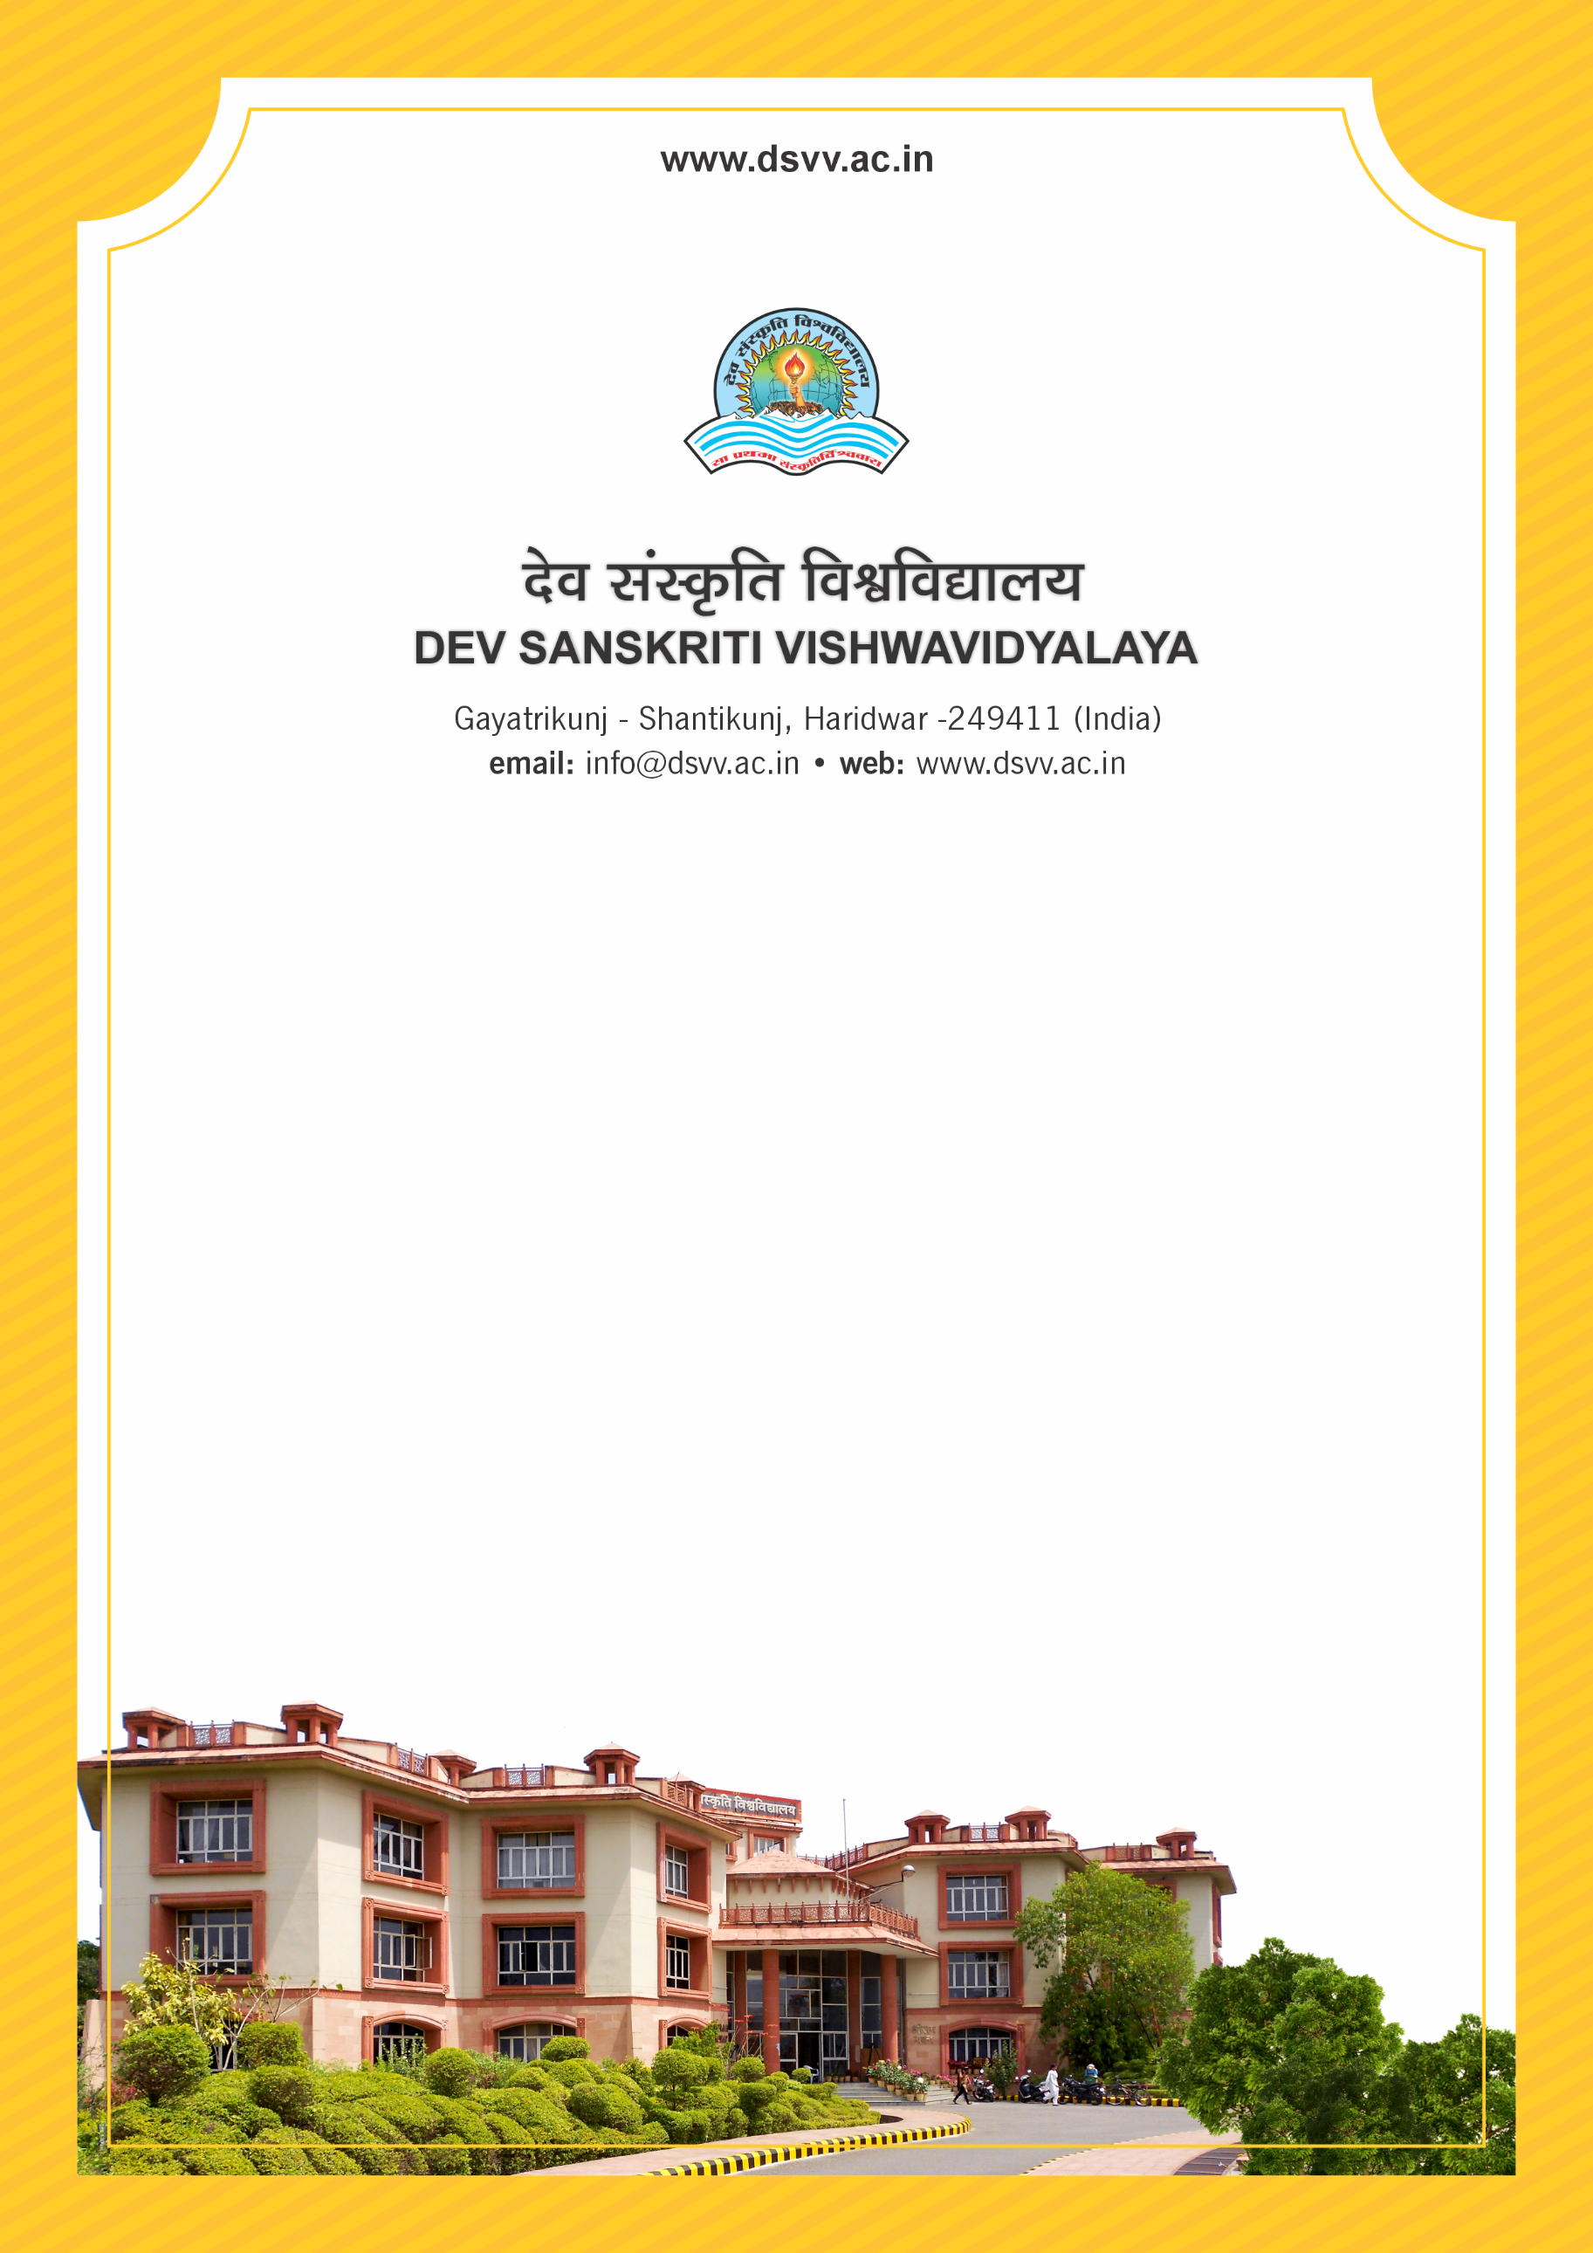
Figure 1Titel
Criteria 3
3.4.5 Number of books and chapters in edited volumes published per teacher during the last five years
3.4.5.1 Total Number of books and chapters in edited volumes published during the last five years
3.4.5
Number of books and chapters in edited volumes published per teacher during the last five years
Response: 0.6
3.4.5.1 Total Number of books and chapters in edited volumes published during the last five years
Response: 77

File Description | Document
List of chapter/book with the links redirecting to the source website
Institutional data in the prescribed format (data template)
E-copy of the Cover page, content page and first page of the publication indicating ISBN number and year of publication for books/chapters
Provide Links for any other relevant document to support the claim (if any)

