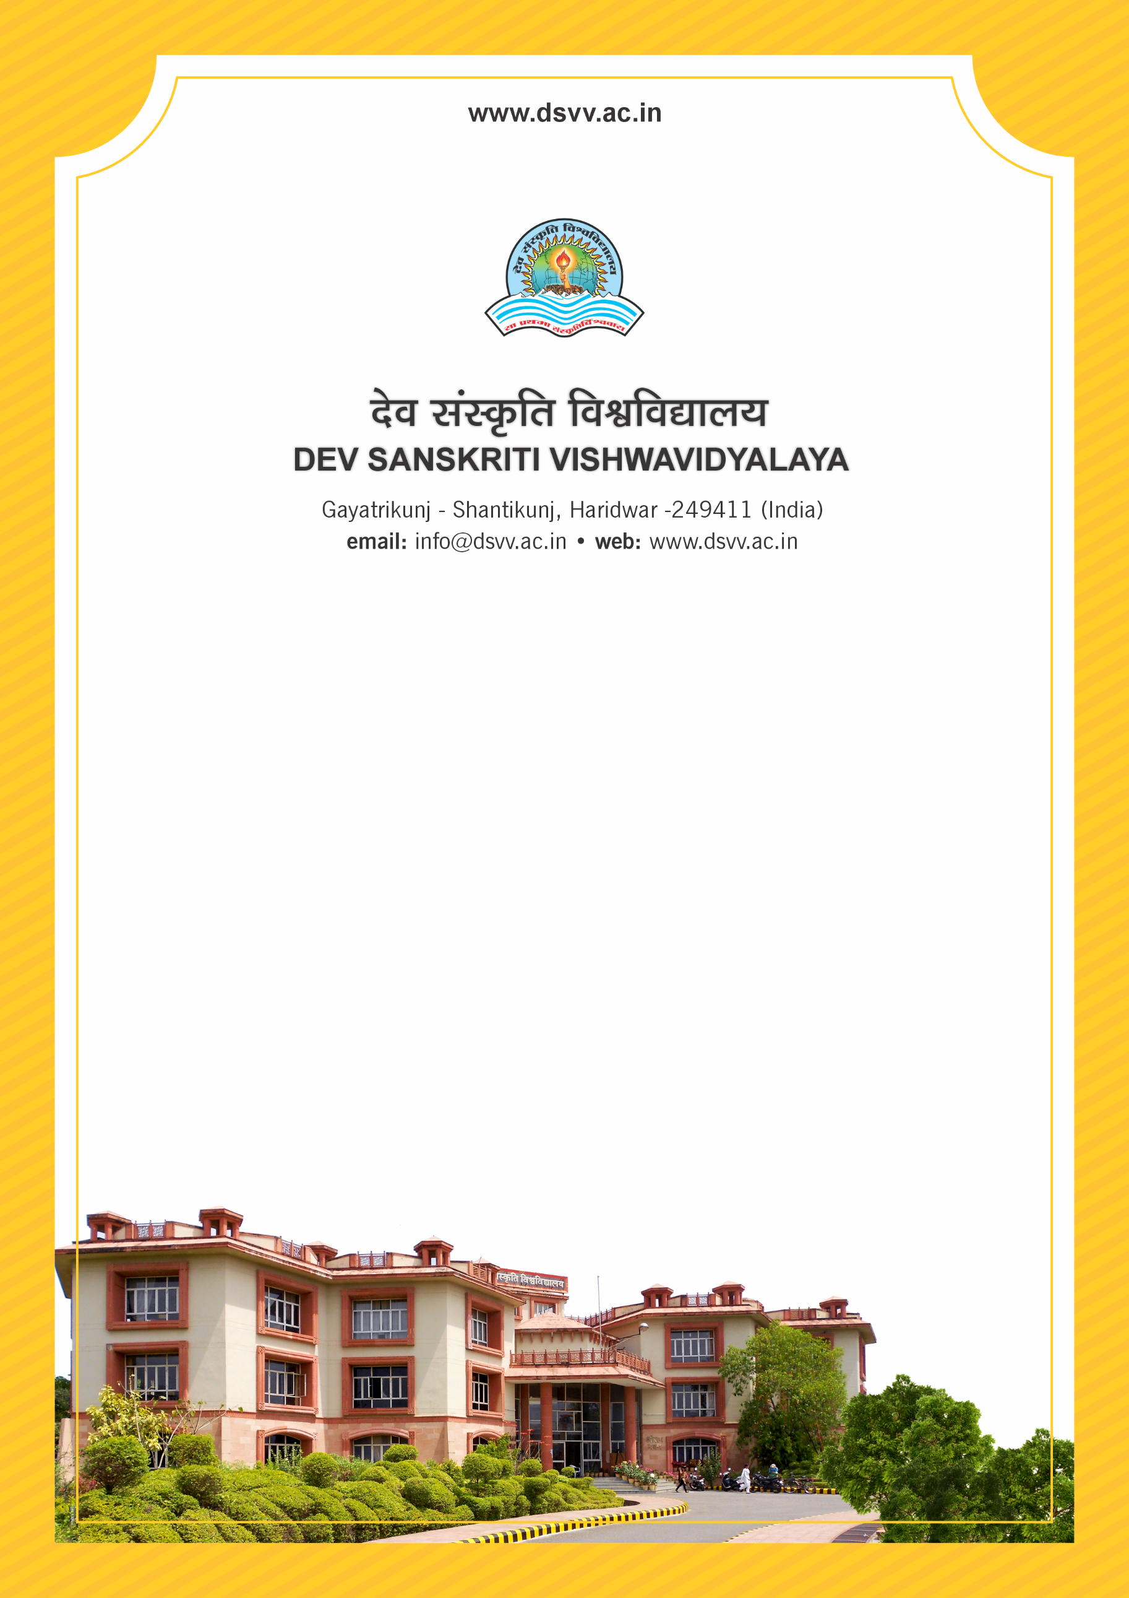
Figure 1Titel
Criteria 3
3.4.4 Number of research papers published per teacher in the Journals as notified on UGC CARE list during the last five years
3.4.4.1 Number of research papers published in the Journals as notified on UGC CARE list during the last five years
3.4.4 Number of research papers published per teacher in the Journals as notified on UGC CARE list during the last five years
Response: 0.24
3.4.4.1 Number of research papers published in the Journals as notified on UGC CARE list during the last five years
Response: 31
File Description | Document
List and links of the papers published in journals listed in UGC CARE list and
Institutional data in the prescribed format (data template)
Provide Links for any other relevant document to support the claim (if any)
Link to the institutional website where the first page/full paper (with author and affiliation details) is published
Link re-directing to journal source-cite website in case of digital journals

