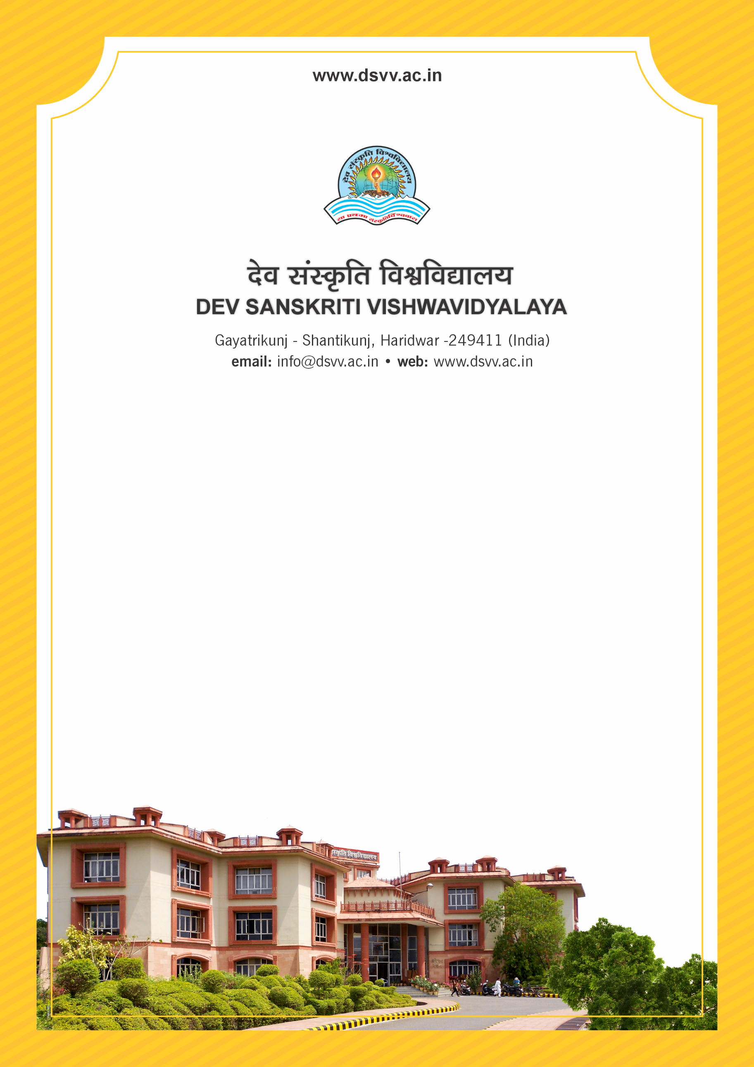
Figure 1Titel
Criteria 3
3.4.3 Number of Ph.Ds awarded per recognized guide during the last five years
3.4.3.1 How many Ph.Ds were awarded during last 5 years
3.4.3.2 Number of teachers recognized as guides during the last five years

3.4.3
Number of Ph.Ds awarded per recognized guide during the last five years
Response: 1.07
3.4.3.1 How many Ph.Ds were awarded during last 5 years
Response: 64
3.4.3.2 Number of teachers recognized as guides during the last five years
Response: 60

File Description | Document
PhD Award letters to PhD students.
Letter from the university indicating name of the PhD student with title of the doctoral study and the name of the guide.
Institutional data in the prescribed format (data template)
Provide Links for any other relevant document to support the claim (if any)

