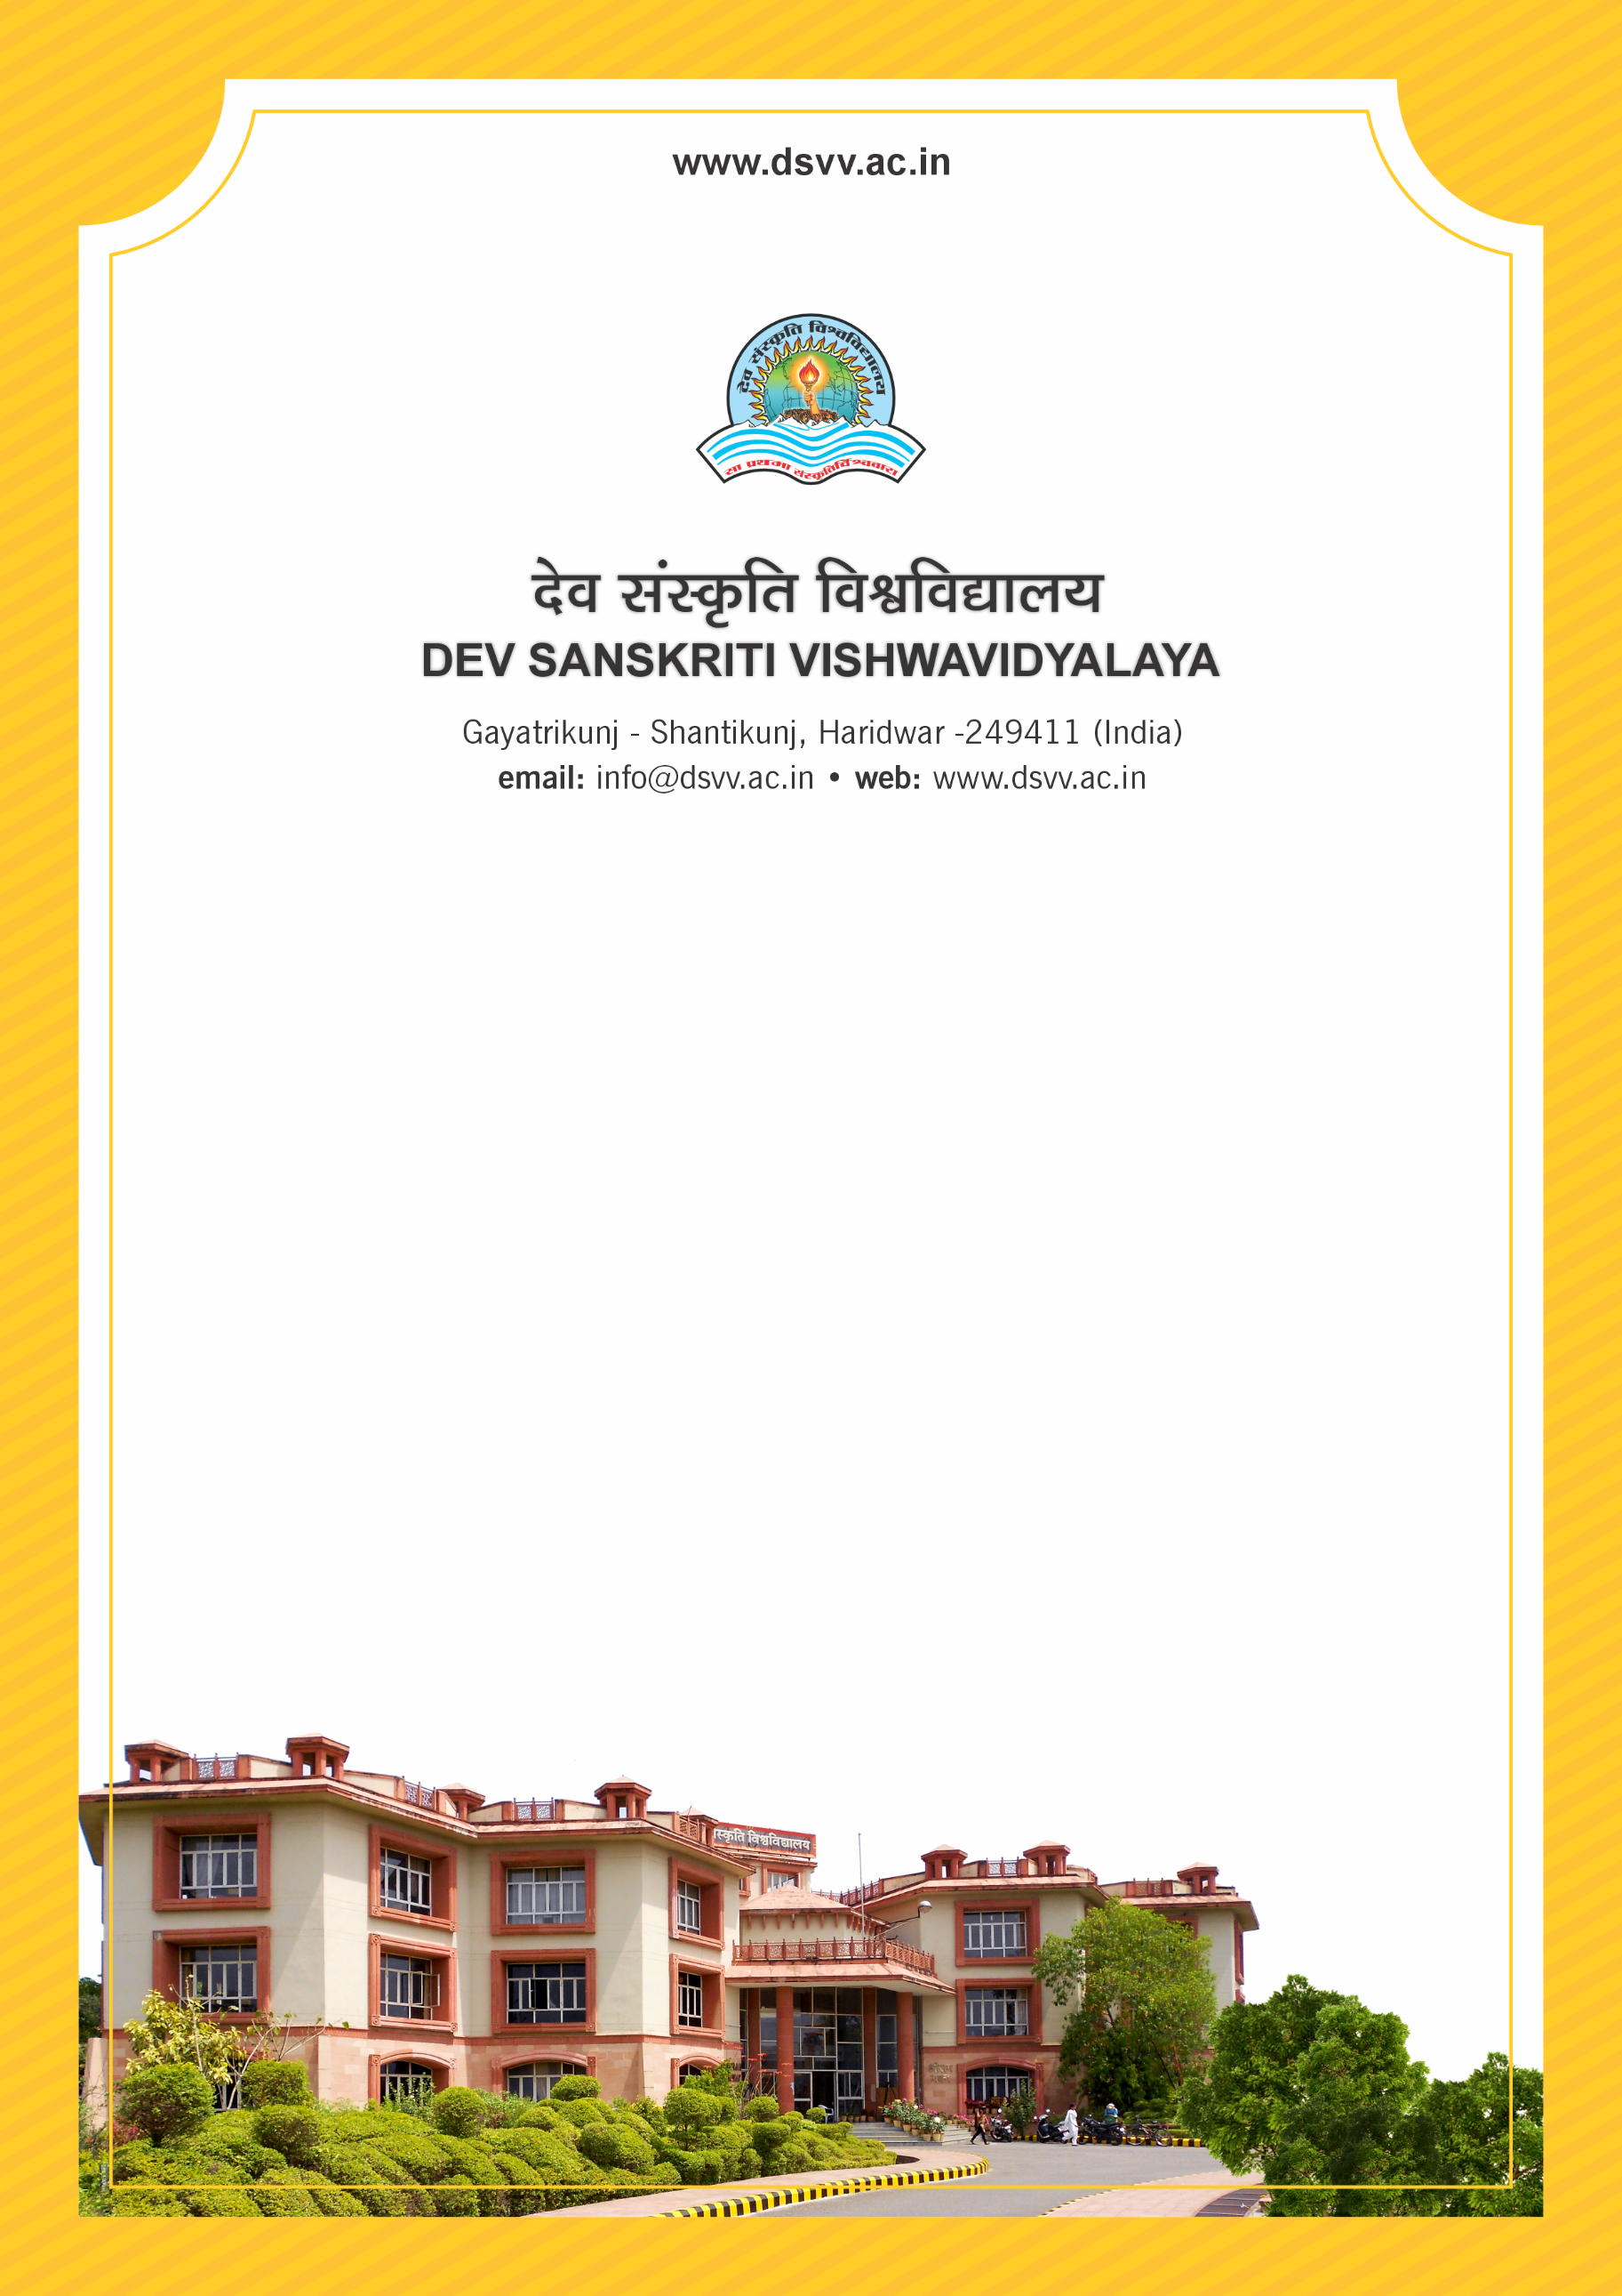
Figure 1Titel
Criteria 3
3.4.2 Total number of Patents awarded during the last five years

3.4.2
Total number of Patents awarded during the last five years
Response: 37

File Description | Document
Patents granted / published in the name of the faculty with the institutional affiliation to the university working during the assessment period only to be given.
Institutional data in the prescribed format (data template)
e-copies of letter of patent grant
Provide Links for any other relevant document to support the claim (if any)

