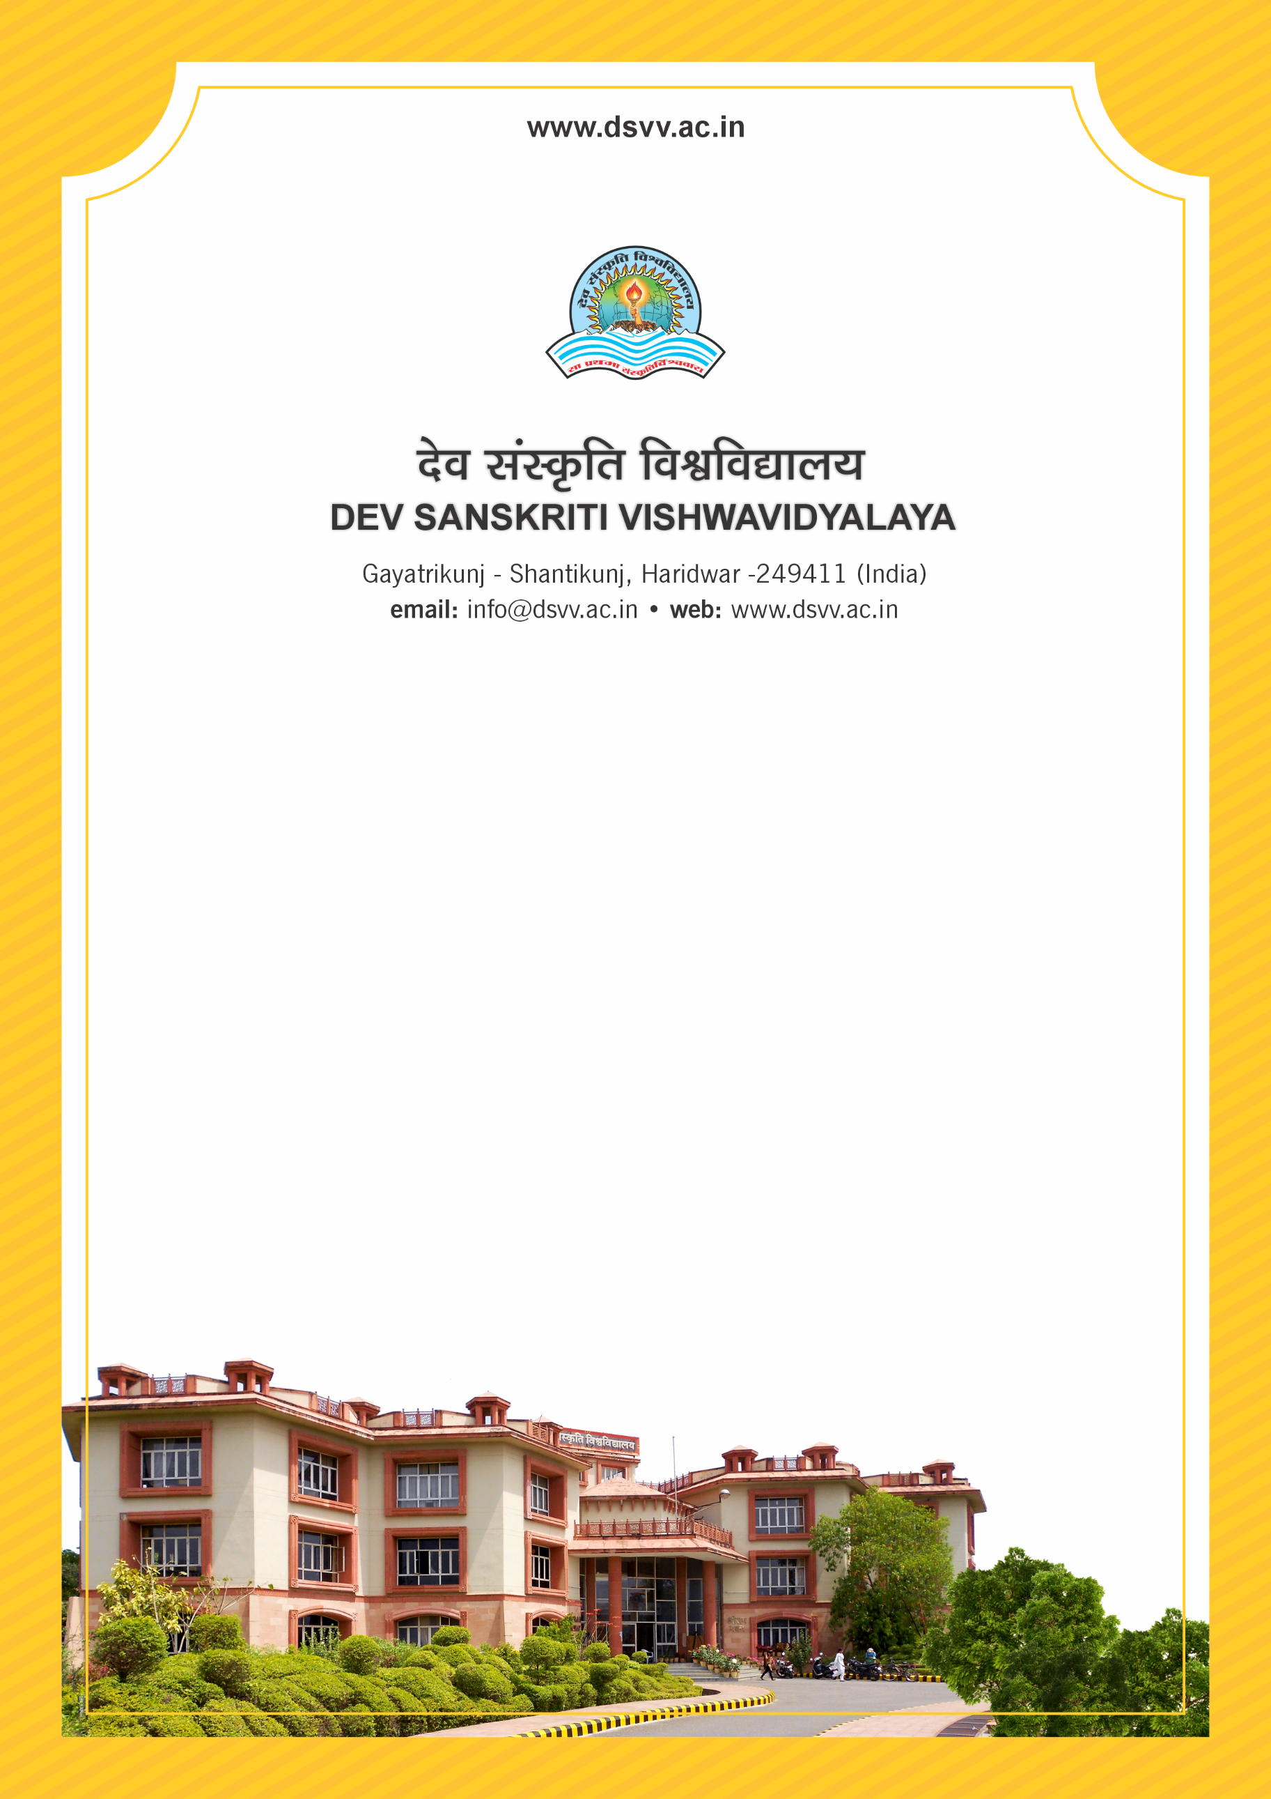
Figure 1Titel
Criteria 3
3.3.2 Total number of awards received for research/innovations by institution/teachers/research scholars/students during the last five years
3.3.2
Total number of awards received for research/innovations by institution/teachers/research scholars/students during the last five years
Response: 268
File Description | Document
Institutional data in the prescribed format (data template)
e- Copies of award letters issued by the awarding agency
Provide Links for any other relevant document to support the claim (if any)

