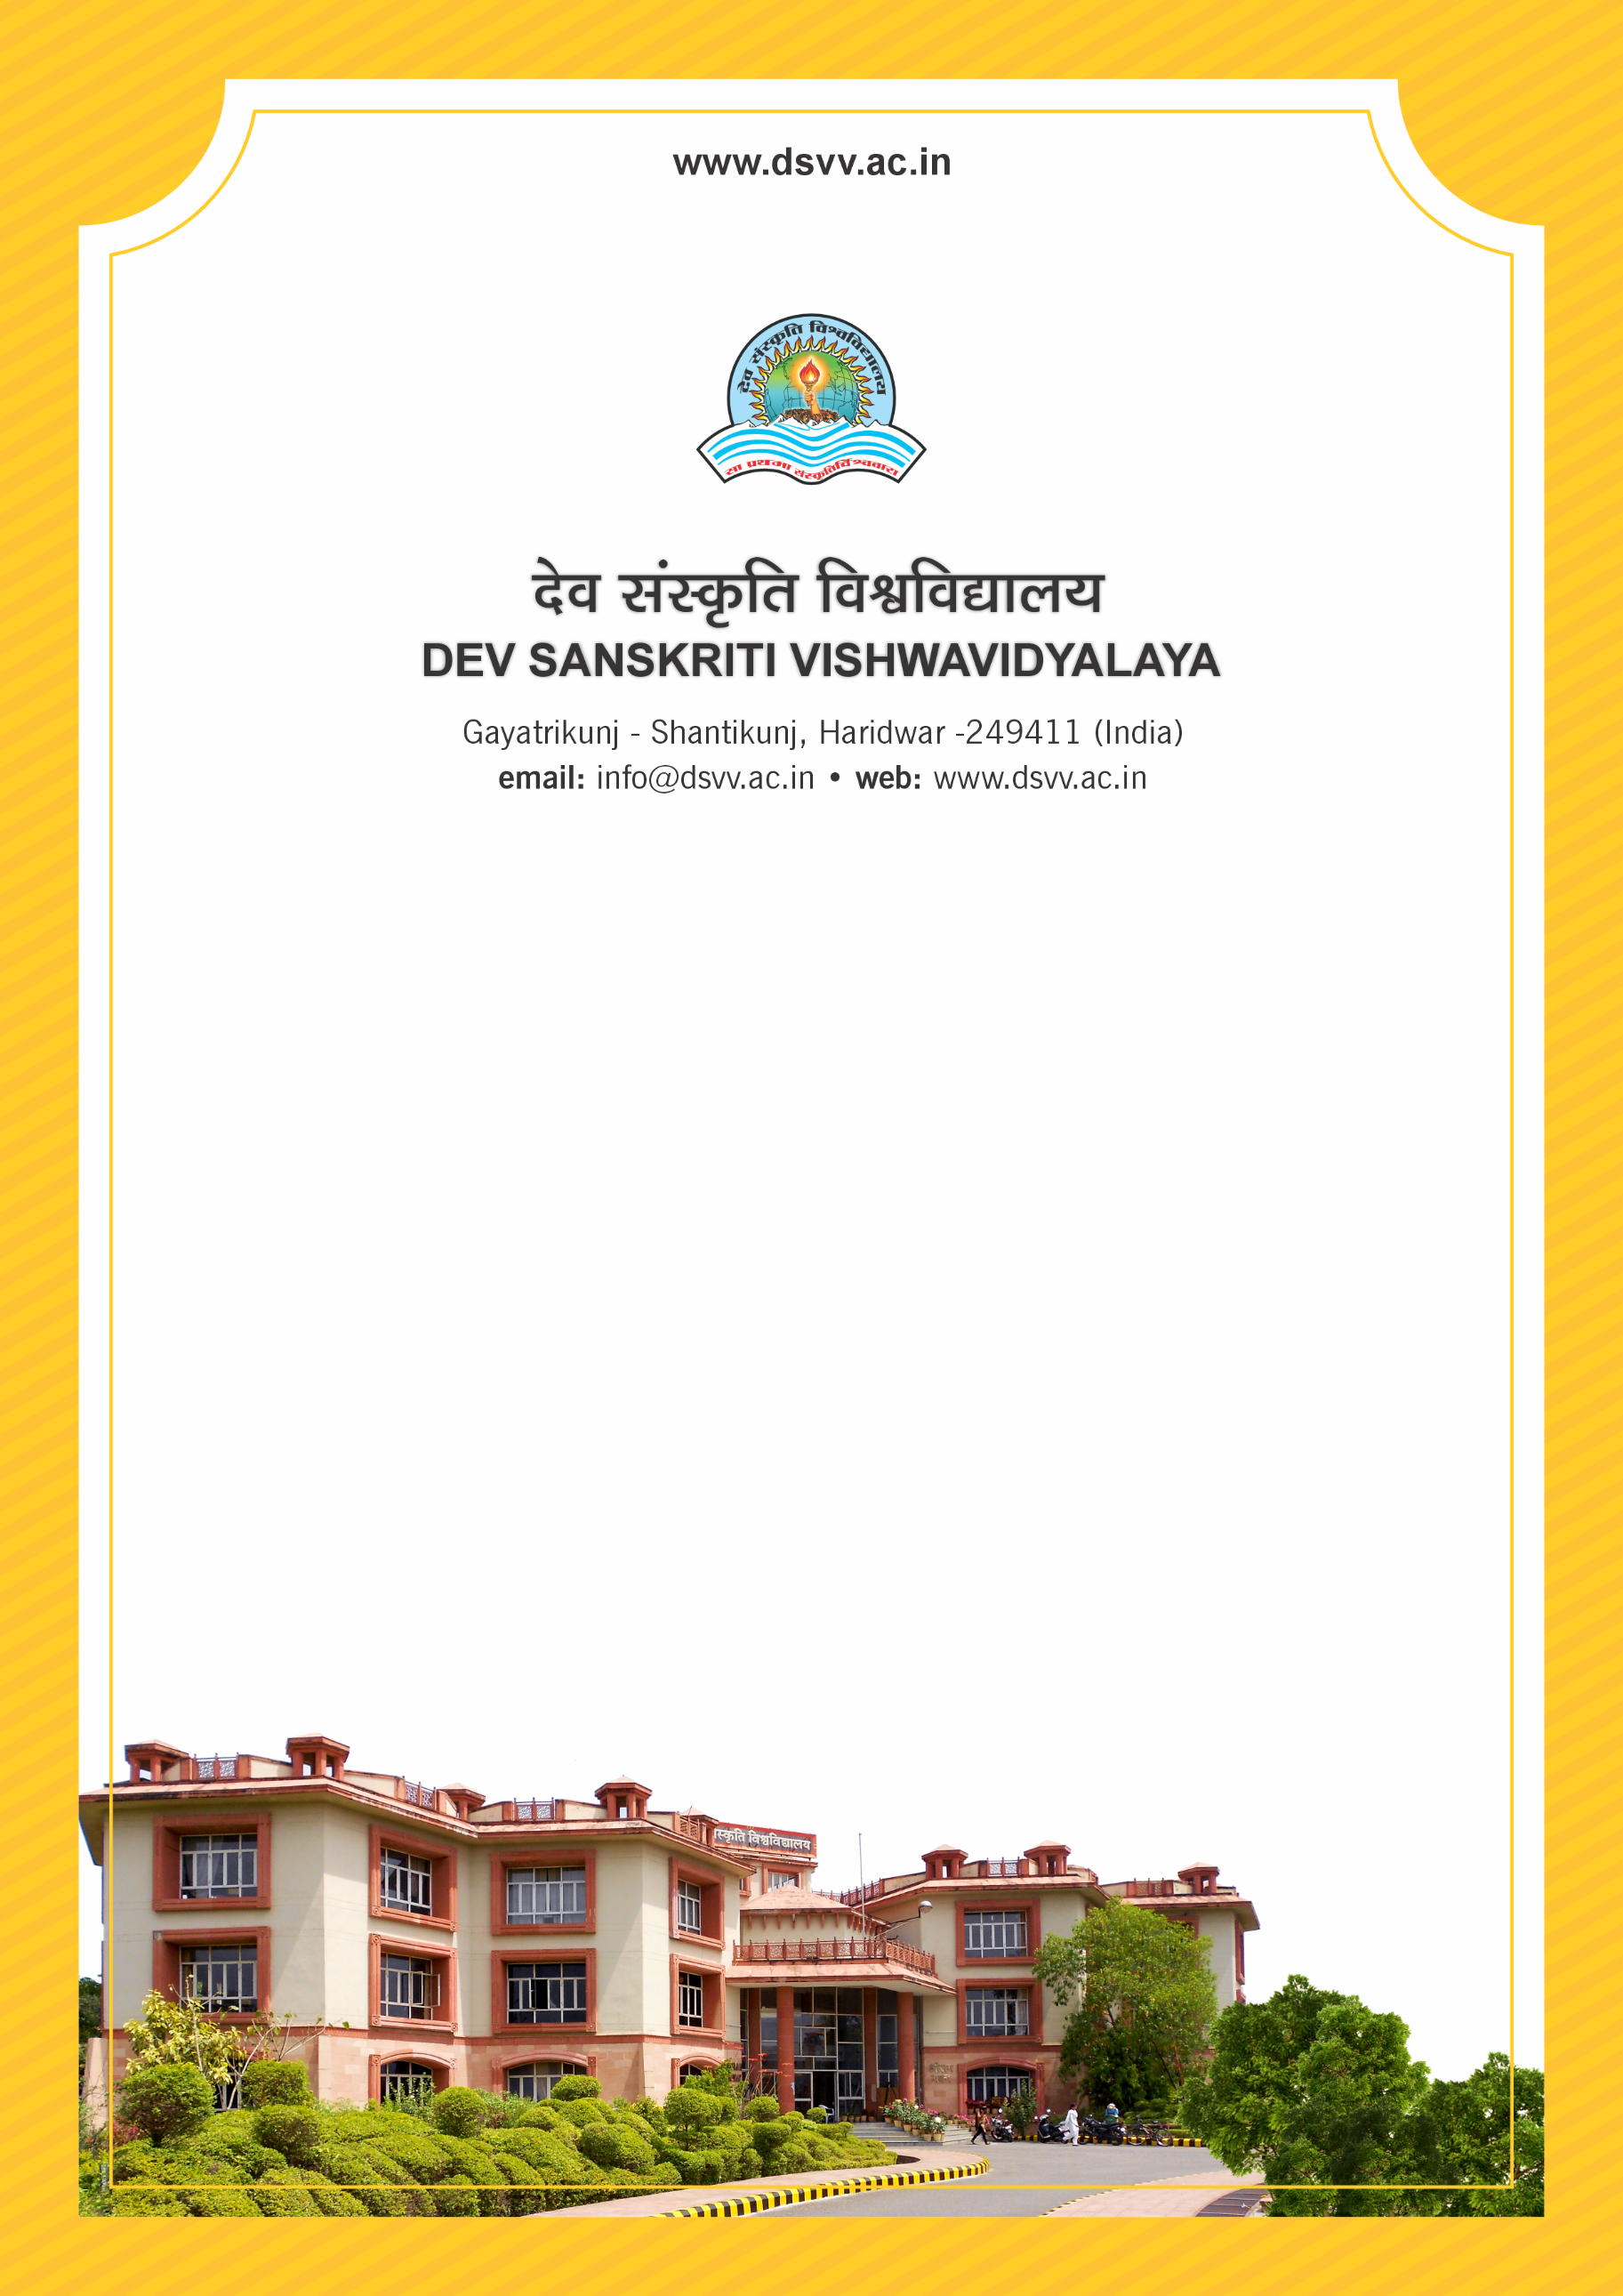
Figure 1Titel
Criteria 3
3.2.2 Number of research projects per teacher funded by government, non-government, industry, corporate houses, international bodies during the last five years
3.2.2.1 Number of research projects funded by government and non-government agencies during the last five years
3.2.2
Number of research projects per teacher funded by government, non-government, industry, corporate houses, international bodies during the last five years
Response: 0.21
3.2.2.1 Number of research projects funded by government and non-government agencies during the last five years
Response: 27
File Description | Document
List of project titles with details of Principal Investigator, amount sanctioned and sanctioning agency etc.
Institutional data in the prescribed format (data template merged with 3.2.1)
E-copies of the grant award letters for research projects sponsored by government agencies.
Provide Links for any other relevant document to support the claim (if any)

