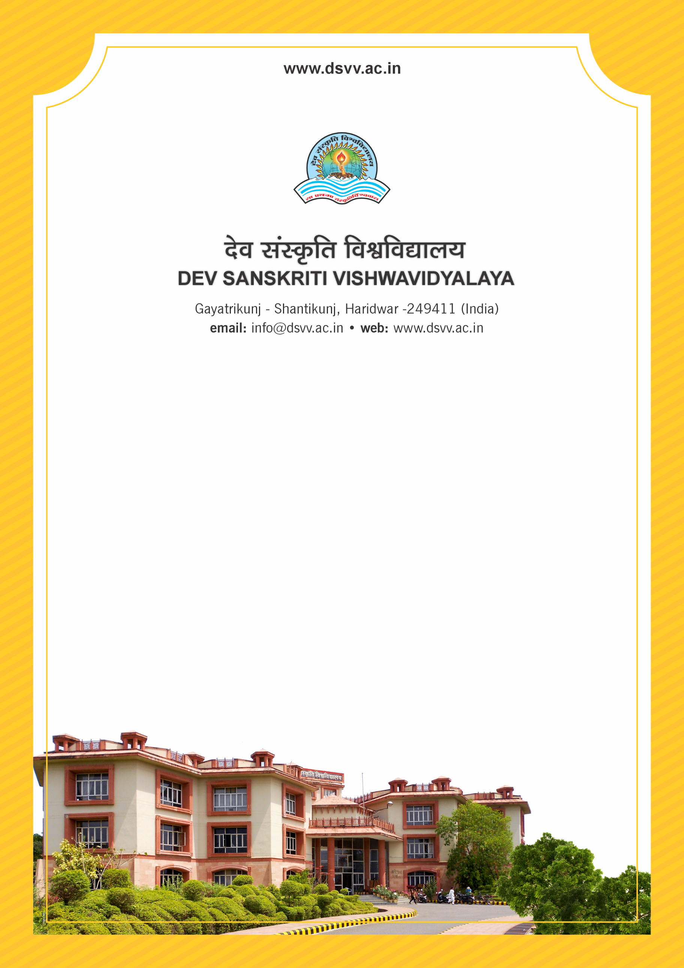
Figure 1Titel
Criteria 3
3.2.1 Total Grants research funding received by the institution and its faculties through Governme006Et and non-government sources such as industry, corporate houses, international bodies for research project, endowment research chairs during the last five years (INR in Lakhs)
3.2.1
Total Grants research funding received by the institution and its faculties through Governme006Et and non-government sources such as industry, corporate houses, international bodies for research project, endowment research chairs during the last five years (INR in Lakhs)
Response: 363.39
File Description | Document
List of Extramural funding received for research, Endowment Research Chairs received during the last five years along with the nature of award, the awarding agency and the amount.
Institutional data in the prescribed format (data template)
E-copies of the letters of award for research, endowments, Chairs sponsored by nongovernment sources
Provide Links for any other relevant document to support the claim (if any)

