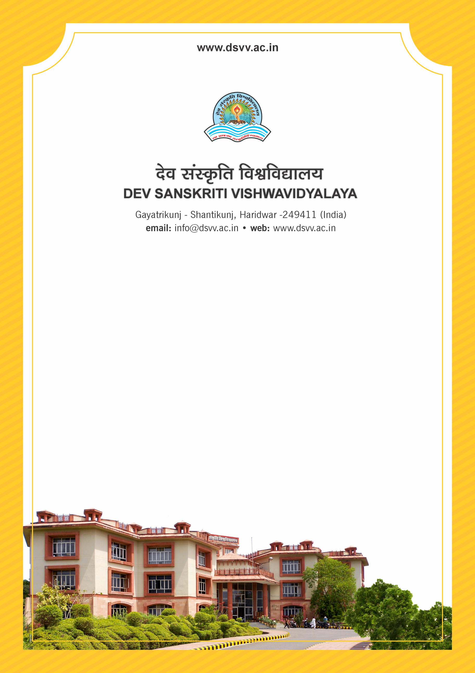
Figure 1Titel
Criteria 3
3.1.3 Percentage of teachers receiving national / international fellowship / financial support by various agencies for advanced studies / research during the last five years.
3.1.3.1 Number of teachers who received national/ international fellowship/financial support from various agencies, for advanced studies / research; year-wise during the last five years
3.1.3
Percentage of teachers receiving national / international fellowship / financial support by various agencies for advanced studies / research during the last five years.
Response: 7.75
3.1.3.1 Number of teachers who received national/ international fellowship/financial support from various agencies, for advanced studies / research; year-wise during the last five years
Response: 10
File Description | Document
List of teachers who have received the awards along with the nature of award, the awarding agency etc.
Institutional data in the prescribed format (data template)
E-copies of the award letters of the teachers.
Provide Links for any other relevant document to support the claim (if any)

