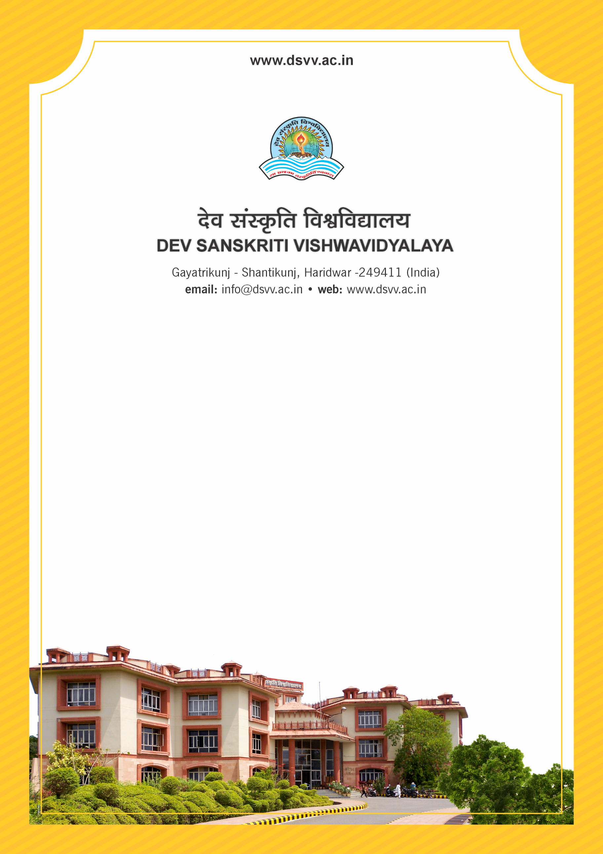
Figure 1Titel
Criteria 3
3.1.2 The institution provides seed money to its teachers for research (average per year)
3.1.2.1 Amount of seed money provided by institution to its teachers for research year wise during last five years (INR in lakhs)
3.1.2
The institution provides seed money to its teachers for research (average per year)
Response: 13.03
3.1.2.1 Amount of seed money provided by institution to its teachers for research year wise during last five years (INR in lakhs)
2023-24 | 2022-23 | 2021-22 | 2020-21 | 2019-20
3.69 | 51.56 | 9.91 | 0 | 0
File Description | Document
Sanction letters of seed money to the teachers is mandatory
List of faculty who have been provided with seed money for research along with the title of the project, duration and amount year-wise
Institutional data in the prescribed format (data template)
Audited Income-Expenditure statement highlighting the expenditure towards seed money endorsed by the Finance Officer
Provide Links for any other relevant document to support the claim (if any)

