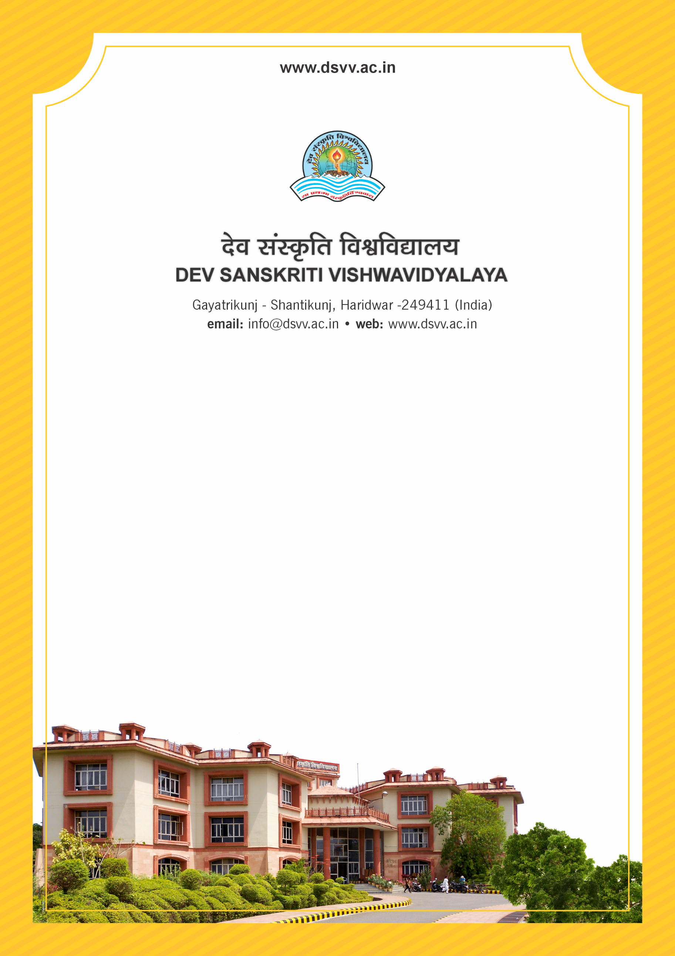
Figure 1Titel
Criteria 2
2.6.2 Pass percentage of students (excluding backlog students) (Data to be provided only for the latest completed academic year)
2.6.2.1 Total number of final year students who passed the examination conducted by Institution.
2.6.2.1
Total number of final year students who passed the examination conducted by Institution.
Response: 81.45
2.6.2.1 Total number of final year students who passed the examination conducted by Institution.
Response: 338File Description | Document
percentage of students of the final year (final semester) eligible for the degree program-wise / year wise
Institutional data in the prescribed format (data template)
Certified report from the Controller of Examinations indicating the pass
Annual report of COE highlighting the pass percentage of students

