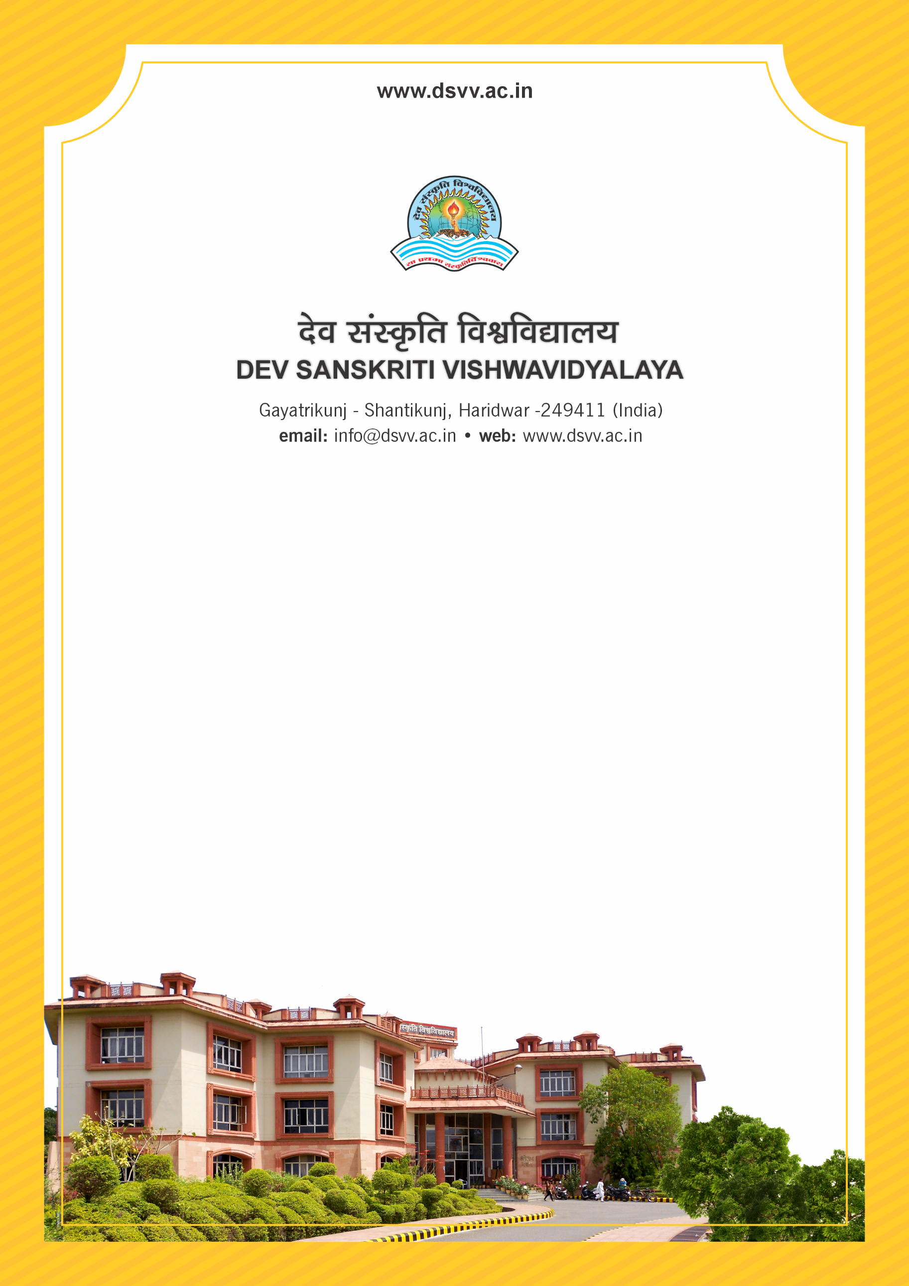
Figure 1Titel
Criteria 2
2.5.3 Status of automation of Examination division along with approved Examination Manual/ordinance

Response: B. Only student registration, Hall ticket issue & Result Processing
2.5.3 Status of automation of Examination division along with approved Examination Manual/ordinance
Response: B. Only student registration, Hall ticket issue & Result Processing
File Description | Document
The screenshot should reflect the HEI name and the name of the module.
The report on the present status of automation of examination division including screenshots of various modules of the software.
Institutional data in the prescribed format (data template)
Copies of the purchase order and bills/AMC of the software.
Provide Links for any other relevant document to support the claim (if any)

