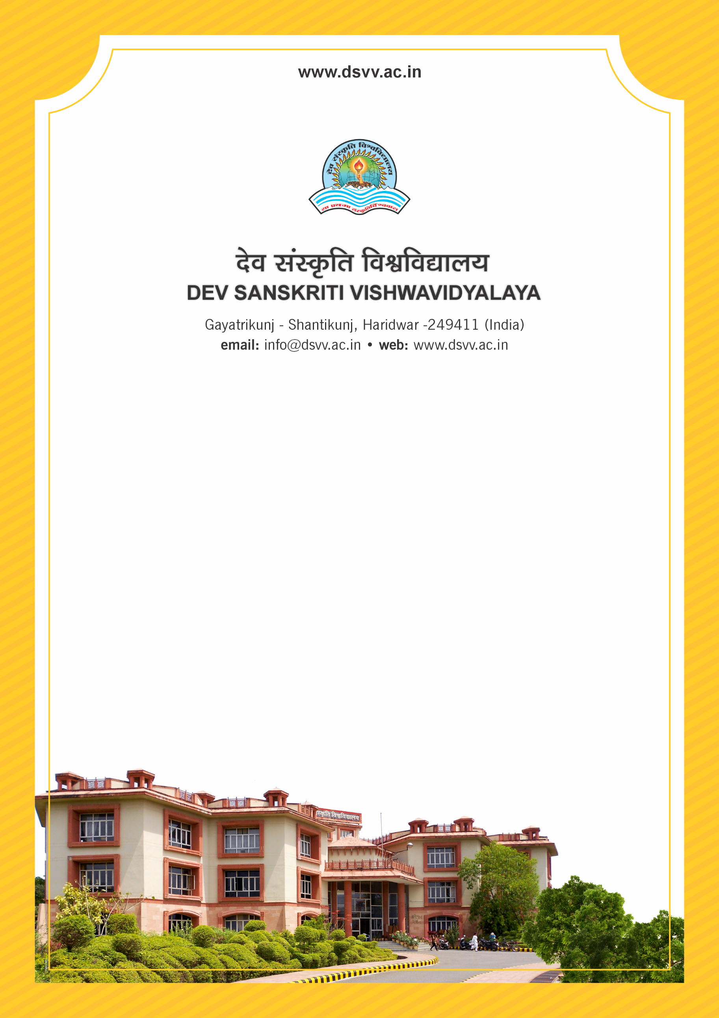
Figure 1Titel
Criteria 2
2.5.2 Percentage of student complaints/grievances about evaluation against total number of students appeared in the examinations during the last five years
2.5.2.1 Number of complaints/grievances about evaluation year-wise during the last five years
2.5.2.2 Number of students appeared in the examination conducted by the institution year wise during the last five years
2.5.2.2
Number of students appeared in the examination conducted by the institution year wise during the last five years
Response: 0.3
2.5.2.1 Number of complaints/grievances about evaluation year-wise during the last five years
2023-24 | 2022-23 | 2021-22 | 2020-21 | 2019-20
4 | 0 | 7 | 4 | 3

2.5.2.2 Number of students appeared in the examination conducted by the institution year wise during the last five years
2023-24 | 2022-23 | 2021-22 | 2020-21 | 2019-20
1068 | 1191 | 1208 | 1245 | 1208
File Description | Document
List the number of students who have applied for re- valuation/re-totalling program wise and the total certified by the Controller of Examinations yearwise for the assessment period.
Institutional data in the prescribed format (data template)
Provide Links for any other relevant document to support the claim (if any)

