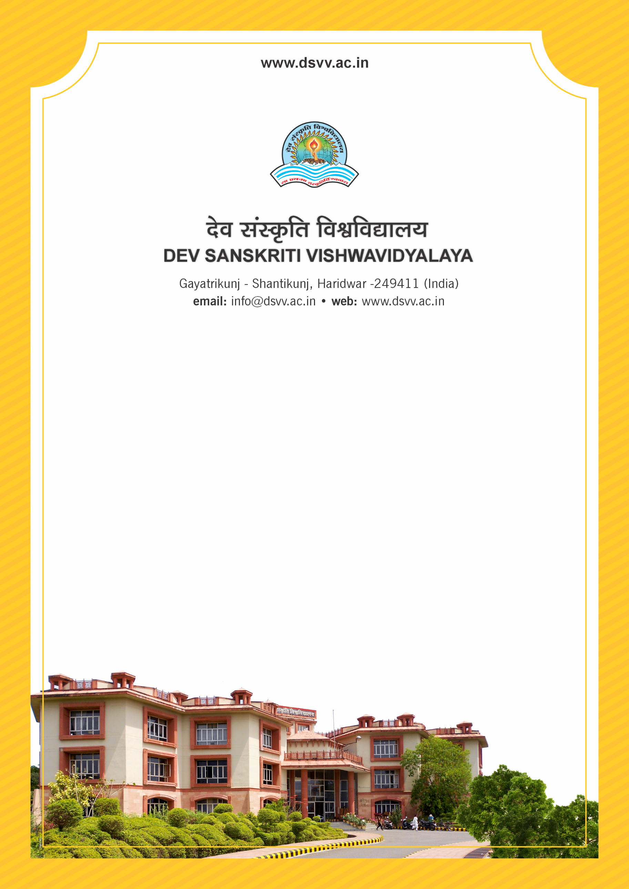
Figure 1Titel
Criteria 2
2.5.1 Average number of days from the date of last semester-end/ year- end examination till the last date of declaration of results during the last five years
2.5.1.1 Number of days from the date of last semester-end/ year- end examination till the last date of declaration of results year wise during the last five years
2.5.1
Average number of days from the date of last semester-end/ year- end examination till the last date of declaration of results during the last five years
Response: 31.4
2.5.1.1 Number of days from the date of last semester-end/ year- end examination till the last date of declaration of results year wise during the last five years
2023-24 | 2022-23 | 2021-22 | 2020-21 | 2019-20
40 | 23 | 31 | 34 | 29

File Description | Document
Provide the relevant information in institutional website as part of public disclosure
Institutional data in the prescribed format (data template)
Provide Links for any other relevant document to support the claim (if any)

