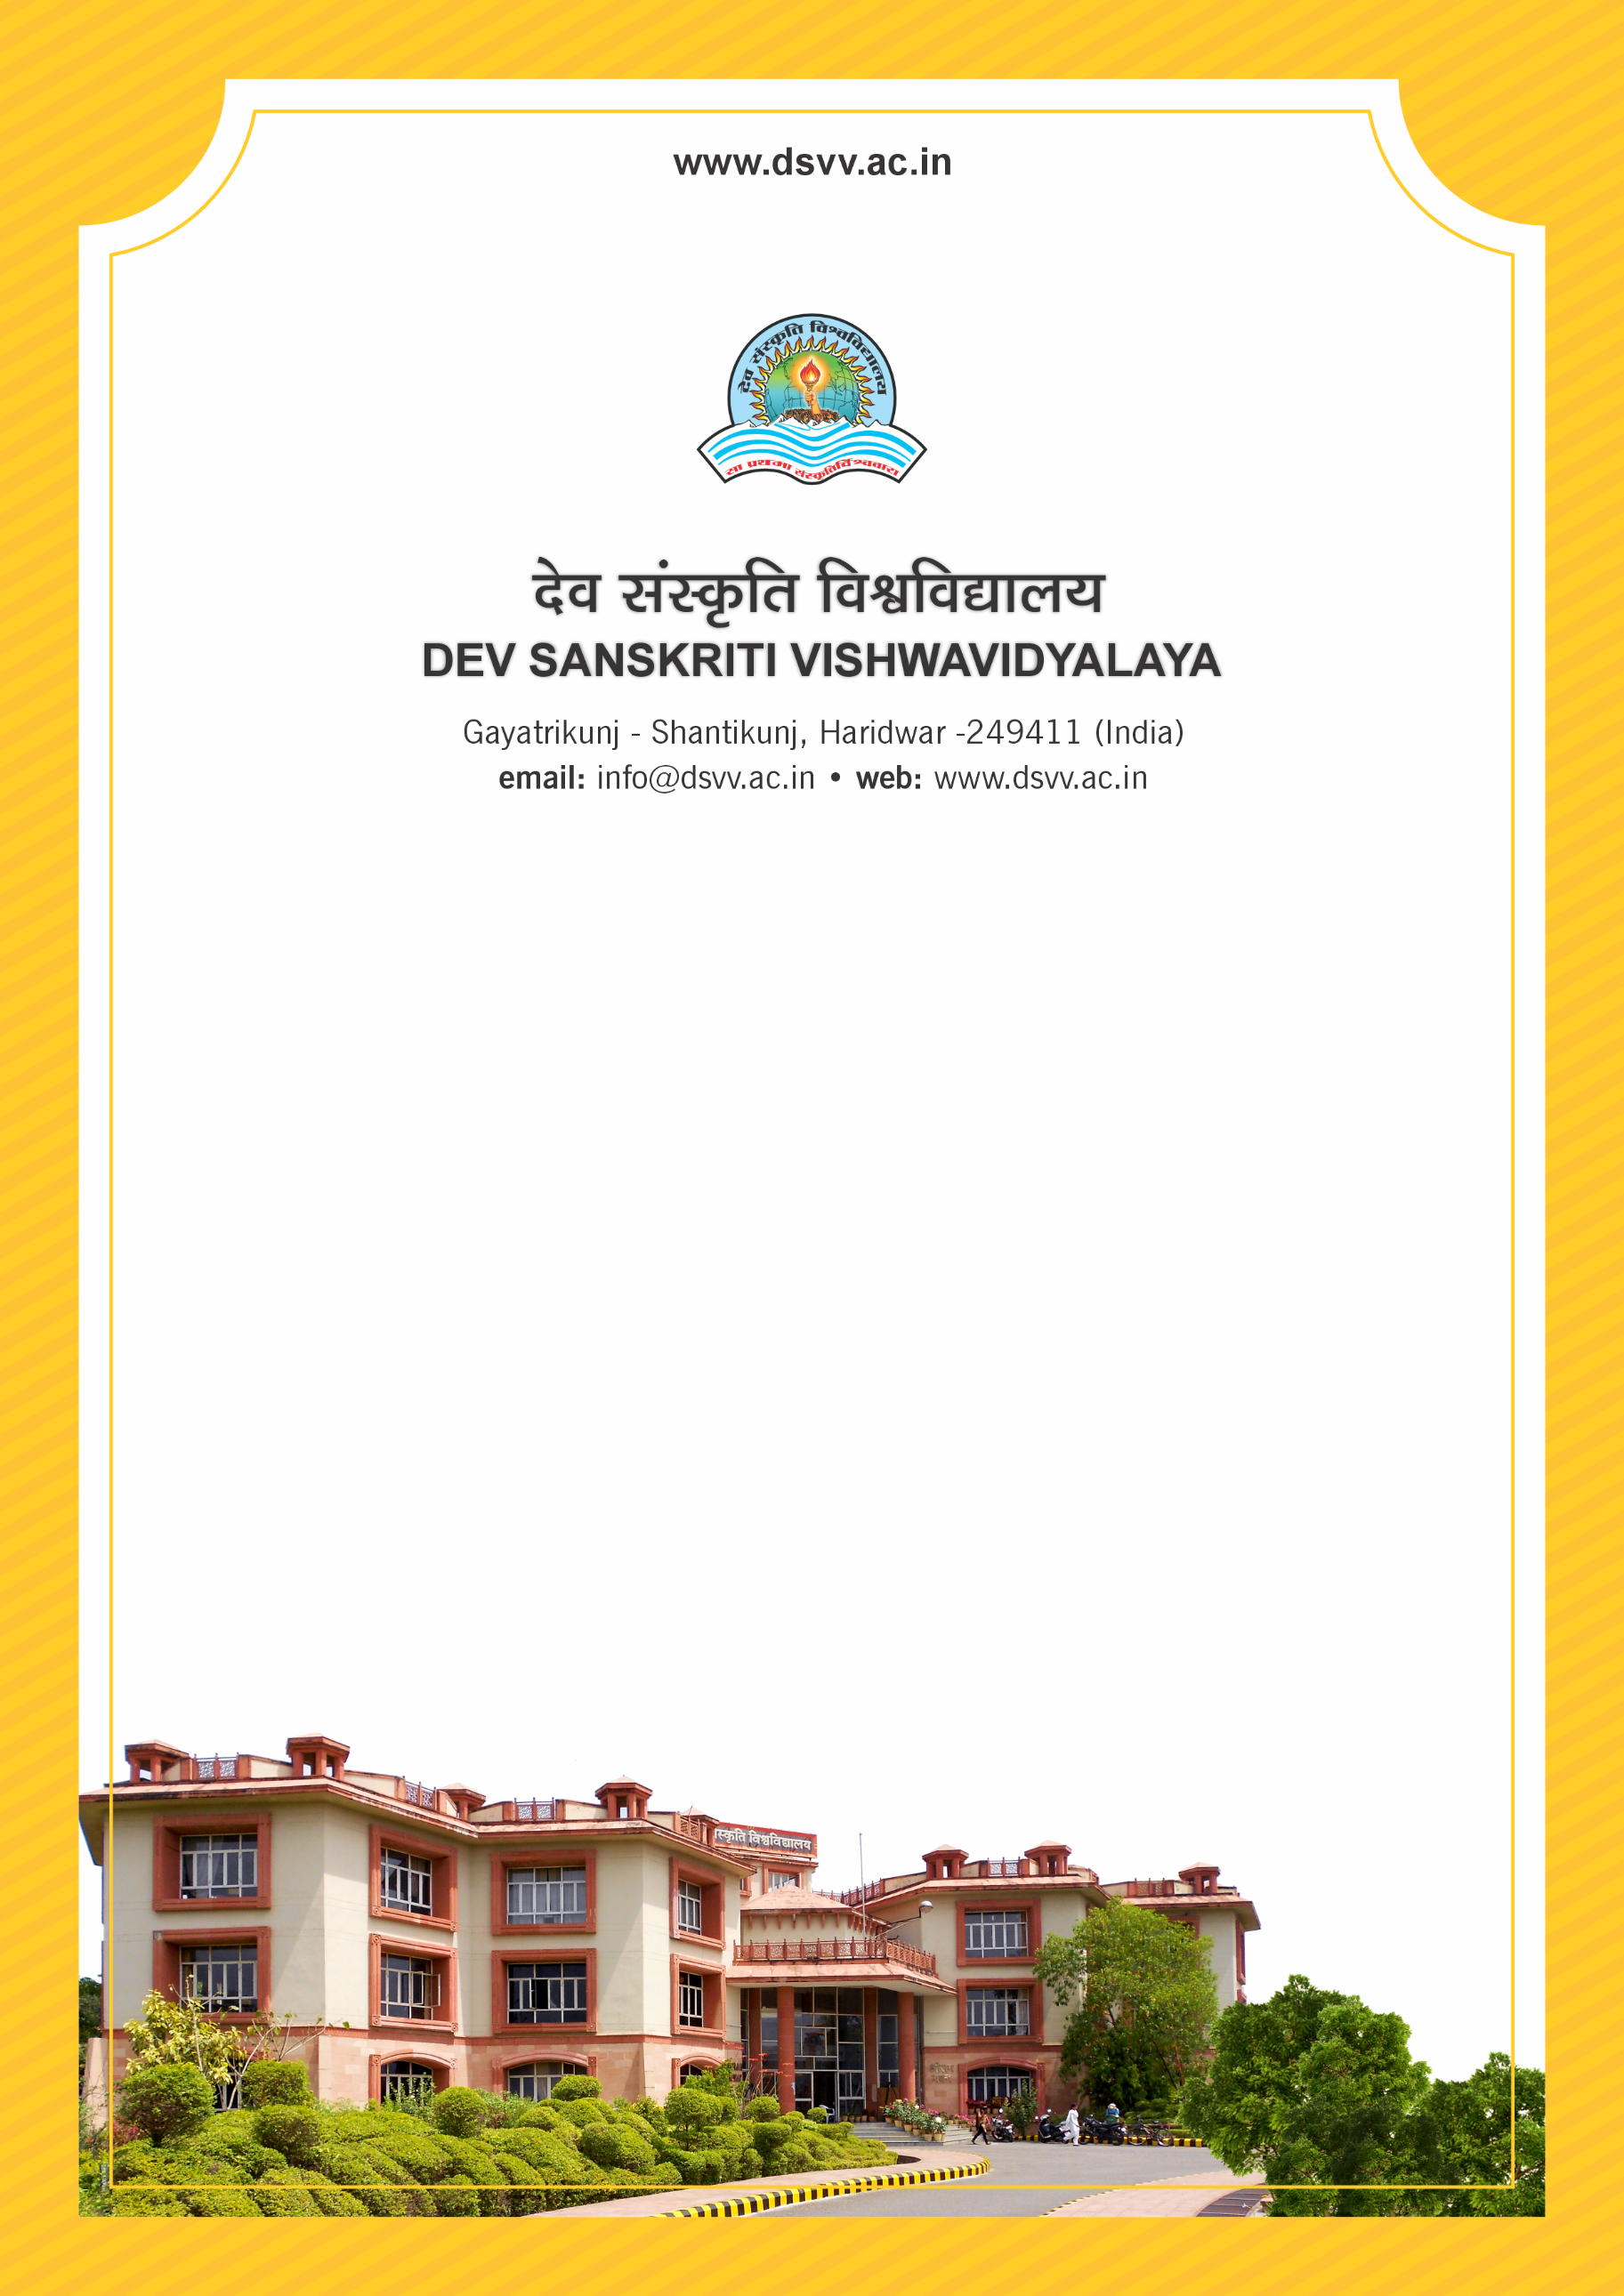
Figure 1Titel
Criteria 2
2.4.3 Average teaching experience of full time teachers (Data to be provided only for the latest completed academic year, in number of years)
2.4.3.1 Total teaching experience of full-time teachers as of latest completed academic year
2.4.3
Average teaching experience of full time teachers (Data to be provided only for the latest completed academic year, in number of years)
Response: 10.79
2.4.3.1 Total teaching experience of full-time teachers as of latest completed academic year
Response: 1392
File Description | Document
Provide the relevant information in institutional website as part of public disclosure
Institutional data in the prescribed format (data template)
Provide Links for any other relevant document to support the claim (if any)

