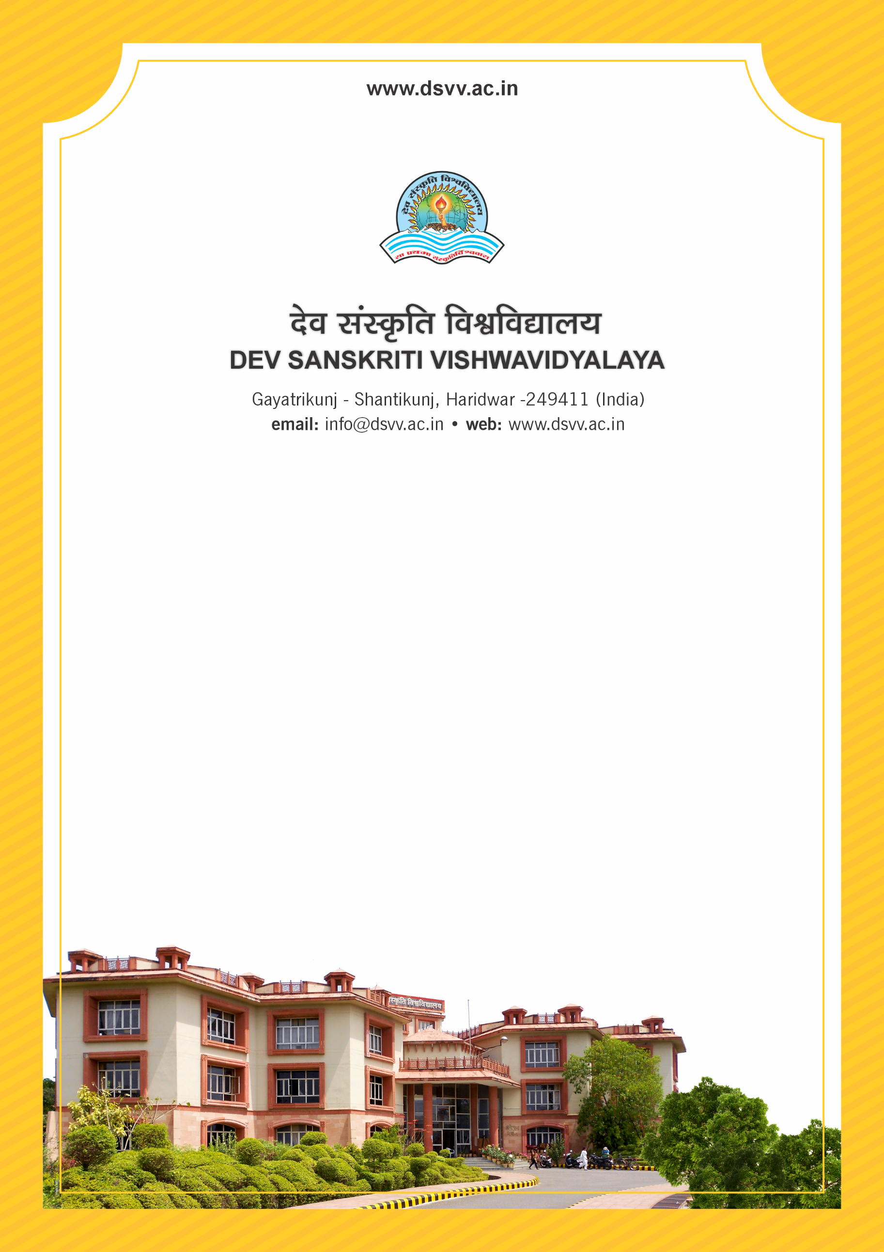
Figure 1Titel
Criteria 2
2.4.2 Percentage of full time teachers with Ph.D./D.M/M.Ch./D.N.B/ Superspeciality/L.L.D/D.S.C/D.Litt. during the last five years
2.4.2.1 Number of full time teachers with Ph.D./D.M/M.Ch./D.N.B/ Superspeciality/L.L.D/D.S.C/D.Litt Superspecialist during the last five years
2.4.2
Percentage of full time teachers with Ph.D./D.M/M.Ch./D.N.B/ Superspeciality/L.L.D/D.S.C/D.Litt. during the last five years
Response: 72.09
2.4.2.1 Number of full time teachers with Ph.D./D.M/M.Ch./D.N.B/ Superspeciality/L.L.D/D.S.C/D.Litt Superspecialist during the last five years
Response: 93
File Description | Document
Provide the relevant information in institutional website as part of public disclosure
List of faculty having Ph.D./D.M/M.Ch./D.N. Superspeciality/ along with particulars of the degree awarding university, subject and the year of award per academic year.
Institutional data in the prescribed format (data template)
Copies of Ph.D./D.M/M.Ch./D.N.B Superspeciality awarded by UGC recognized universities
Provide Links for any other relevant document to support the claim (if any)

