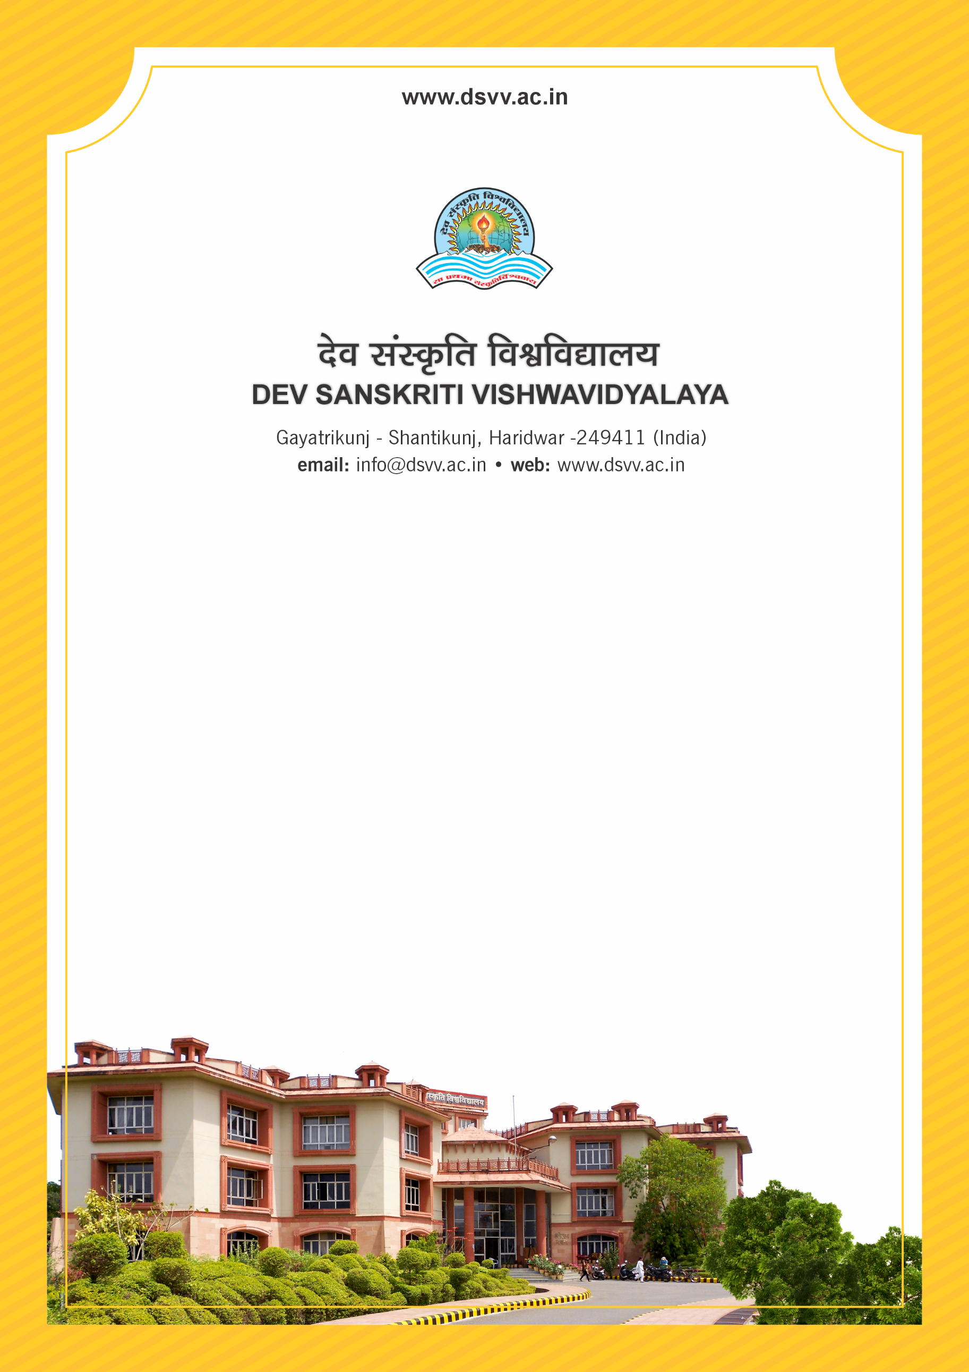
Figure 1Titel
Criteria 2
2.4.1 Average percentage of full time teachers appointed against the number of sanctioned posts year wise during the last five years
2.4.1.1 Total Number of Sanctioned year wise during the last five years
2.4.1 Average percentage of full time teachers appointed against the number of sanctioned posts year wise during the last five years
Response: 100
2.4.1.1 Total Number of Sanctioned year wise during the last five years
2023-24 | 2022-23 | 2021-22 | 2020-21 | 2019-20
129 | 128 | 114 | 108 | 110

File Description | Document
Sanction letters indicating number of posts sanctioned by the competent authority (including Management sanctioned posts).
Provide the relevant information in institutional website as part of public disclosure
Institutional data in the prescribed format (data template merged with 2.4.3 and 2.4.4)
Provide Links for any other relevant document to support the claim (if any)

