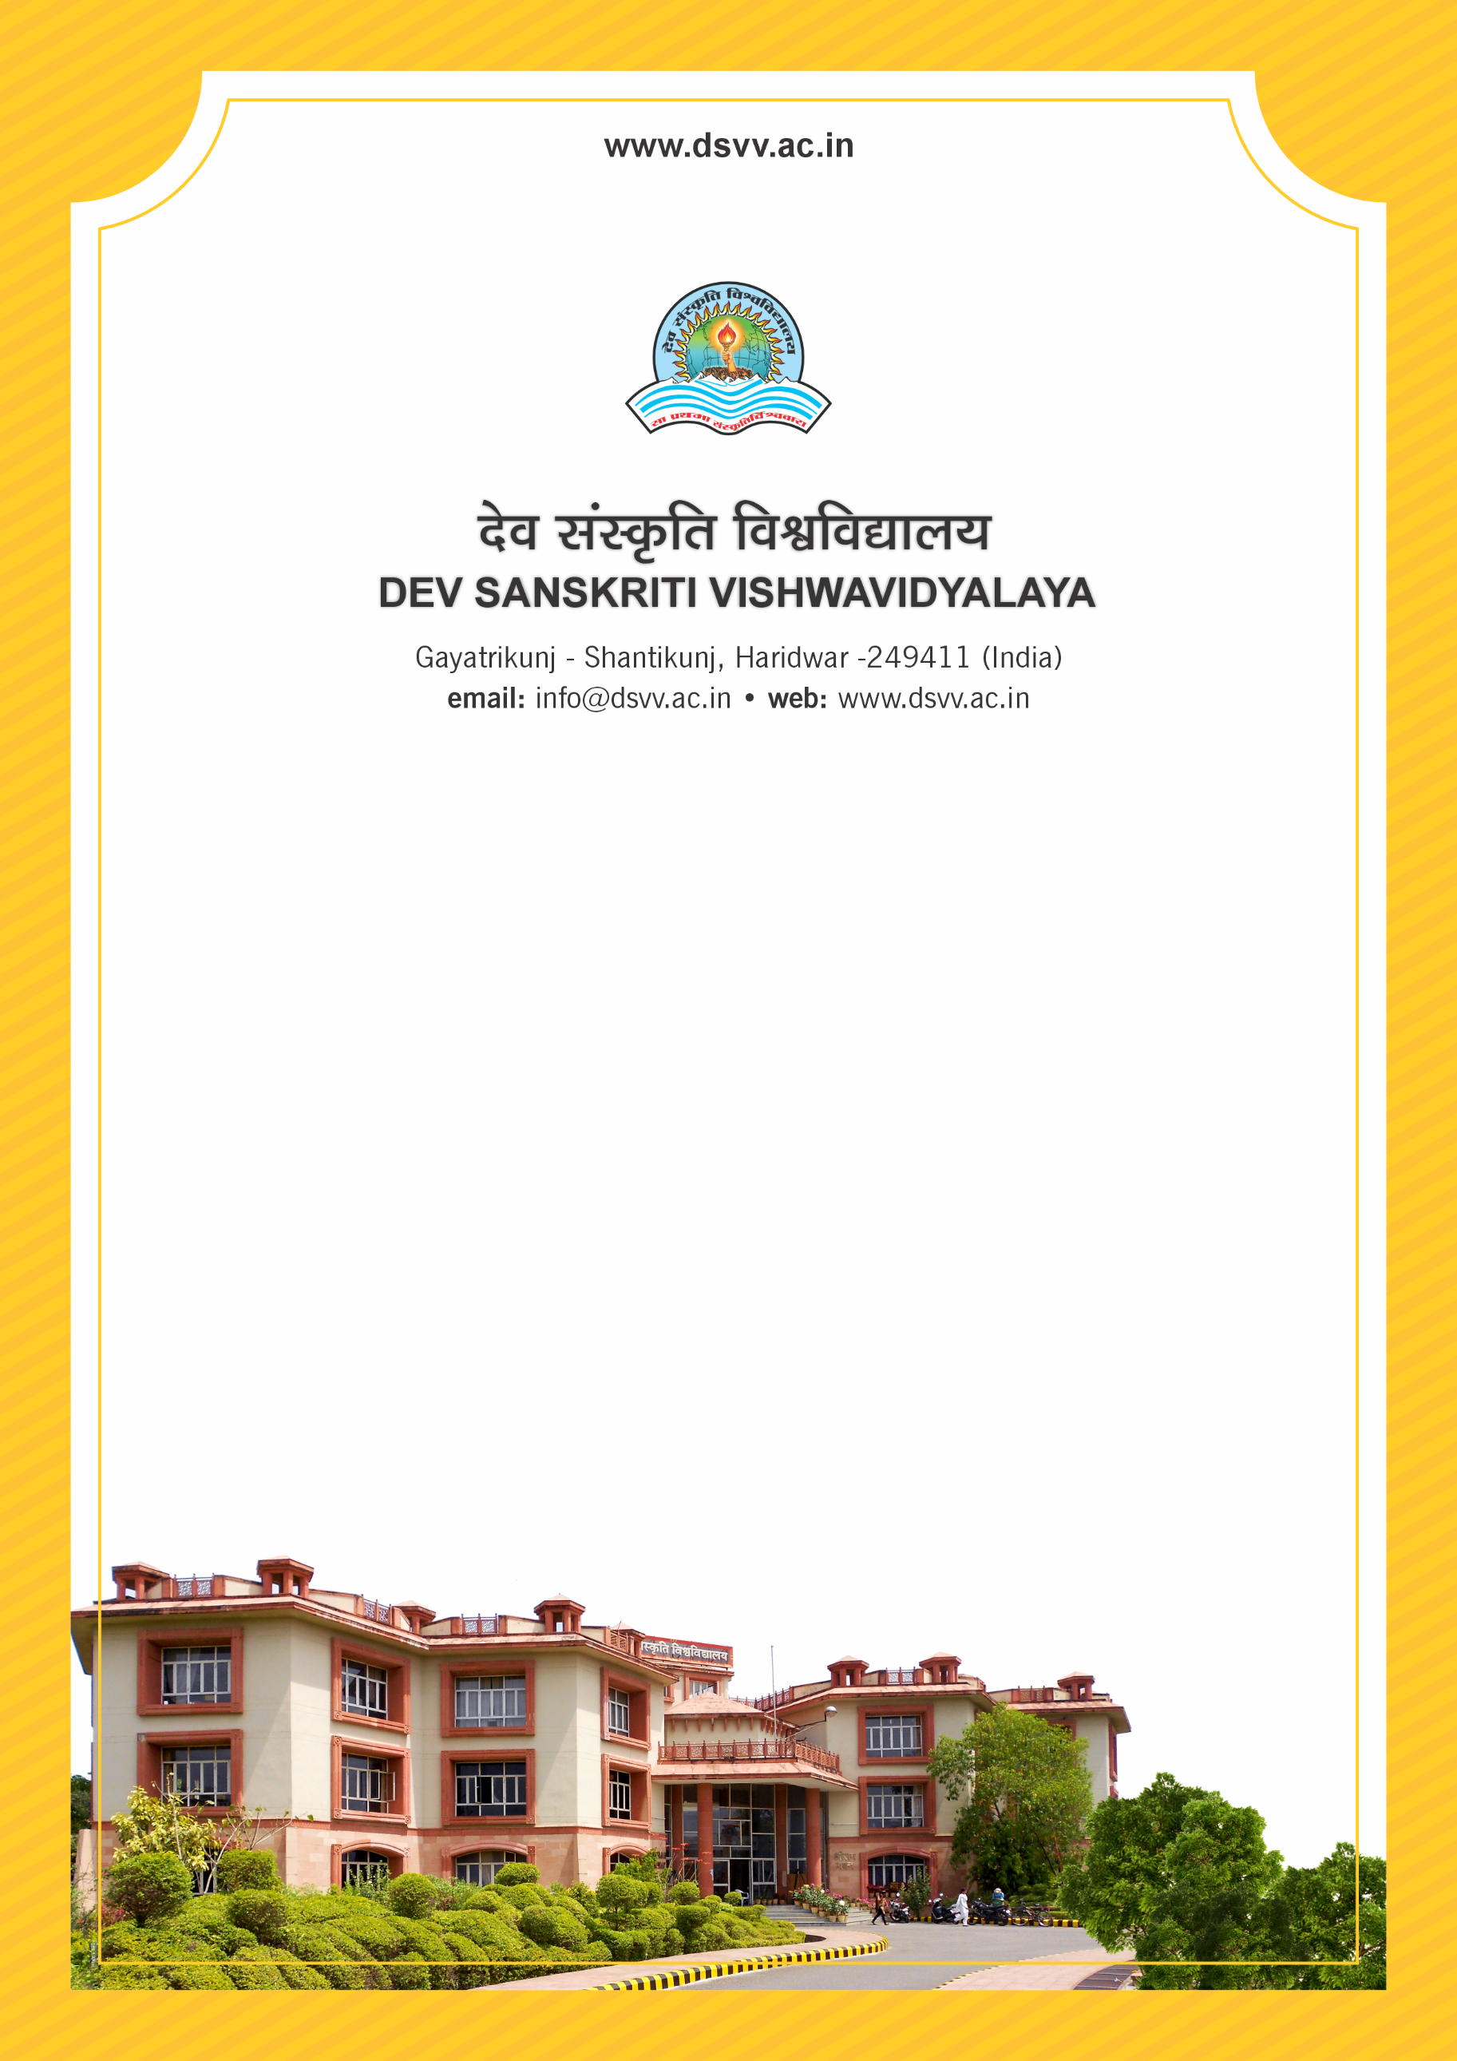
Figure 1Titel
Criteria 2
2.2.2 Student - Full time teacher ratio (Data for the latest completed academic year)
2.2.2
Student - Full time teacher ratio (Data for the latest completed academic year)
Response: 8.7
File Description | Document
List showing the number of students in each of the programs for the latest completed academic year across all semesters
Certified list of full time teachers along with the departmental affiliation in the latest completed academic year.
Provide Links for any other relevant document to support the claim (if any)

