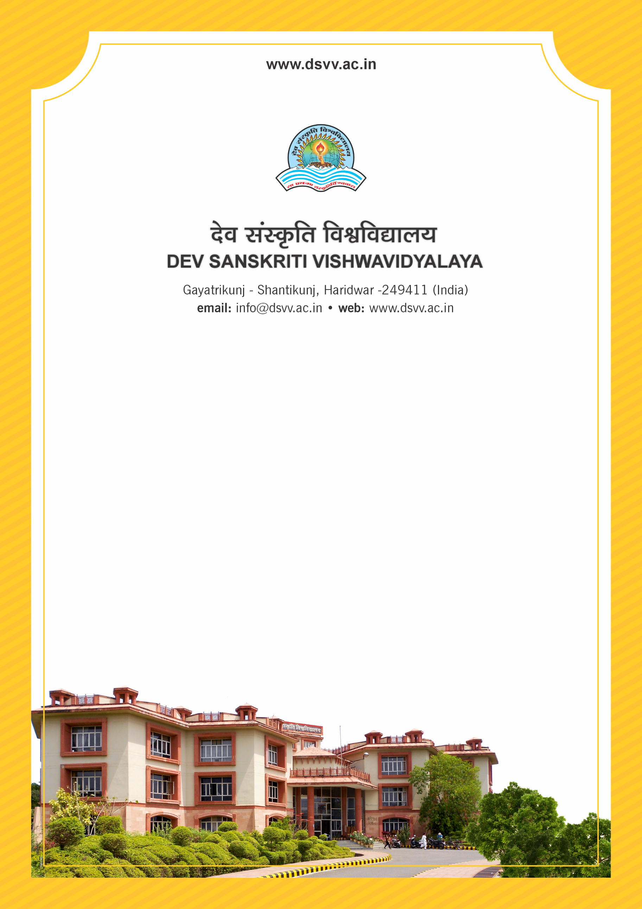
Figure 1Titel
Criteria 2
2.1.2 Percentage of seats filled against reserved categories (SC, ST, OBC etc.) as per applicable reservation policy for the first year admission during the last five years
2.1.2.1 Number of actual students admitted against the reserved categories in the first year of the programme year-wise during the last five years
2.1.2.2 Total number of seats earmarked for reserved category as per GOI or State Government rule year-wise during the last five years
2.1.2
Percentage of seats filled against reserved categories (SC, ST, OBC etc.) as per applicable reservation policy for the first year admission during the last five years
Response: 15.05
2.1.2.1 Number of actual students admitted against the reserved categories in the first year of the programme year-wise during the last five years
2023-24 | 2022-23 | 2021-22 | 2020-21 | 2019-20
25 | 26 | 40 | 43 | 38

2.1.2.2 Total number of seats earmarked for reserved category as per GOI or State Government rule year-wise during the last five years
2023-24 | 2022-23 | 2021-22 | 2020-21 | 2019-20
222 | 222 | 228 | 230 | 241
File Description | Document
Provide the relevant information in institutional website as part of public disclosure
Institutional data in the prescribed format (data template)
Final admission list indicating the category as published by the HEI and endorsed by the competent authority.
Copy of the letter issued by the State govt. or Central Government Indicating the reserved categories (SC, ST, OBC, Divyangjan, etc.) to be considered as per the state rule (Translated copy in English to be provided as applicable)
Provide Links for any other relevant document to support the claim (if any)

