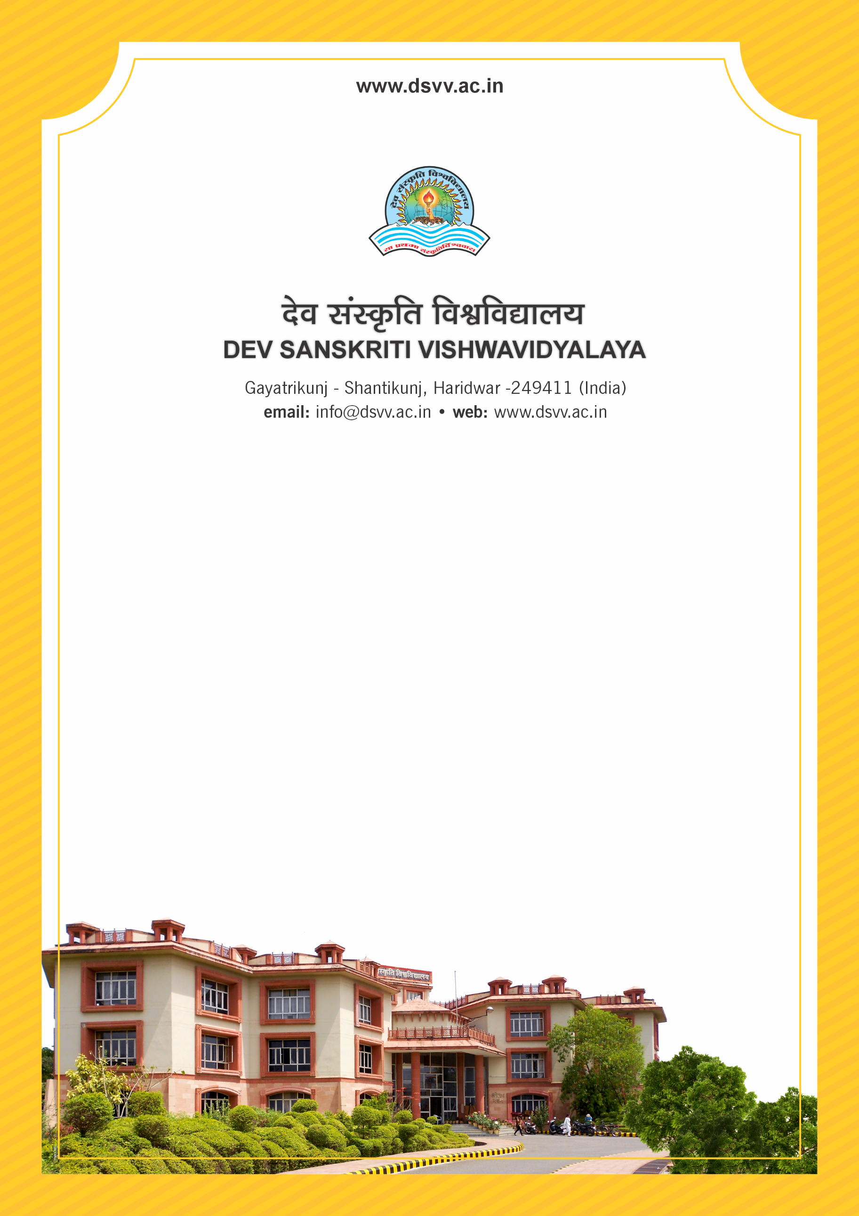
Figure 1Titel
Criteria 2
2.1.1 Enrolment percentage
2.1.1.1 Number of sanctioned seats year wise during last five years
2.1.1.2 Number of seats filled year wise during last five years (Only first year admissions to be considered)
2.1.1
Enrolment percentage
Response: 91.49
2.1.1.1 Number of sanctioned seats year wise during last five years
2023-24 | 2022-23 | 2021-22 | 2020-21 | 2019-20
571 | 600 | 610 | 620 | 653

2.1.1.2 Number of seats filled year wise during last five years (Only first year admissions to be considered)
2023-24 | 2022-23 | 2021-22 | 2020-21 | 2019-20
504 | 503 | 597 | 578 | 612
File Description | Document
Provide the relevant information in institutional website as part of public disclosure
Institutional data in the prescribed format (data template)
Document relating to sanction of intake as approved by competent authority
Admission extract signed by the competent authority (only fresh admissions to be considered)
Provide Links for any other relevant document to support the claim (if any)

