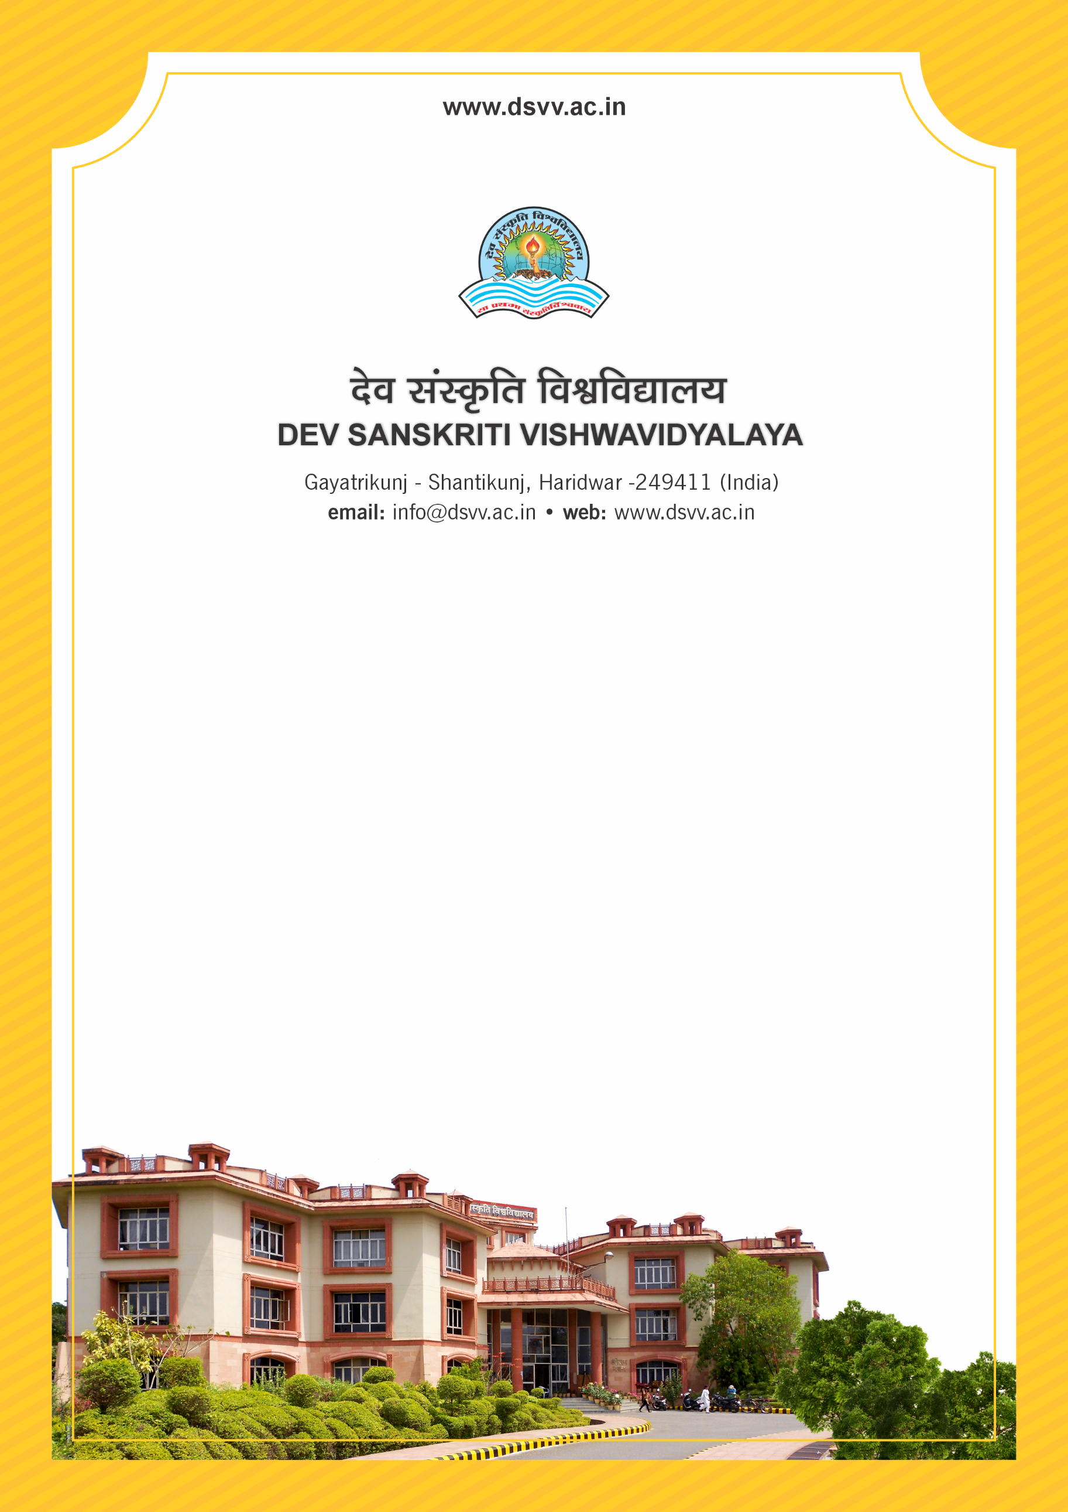
Figure 1Titel
Criteria 1
1.4.1 Structured feedback for curriculum and its transaction is regularly obtained from stakeholders like Students, Teachers, Employers, Alumni, Academic peers etc., and Feedback processes of the institution may be classified as follows:
Response: B. Feedback collected, analysed, action has been taken and communicated to the relevant bodies
1.4.1
Structured feedback for curriculum and its transaction is regularly obtained from stakeholders like Students, Teachers, Employers, Alumni, Academic peers etc., and Feedback processes of the institution may be classified as follows:
Response: B. Feedback collected, analysed, action has been taken and communicated to the relevant bodies
File Description | Document
Institutional data in the prescribed format (data template)
Feedback analysis report submitted to appropriate committee/bodies
At least 4 filled-in feedback form from different stake holders like Students, Teachers, Employers, Alumni etc.
Action taken report on the feedback analysis and its report to appropriate committee/bodies
Provide Links for any other relevant document to support the claim (if any)

