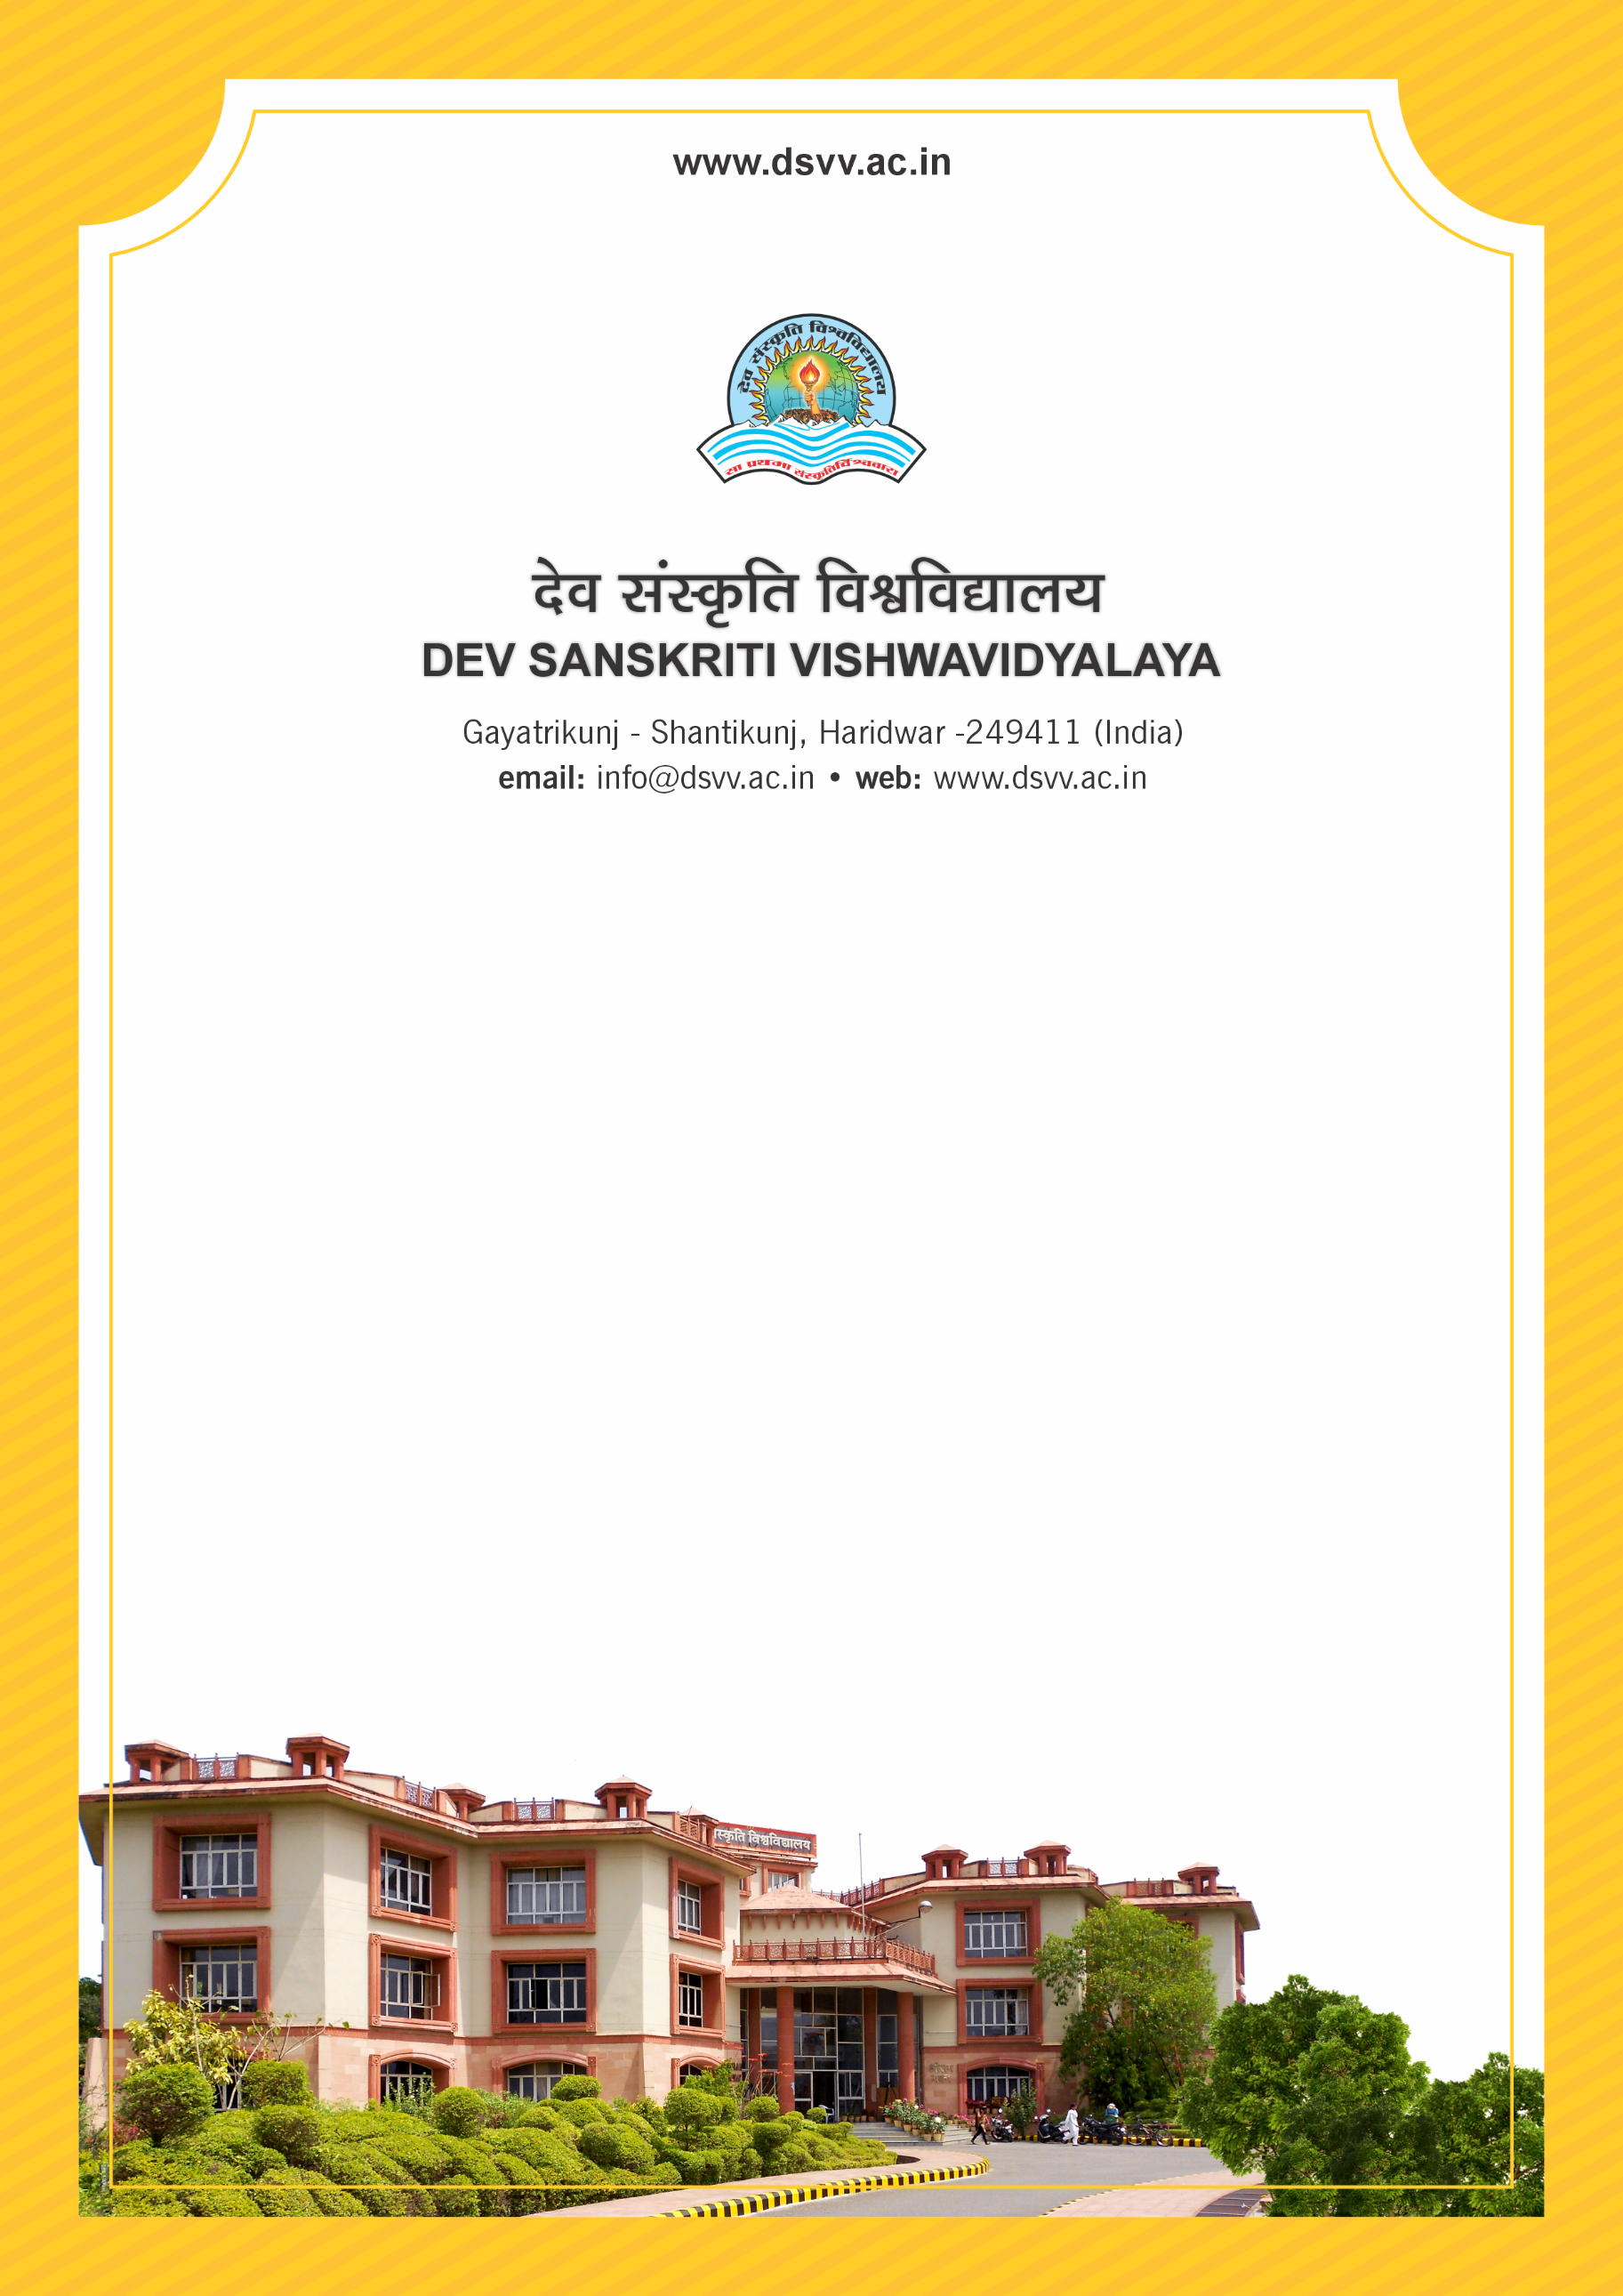
Figure 1Titel
Criteria 1
1.3.3 Percentage of programmes that have components of field projects / research projects / internships during the last five years.
1.3.3.1 Total Number of programmes that have components of field projects / research projects /internships (without repeat count) during the last five years
1.3.3.2 Total Number of programmes offered (without repeat count) during the last five years
1.3.3
Percentage of programmes that have components of field projects / research projects / internships during the last five years.
Response: 58.33
1.3.3.1 Total Number of programmes that have components of field projects / research projects / internships (without repeat count) during the last five years
Response: 21
1.3.3.2 Total Number of programmes offered (without repeat count) during the last five years
Response: 36
File Description | Document
Sample Internship completion letter provided by host institutions
Provide the relevant information in institutional website as part of public disclosure
Program and course contents having element of field projects / research projects / internships as approved by BOS
Institutional data in the prescribed format (data template)
Provide Links for any other relevant document to support the claim (if any)

