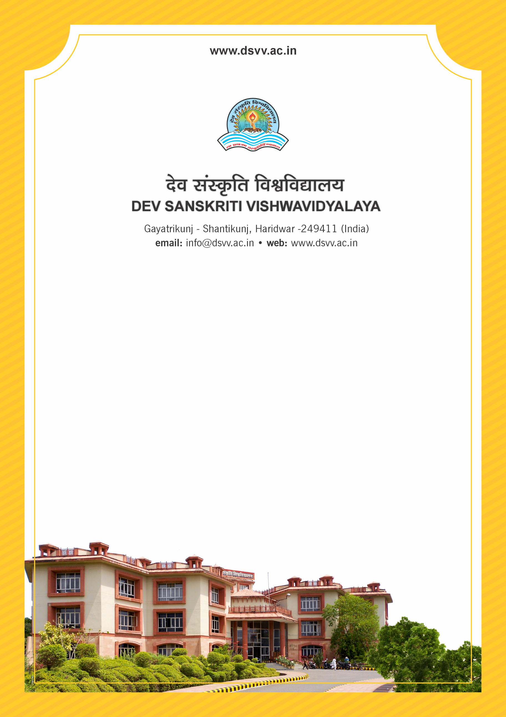
Figure 1Titel
Criteria 1
1.3.2 Number of certificate/value added courses/Diploma Programme offered by the institutions and online courses of MOOCs, SWAYAM/e Pathshala/ NPTEL and other recognized platforms (without repeat count) where the students of the institution have enrolled and successfully completed during the last five years
1.3.2
Number of certificate/value added courses/Diploma Programme offered by the institutions and online courses of MOOCs, SWAYAM/e Pathshala/ NPTEL and other recognized platforms (without repeat count) where the students of the institution have enrolled and successfully completed during the last five years
Response: 0
File Description | Document
Provide the relevant information in institutional website as part of public disclosure
List of students and the attendance sheet for the above mentioned programs
Institutional programme brochure/notice for Certificate/Value added programs with course modules and outcomes
Institutional data in the prescribed format (data template)
Evidence of course completion, like course completion certificate etc.

