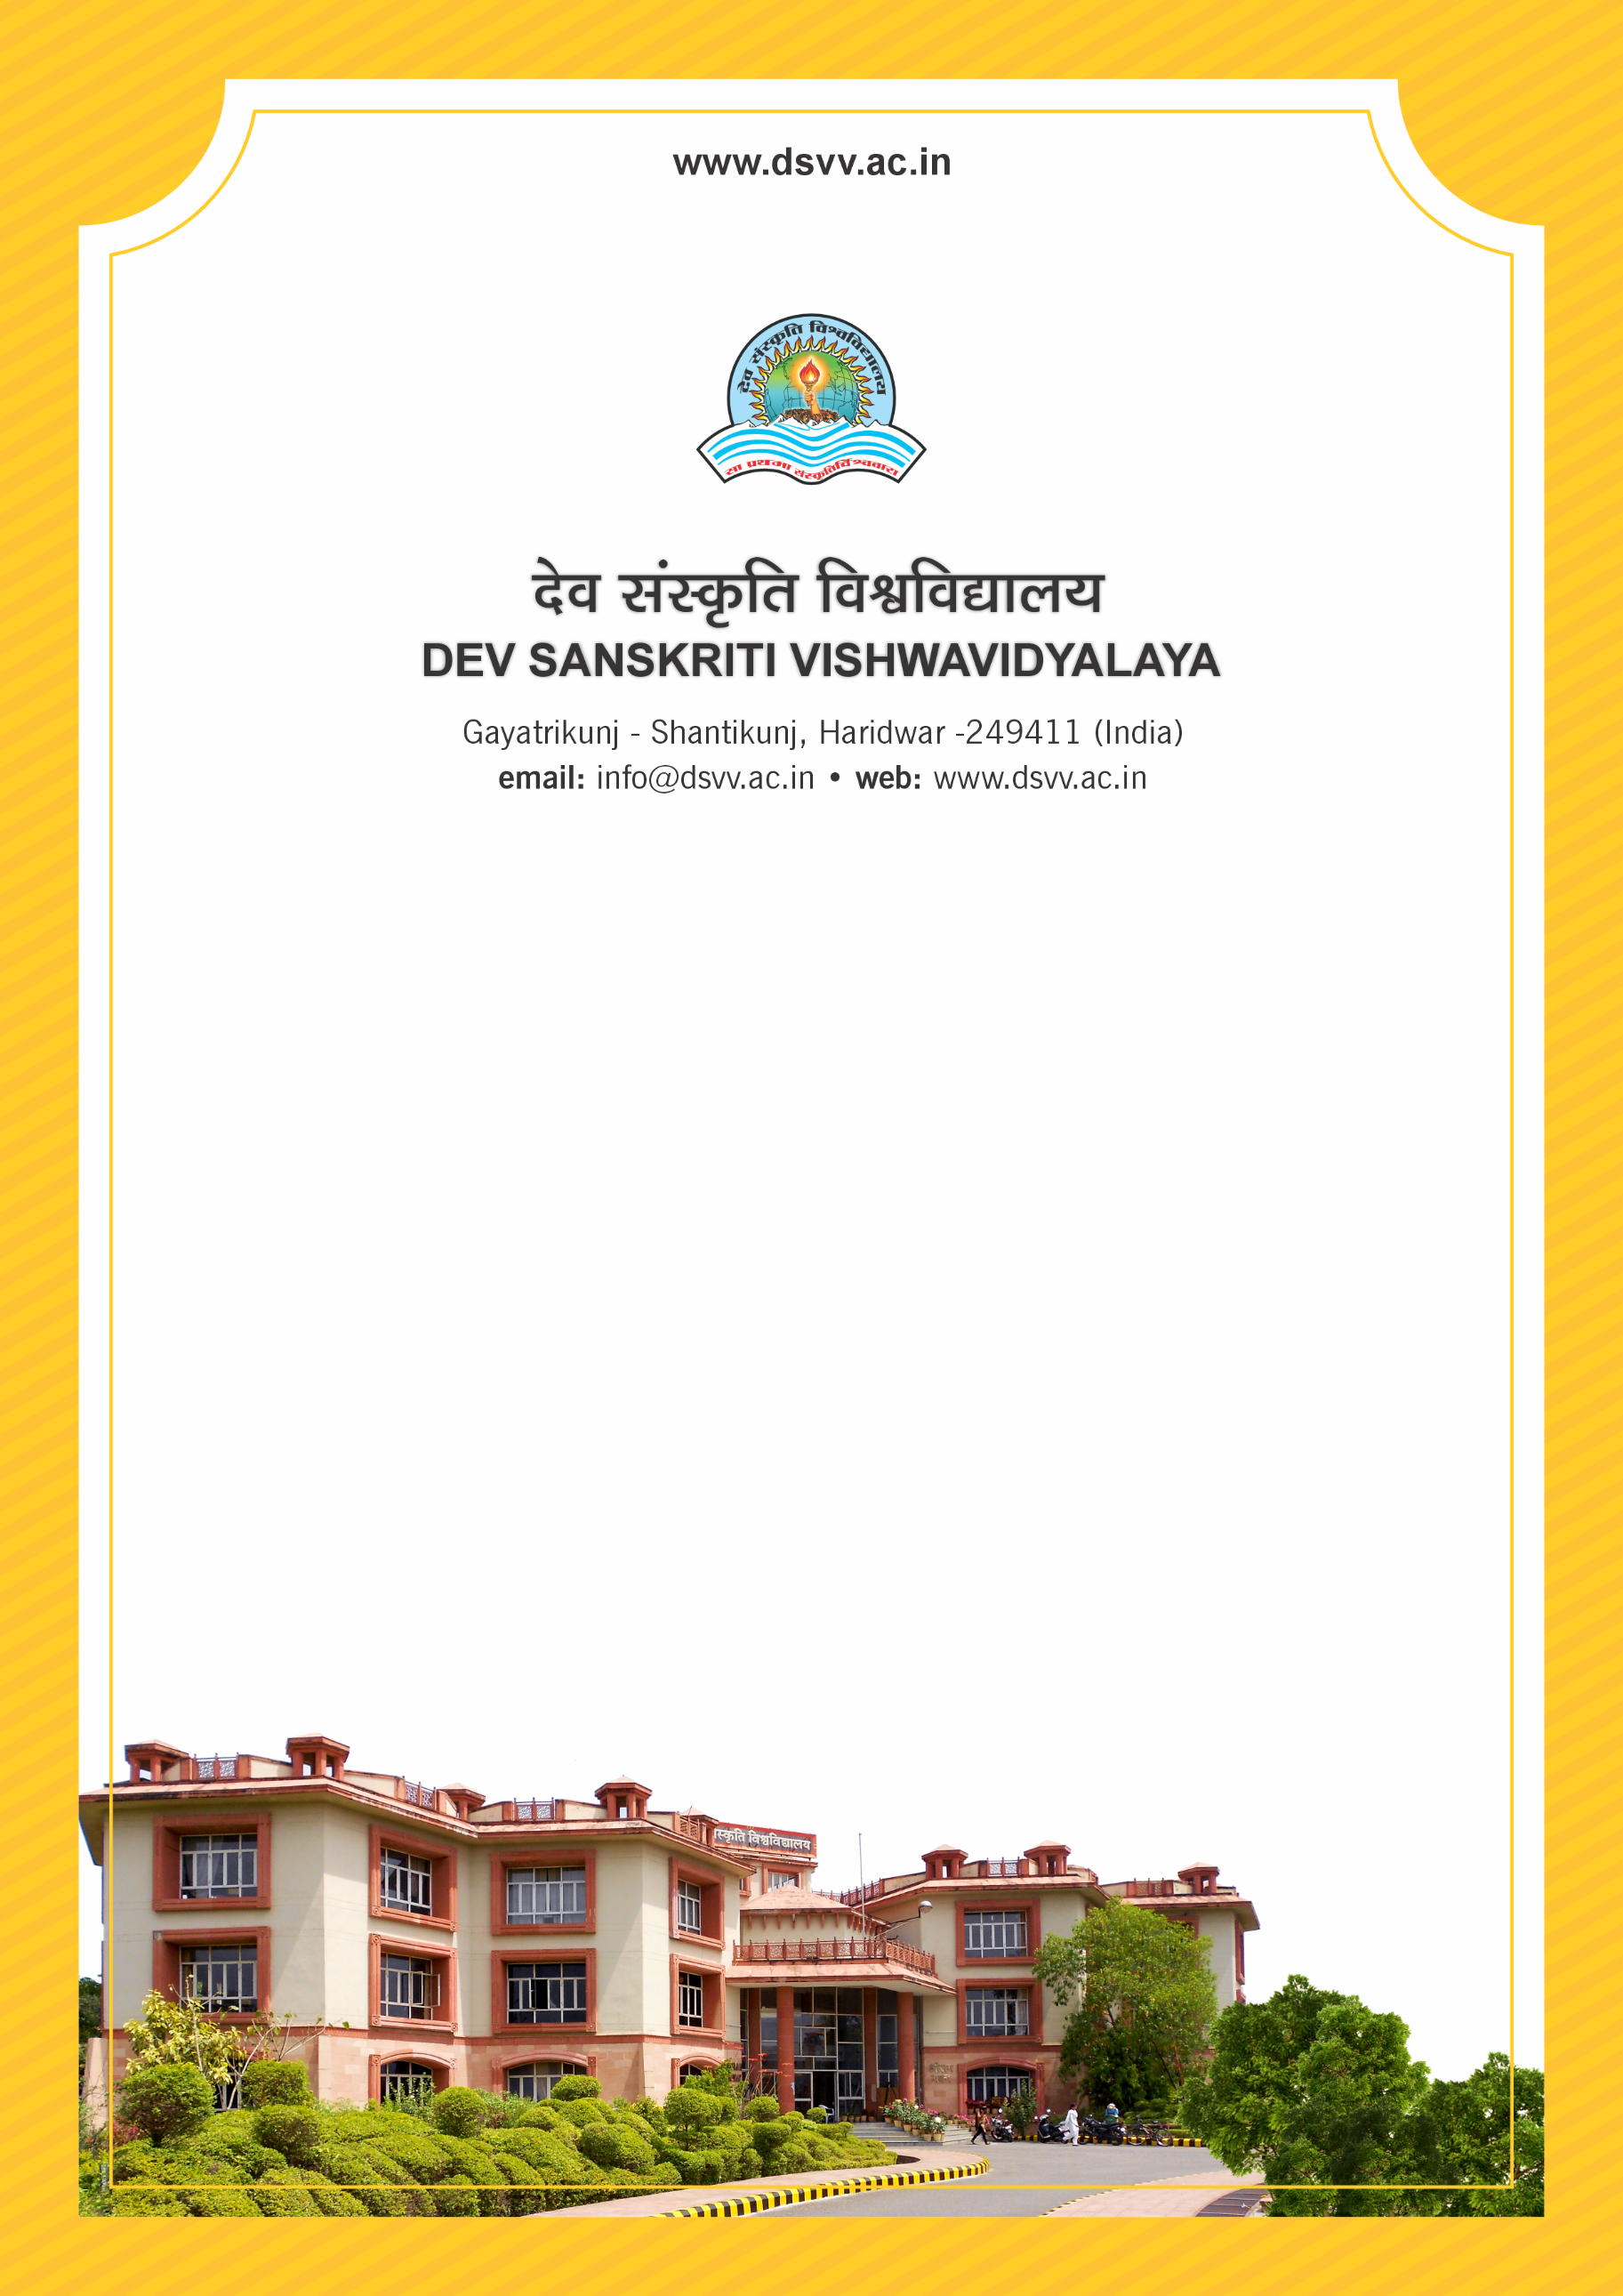
Figure 1Titel
Criteria 1
1.2.1 Percentage of new courses introduced out of the total number of courses across all programmes offered during the last five years
1.2.1.1 Number of new courses introduced during the last five years:
1.2.1.2 Consolidated number of courses offered by the institution across all Programmes (without repeat count) during the last five years :
1.2.1
Percentage of new courses introduced out of the total number of courses across all programmes offered during the last five years
Response: 19.78
1.2.1.1 Number of new courses introduced during the last five years:
Response: 197
1.2.1.2 Consolidated number of courses offered by the institution across all Programmes (without repeat count) during the last five years :
File Description | Document
Subsequent Academic Council meeting extracts endorsing the decision of BOS
Provide the relevant information in institutional website as part of public disclosure
Minutes of Board of Studies meeting clearly specifying the syllabus approval of new courses
Institutional data in the prescribed format (data template)
Response: 996

